**FOR TEACHERS**

**by Sazea Begum**

**edited by Jessica Genter**

**Student Objectives:**

1. SWBAT explain the difference between abiotic and biotic factors
2. SWBAT describe the flow of energy through and ecosystem
3. SWBAT recognize how unfavorable abiotic and biotic factors affect a species
4. SWBAT to analyze the correlation between malaria and DDT.
5. SWBAT analyze data on DDT and its alternatives.

The worksheet below can stand alone as its own lesson. If you wish for additional resources, please use our suggestions below.

**Connecting abiotic factors to biotic factors**

Allow students to choose an ecosystem (savannah, desert, tropical rain forest, coral reef, bottomland hardwood forest, etc.) to study. Students identify key biotic and abiotic elements in the ecosystem.

1. Students make a list of the abiotic elements in their ecosystem of choice.

2. Students make a list of the plants and animals (herbivores, carnivores, omnivores) in their ecosystem of choice.

3. Have students use a minimum of at least 3 abiotic elements, 3 plants, 3 herbivores, 3 omnivores and 3 carnivores in their ecosystem and design an interactions web. Draw lines between the elements to show there is interaction between the two elements. Use arrows to show who is the consumer between the two elements. Write the type of interaction that is occurring on each line.

Example: breathe

air --------------------> deer

4. After the groups have completed their interaction webs, have each group share its web with another group and allow the groups to modify their webs.

5. Have groups share their webs with more groups and allow those groups to modify their webs.

6. Post interaction webs in the classroom. Allow students to review these.

7. Have a discussion of the different ecosystems and their interactions, during which students draw conclusions about the importance of interactions within ecosystems and how these interactions allow the ecosystems to sustain their carrying capacities.

8. Have groups remove one abiotic or biotic element from their interactions web and describe how it would affect the ecosystem.

9. Circle the organisms that you think would be affected if your chosen ecosystem was exposed to pesticides.

**Discussion Questions:**

1. How do the animals and plants interact with the abiotic elements in your ecosystem?
2. How important are interactions to the carrying capacity of a particular species within an ecosystem?
3. Name the abiotic factors in your chosen ecosystem.
4. How would a natural disaster affect the carrying capacity of your ecosystem?
5. How would human activities affect the carrying capacity of your ecosystem?

Name:_________________________________________ Date:_______________ PD: _____

Malaria is an infectious disease that is transferred to humans through mosquitoes. Infected female mosquitoes will bite humans and transfer the parasite through their saliva directly into a person’s circulatory system. Malaria is widespread in tropical and subtropical regions, including places like South Africa and South America.

DDT is a pesticide used to kill insects including mosquitoes. It has had many uses since it was first synthesized in 1874, but was primarily used to control agricultural pests. In 1972, it was banned in the United States because of the harmful ecological effects it has on the environment.

South Africa historically used DDT to control the spread of malaria by going inside houses and spraying the entire indoor area. In 1996, they replaced DDT with another insecticide considered to be less toxic than DDT. In 2001, South Africa reintroduced DDT as a house spray to control malaria.

Below you will see two graphs visually representing the correlation between malaria and DDT in South Africa as well as countries in South America.

**Answer questions 1-3 using the graph below.**

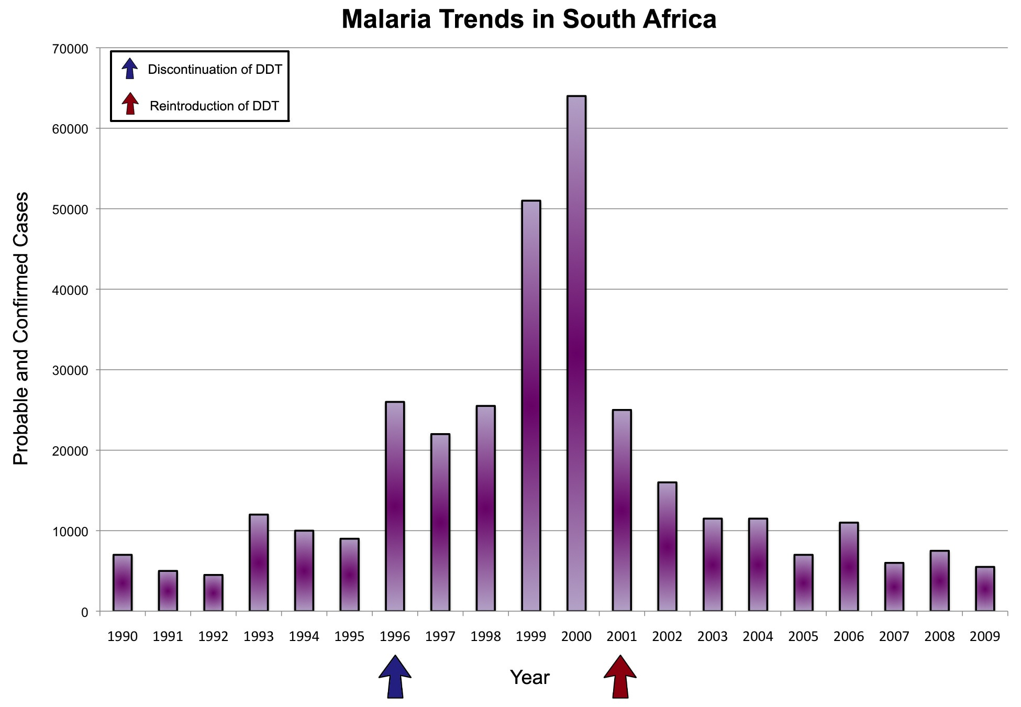

Data from Prenatal exposure to DDT in malaria endemic region following indoor residual spraying and in non-malaria coastal regions of South Africa

1. What is the trend of malaria cases from 1990 to 2000?

As a whole, malaria cases rose from 1990 to 2000.

2. What is the trend of malaria cases from 2001-2009?

Malaria cases dropped dramatically from 2000 to 2001 and then continued to fall.

3. How did the events of 1996 and 2001 affect the number of malaria cases?

Malaria cases stayed relatively the same until 1999, when they rose dramatically.

**Use the graph below to answer questions 4-6.**

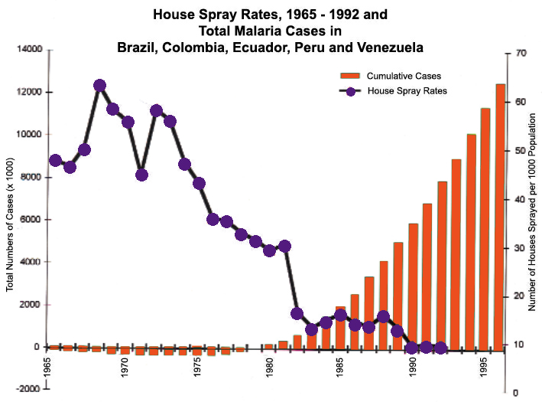

Data from: Comparison of house spraying and insecticide-treated nets for malaria control

4. How did the cumulative cases of malaria change from 1955 to 1995?

The cumulative cases stayed stable until 1980, then they began (and continued) to rise.

5. How did the house spray rates change from 1955 to 1995?

The house spray rates stayed between 8,000,000 and 10,000,000 cases until 1975, when they dropped dramatically. They stayed around 2,000,000 cases from the early 1980s to 1990, when they disappeared altogether.

6. What can you determine is the relationship between the cumulative cases of malaria and house spraying rates?

As the house spray rates decrease, the cumulative malaria cases increase.

Insecticide-treated mosquito nets are also used to combat malaria. These nets form a protective barrier around sleeping humans by killing mosquitoes and other insects.

The table below shows the percentage of people affected in areas with treated nets and untreated nets. Use the table below to answer question 7.

|  |  |  |
| --- | --- | --- |
| **Study Area** | **Treated Nets** | **No Nets** |
| Cameroon | 18% | 28% |
| Sierra Leone | 33% | 46% |

7. How does having treated nets affect the number of individuals affected with malaria?

Treated nets decrease the number of malaria cases in individuals.

8. How would spraying houses with insecticide affect the abiotic factors in a local environment?

Spraying houses releases insecticides, changing the composition of the air in local environments.

9. Would treated nets have the same effect?

No, because treated nets do not release chemicals into the air.

10. If you had to choose between spraying your house with insecticide or using insecticide-treated nets, what would you choose? Why?

Students’ answers should relate in some way to their previous answers.