Full Name: ______________________________ Class: _______________ Date: __________

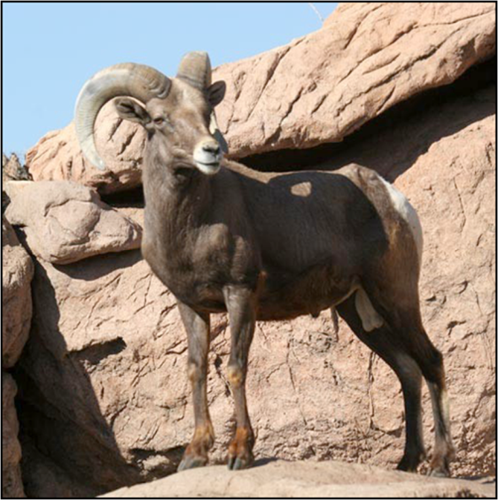 | Investigation Booklet:  Bighorn Sheep

Lesson 1: Setting the Stage & the Scientific Process in Action

1. What is the research question for this unit?
________________________________________________________________________________
________________________________________________________________________________

2. What geographic area defines each bighorn sheep population?

________________________________________________________________________________________________________________________________________________________________

3. How have people changed bighorn sheep habitat and what is the economic motivation for making these changes?

________________________________________________________________________________________________________________________________________________________________

4. How do highways affect mating between different sheep populations?

________________________________________________________________________________________________________________________________________________________________

5. Clinton Epps made this statement in the video: “I have to be able to see the landscape to visualize the important questions. I have to experience the landscape to really be able to think well about what I want to study, how I want to study— I can’t do that studying at a desk.”

Why do you think he feels this way?

________________________________________________________________________________
________________________________________________________________________________

6. From the allele frequency diagram below determine which two populations, A, B, or C breed most frequently and explain your answer.

Population A Population B Population C
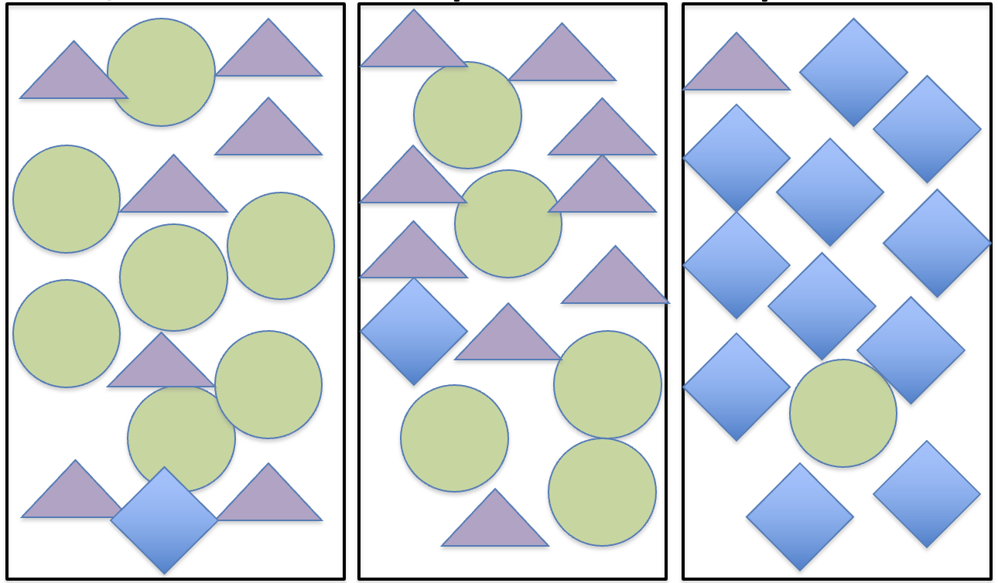
_____________________________________________________

_____________________________________________________

_____________________________________________________

_____________________________________________________

7. Instead of using shapes, use Xs and Os as your alleles to draw two populations that show high levels of breeding.

8. Use Xs and Os as your alleles to draw two populations that show low levels of breeding.

Lesson 2: Exploring the role of isolated populations in inbreeding

Use the pages below to complete the table and question below:

Examples of Inbreeding in Wild and Domestic Animals
 | Domestic Dogs | Florida Panthers | Thoroughbred Horses
Why has inbreeding occurred?

Describe the related health problems.

Examples of Inbreeding in People
 | Hapsburg Family | Amish People
Why has inbreeding occurred?

Describe the related health problems.

1. Why is it important for individuals from different small populations to be able to breed with one another?

Thoroughbred Horses  History  The Thoroughbred line of racehorses began 300 years ago in  England with horses from North Africa and the Middle East. Breeders keep careful records of horse parentage to understand the family history of new breeding horses.  Breeding  Analysis of Thoroughbred family histories and genes shows that all modern racehorses are descended from only 28 horses. In fact, most horses are descended from three horses with only one of those males contributing genes to almost all Thoroughbreds alive today!  Inbreeding Effects  Selectively choosing to mate fast horses has made Thoroughbreds the fastest breed of horses, but it has also made them inbred, which contributes to reproductive issues and skeletal defects that cause bone breaks. Horses that break a bone are usually put down. | 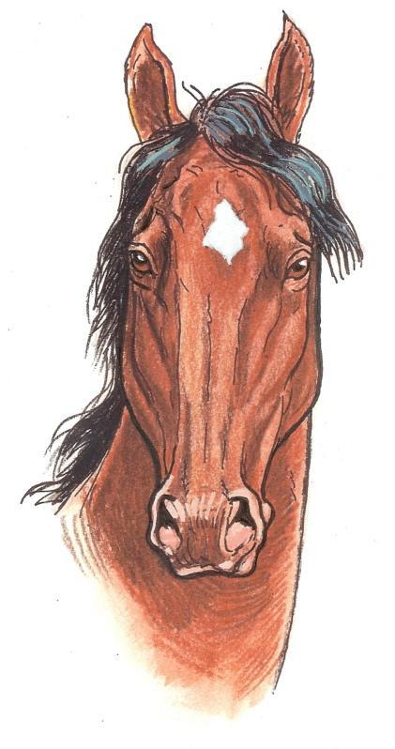

 |  | 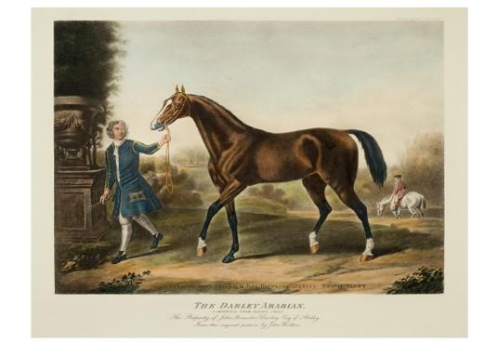
The three Triple Crown races, the Kentucky Derby, Preakness Stakes and Belmont Stakes, are the major events for U.S. three-year-old Thoroughbred horses. | A Thoroughbred horse on the Kentucky State quarter, a state known for thoroughbred horse breeding. | Most racehorses today are descended from the Darley Arabian, depicted above.

Dogs  Why do different breeds look so different?  Over many centuries, dogs were selectively bred, often by mating  close relatives with similar traits, to produce the many diverse dog breeds we see today.  The Downside of Breeding Close Relatives  This technique allowed breeders to successfully produce many  different breeds of dogs but has also led to health problems in  purebreds due to inbreeding. | Great Danes  Originally bred for their hunting skills and then to be guard dogs in Germany.  Health Problems:  • Heart problems  • Wobbly walking  • Severe hip pain

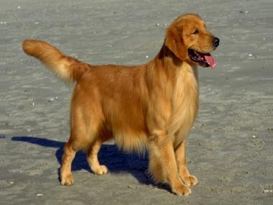 | Golden Retrievers  Bred to fetch birds shot down by hunters; they have soft mouths and love water – characteristics useful for returning fallen birds undamaged to the shooter.  Health Problems:  • Heart problems  • Wobbly walking  • Severe hip pain | 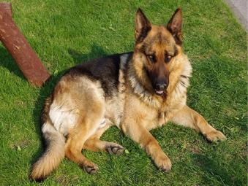 | German Shepherds  Bred to herd sheep.  Health Problems:  • Severe hip and elbow  pain  • Heart problems  • Nerve problems
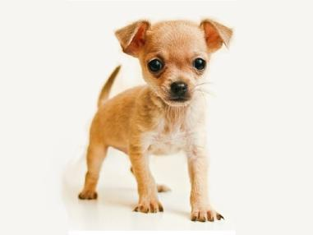 | Chihuahuas  Originally bred in Mexico to be companion dogs.  Health Problems:  • Seizures  • Low blood sugar  • Eye problems | 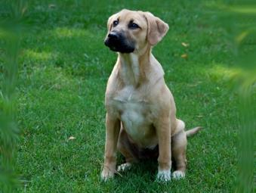 | Mutts  Dogs that are a mix of more than one breed have been found to live longer and have fewer health problems than purebred dogs.

The Florida Panther: Fighting for Survival  Endangered and Inbred  The panther used to be abundant throughout the Southeast United States. Today, due to habitat loss and hunting, only 80-100 panthers survive in Southern Florida. So few Florida panthers remain that close relatives breed, making undesirable traits like heart defects and abnormal sperm common. Panthers born with these defects cannot survive in the wild or if they do, they cannot successfully parent a new generation of panthers.  Attempting to Solve the Problem  Scientists bred few Texas panthers with the Florida panthers. They hope that the addition of new genetic material will help the Florida panther population to become healthier. |  | 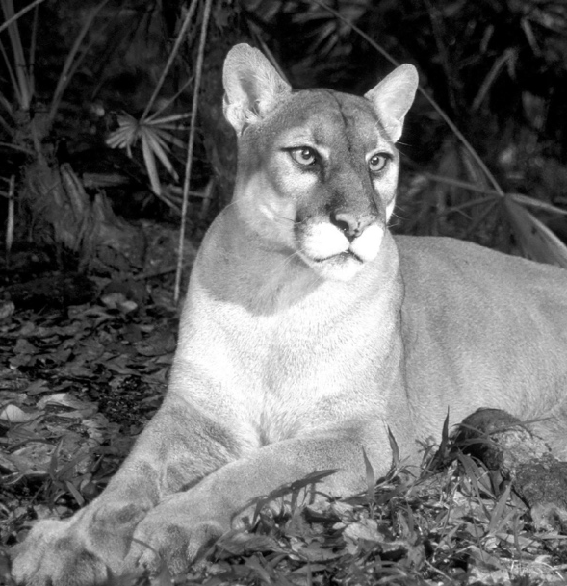
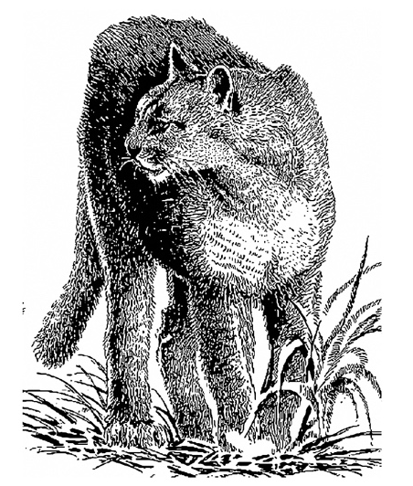 | 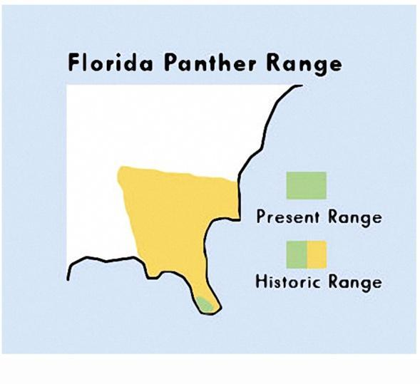 |  | 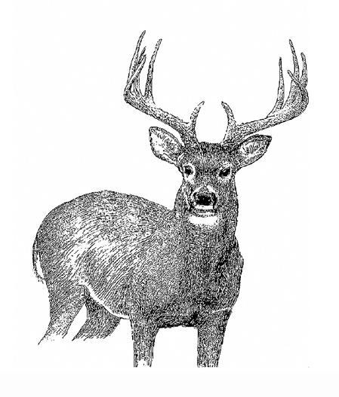
The Florida panther, the state animal of Florida, is part of an animal group sometimes called mountain lions, pumas, panthers, and cougars. | The Florida panther used to be found throughout the Southeast United States including Arkansas, Louisiana, Mississippi, Alabama, Georgia, Florida, and even some of Tennessee and South Carolina. Today, it is only found in the southernmost tip of Florida. |  | Panthers mostly eat white tailed deer, but they also eat raccoons, rabbits, feral hogs, and birds. Keep pets away from them because they will eat them too!

Maple Syrup Urine Disease  What is it?  People are born with this disease if they inherited an improperly functioning gene from both their parents. Affected babies cannot break down certain protein components, which build up in the body leading to sweet smelling urine, like maple syrup. Left untreated, babies become brain damaged.  Treatment  This disorder is treated by exclusively eating foods that do not contain the proteins which cannot be broken down.  Where is it Common?  A greater proportion of Amish suffer from this disorder than the general population because many of today’s Amish are descendants of a small founding group that carried the gene for this disorder. The smallness of the original founding group means that the gene for this disorder is carried by a higher proportion of Amish than in the general population. | 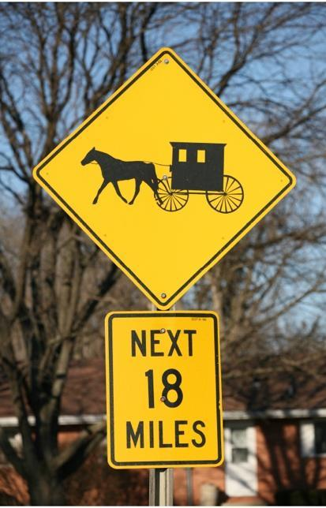

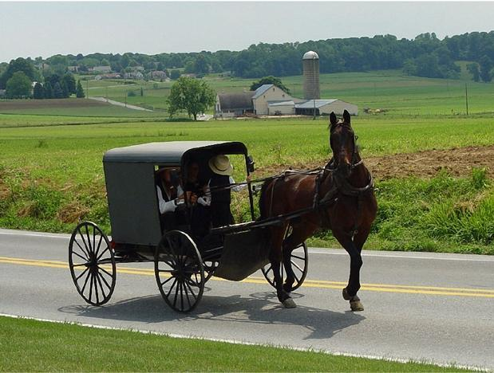  The largest Amish communities are in Ohio, Pennsylvania, and Indiana. | 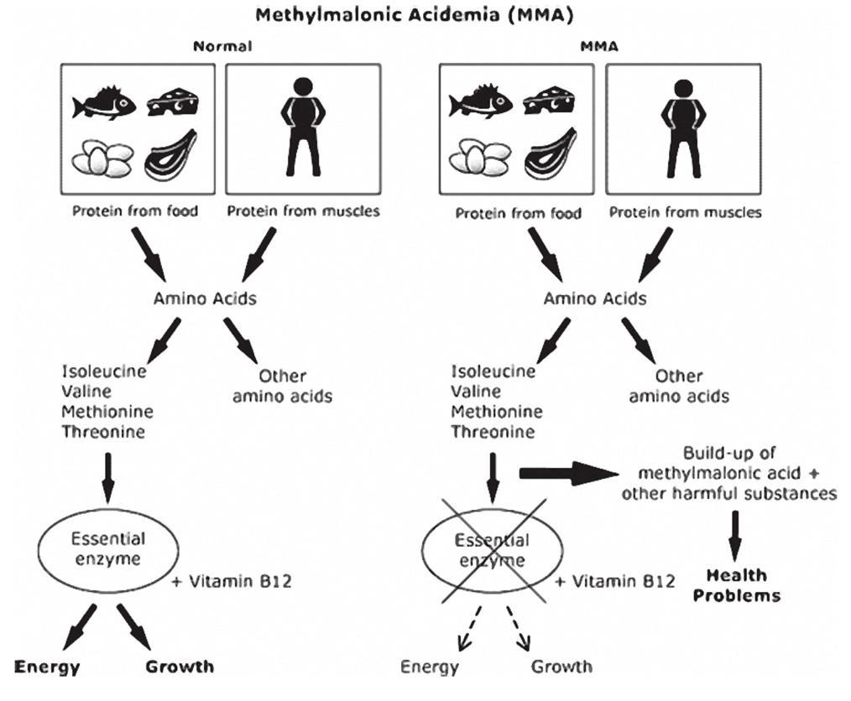

Inbreeding Amongst European Royalty

The House of Habsburg
This European royal family ruled over enormous regions of central and western Europe during the Middle Ages and into the Renaissance period.

Inbreeding
To keep “pure” bloodlines and seal alliances for increased power, the Habsburgs intermarried one another frequently. Marriages between first cousins and uncles and nieces were common.

The Habsburg Jaw
In the mid 1400s, the Habsburg Jaw was first noticed in the royal family. This condition, where the lower jaw grows faster than the upper jaw results in an elongated chin and can worsen with age. The jaw was so common in the Habsburg family that the condition was named after them!

Photo of person with  Habsburg Jaw | Charles II (1161-1700), the last Habsburg King of Spain had the most extreme case of Habsburg Jaw recorded. He was also mentally disabled. Analysis of the previous marriages that led to his birth reveals multiple uncle-niece and first cousin marriages. | This coin of Leopold I (1640-1705), another Habsburg, shows the characteristic Habsburg Lip. Some coin collectors do not believe this coin is accurate.

Full Name: ______________________________. Class: _______________ Date: __________

OPTIONAL PRE-LESSON ACTIVITY FOR DEEPER ENRICHMENT (4 pages)

F_{ST} Values: How to measure breeding levels between populations

Concept Summary:
_{Population A} _{Population B} _{Population C}
To measure breeding between populations scientists do pairwise comparisons of gene frequencies between populations. For populations A, B, & C, they would do pairwise gene frequency comparisons of the following:

Population A to Population B
Population A to Population C
Population B to Population C

Shapes represent different versions of the same
gene (alleles)

F_{ST} Values
The value that they calculate is called the fixation index or F _{ST} value. It is a measure of the difference in the allele frequency between two populations. Fixation index values range from 0 to 1:
- 0 means complete sharing of genetic material
- 1 means no sharing.

For values equal to 1(meaning no sharing), scientists say that the populations are fixed. If populations are referred to as fixed, it means that they do not share any alleles with one another, i.e., they do not breed with one another; they are completely isolated from one another. Practically speaking F_{ST} values are never as high as 1 because these values are only utilized to measure breeding between populations of the same species. Different populations of the same species always show some evidence of interbreeding, even if that breeding stopped a long time ago.

F _{ST} values for mammals generally range from 0 to 0.25, with most values being close to 0.1:
- High values (close to 0.2) indicate some isolation between populations, and most likely mean that the populations are not currently interbreeding.
- Low values (hovering close to 0) indicate that the populations are sharing their genetic material through high levels of breeding.

Isolation for Populations A, B and C

1. Quickly scan the diagram on the previous page. Which population do you think is the most isolated? Why?
__________________________________________________________________________________________________________________
__________________________________________________________________________________________________________________

2. Would the pairwise F_{ST} value for Population C be high or low in relation to the other populations? __________________________________________________________________________________________________________________
__________________________________________________________________________________________________________________

You can see that populations A and B share many more of the same alleles than they do with population C, meaning that the F_{ST} value for populations A and B is low and the F_{ST} value for population C to population A or B is high. The low F_{ST} value for the relationship between population A and B means that they show high levels of breeding and the high F_{ST} value for population C and population A or B means that they show low levels of breeding with one another.

The Bighorn Sheep

Dr. Clinton Epps and his colleagues collected DNA from mountaintop populations of bighorn sheep to determine whether highways act as barrier that prevent bighorn sheep populations from different mountaintops from mating.

3. To conclude that highways are a barrier to breeding between sheep populations, what would love F_{ST} values be for the following conditions?

- Populations that are geographically close without a highway between them:
__________________________________________________________________________________________________________________

- Populations that are geographically close with a highway between them:
__________________________________________________________________________________________________________________

4. Write a hypothesis statement for your predictions above.
__________________________________________________________________________________________________________________
__________________________________________________________________________________________________________________
The F_{ST} values that Dr. Epps calculated ranged from 0.001 to almost 0.30.

5. What do the low values indicate (0.001) about breeding and connectivity between populations?
__________________________________________________________________________________________________________________
__________________________________________________________________________________________________________________

6. What do the high values indicate (≥0.25) about breeding and connectivity between populations?
__________________________________________________________________________________________________________________
__________________________________________________________________________________________________________________

Understanding the Bighorn Sheep F_{ST} Values
Because low F_{ST} values indicate high connectivity between populations (easy connection makes high breeding possible) and high F_{ST} values indicate low connectivity between populations (poor connections makes breeding difficult), we depicted high levels of breeding with many arrows (↕ ↕ ↕ ↕) to signify the connections between breeding populations. We depicted low levels of breeding with few arrows (↕) to signify the few connections between non-breeding populations.

Below is the scale used to determine the number of arrows between populations that are illustrated on the maps in the pages that follow. Observe the relationship between F_{ST} value and arrow number:
0.30 – 0.25 = ↕
0.24 – 0.20 = ↕↕
0.19 – 0.15 = ↕↕↕
0.14 – 0.10 = ↕↕↕↕
0.09 – 0.05 = ↕↕↕↕↕
0.04 – 0.001 = ↕↕↕↕↕↕

7. Apply the scale to the bighorn sheep mountaintop populations. Fill in the appropriate number of arrows ( ↕ ). A sample response is filled in for Old Dad and Cady Sheep.
Breeding Evidence of Cady Sheep
 | Cady Sheep (F_{ST}) | Cady Sheep ( ↕ )
Old Dad Sheep | 0.11 | ↕↕↕↕
Granite Sheep | 0.11
Newberry Sheep | 0.26

Breeding Evidence of Eagle-Buzzard Spring Sheep
 | Eagle-Buzzard Spring Sheep (F_{ST}) | Eagle Buzzard Spring Sheep ( ↕ )
Little San Bernardino Sheep | 0.11
Orocopeia Sheep | 0.11
Eagle Lost Plains Sheep | 0.26

Breeding Evidence of Hackberry Sheep
 | Hackberry Sheep (F_{ST}) | Hackberry Sheep ( ↕ )
Wood Sheep | 0.02
Piute Range Sheep | 0.08
Providence Sheep | 0.06

Breeding Evidence of Indian Spring Sheep
 | Indian Spring Sheep (F_{ST}) | Indian Spring Sheep ( ↕ )
Clark Sheep | 0.20
Old Dad Sheep | 0.10
Providence Sheep | 0.11

Breeding Evidence of Marble Sheep
 | Marble Sheep (F_{ST}) | Marble Sheep ( ↕ )
Granite Sheep | 0.10
South Bristol Sheep | 0.04
Clipper Sheep | 0.05

Breeding Evidence of San Gorgonio Sheep
 | San Gorgonio Sheep (F_{ST}) | San Gorgonio Sheep ( ↕ )
Cushenbury Sheep | 0.07
San Gabriel Sheep | 0.27
Little San Bernardino Sheep | 0.15

After completing these charts, move on to the map activity below. If you choose to skip this activity, begin below.

Full Name: ______________________________. Class: _______________ Date: __________

Lesson 3: How Do You Investigate and Represent Data?

On the following pages you measure and record the geographic distance between populations and draw the number of arrows that show breeding connectivity between populations. Answer questions 1 and 2 below to explain how knowing the geographic distance and DNA connectivity among populations is helpful for understanding bighorn sheep breeding.

1. What is the purpose of measuring the geographic distance between the bighorn sheep populations?

________________________________________________________________________________
________________________________________________________________________________
________________________________________________________________________________
________________________________________________________________________________

2. If two bighorn sheep populations breed frequently, would you expect them to share many or few DNA arrows? Many arrows would indicate high genetic connectivity and few arrows would indicate low genetic connectivity. Explain your answer.

________________________________________________________________________________
________________________________________________________________________________
________________________________________________________________________________
________________________________________________________________________________

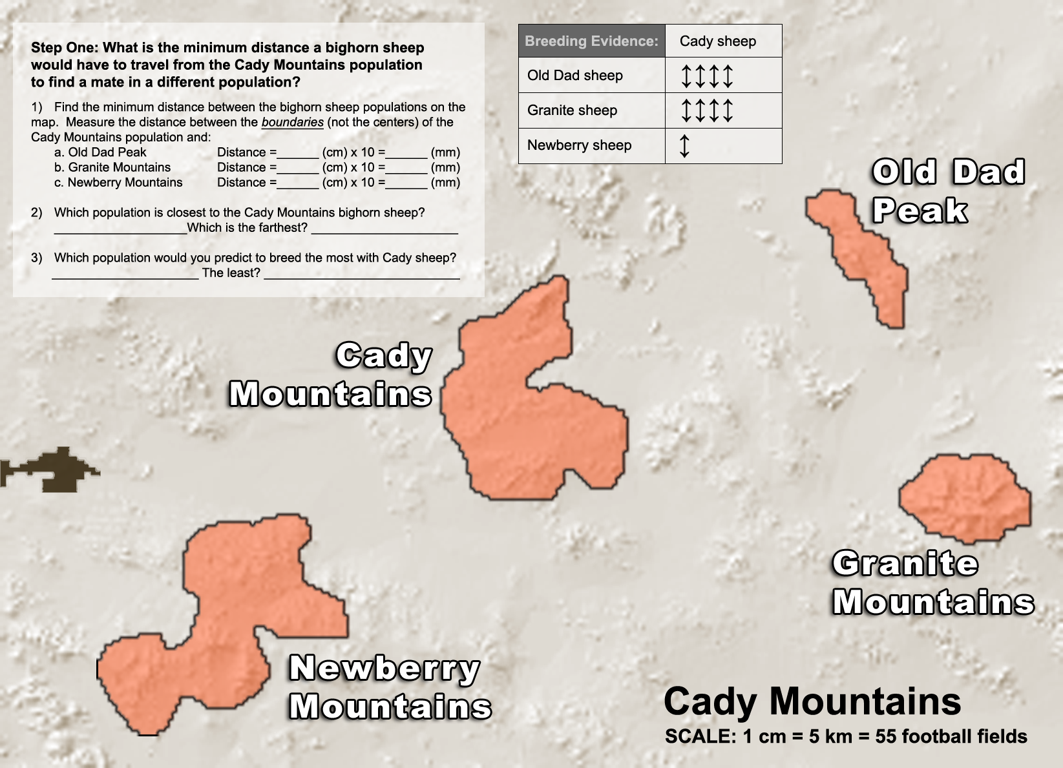

How much mating is taking place between sheep populations on neighboring mountains?

By looking at the genes of different populations, scientists can tell how much breeding takes place between neighboring populations.

The genetic data displayed as arrows on the map indicate breeding levels between different mountaintop sheep populations:
- Many arrows (↕↕↕↕↕↕↕↕) means more breeding between two populations
- Few arrows (↕) means less breeding between populations.

Step 2: Connecting sheep populations with double headed arrows

Draw double-headed arrows on the map to connect the sheep populations from different mountains
to one another. For instance, connect Old Dad and Cady Mountain sheep with four double-headed arrows (arrow data on map).

Step 3: Compare your predictions from step 1 with the data from step 2:

Q1. Based upon distance, what sheep population would you have expected Cady Mountain sheep to breed with most frequently?
__________________________________________________________________________________________________________________
Q2. What do the genetic data show? Which population do they breed with most frequently?
__________________________________________________________________________________________________________________
Q3. Predict where the highway is located and draw it onto the map.
__________________________________________________________________________________________________________________

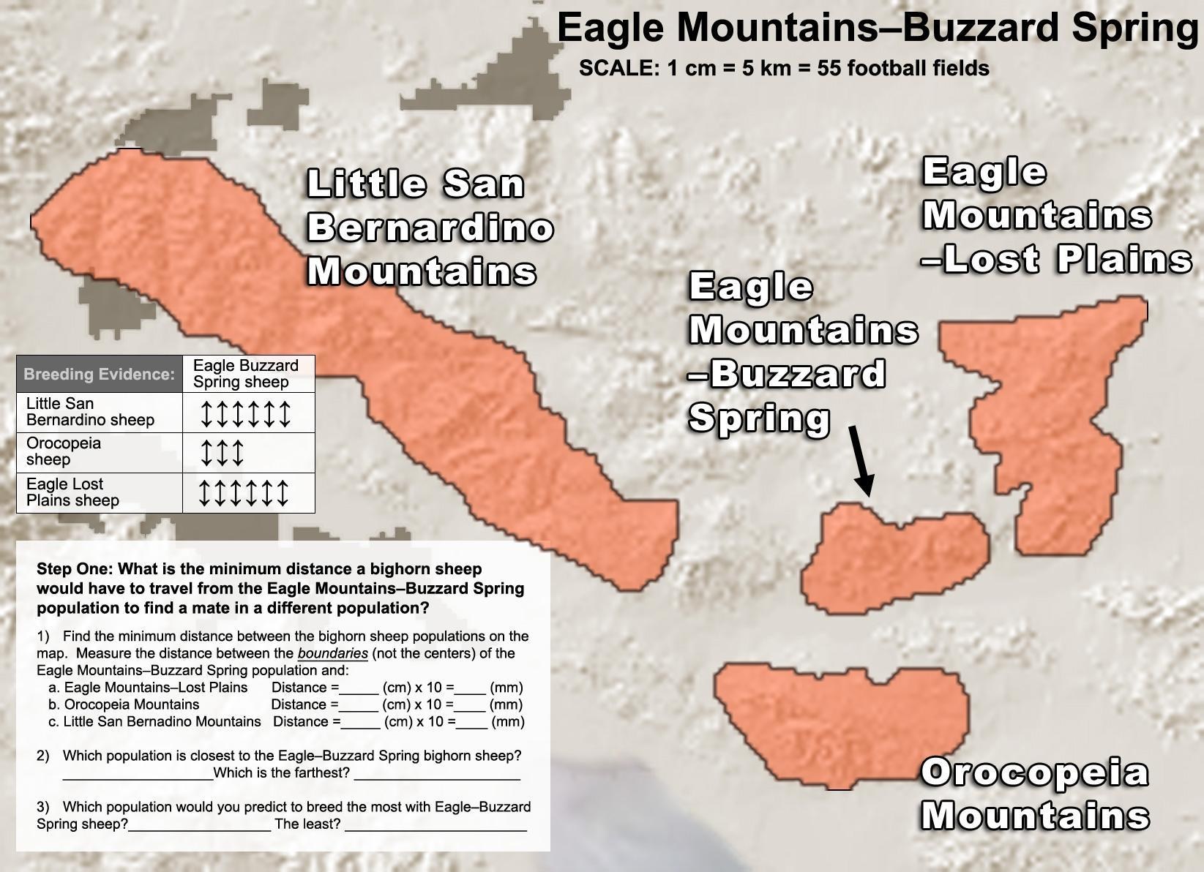

How much mating is taking place between sheep populations on neighboring mountains?

By looking at the genes of different populations, scientists can tell how much breeding takes place between neighboring populations.

The genetic data displayed as arrows on the map indicate breeding levels between different mountaintop sheep populations:
- Many arrows (↕↕↕↕↕↕↕↕) means that more breeding occurs between two populations
- Few arrows (↕) means that less breeding occurs between populations.

Step 2: Connecting sheep populations with double headed arrows

Draw double-headed arrows on the map to connect the sheep populations from different mountains
to one another. For instance, connect Eagle-Buzzard Spring Mountain and Little San Bernardino Mountain sheep with six double-headed arrows (arrow data on map).

Step 3: Compare your predictions from step 1 with the data from step 2:

Q1. Based upon distance, what sheep population would you expect Eagle-Buzzard Spring sheep to breed with least often?
__________________________________________________________________________________________________________________
Q2. What do the genetic data show? With what sheep population do they show the least signs of breeding?
__________________________________________________________________________________________________________________
Q3. Predict where the highway is located and draw it onto the map. __________________________________________________________________________________________________________________

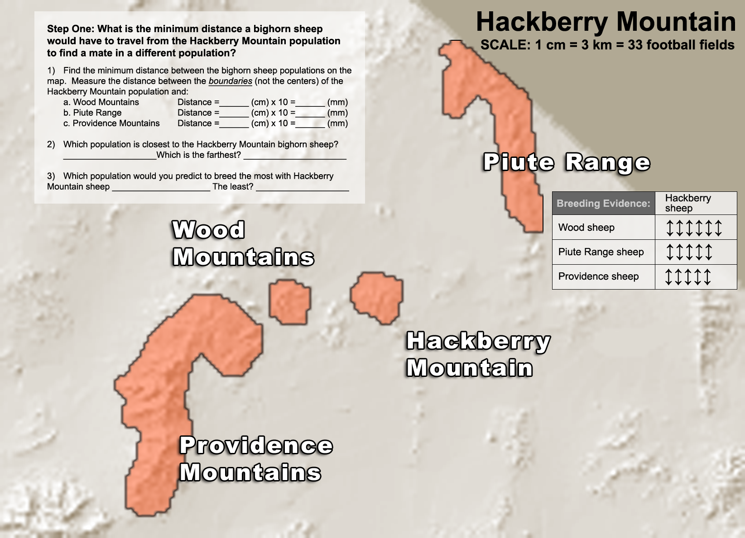

How much mating is taking place between sheep populations on neighboring mountains?

By looking at the genes of different populations, scientists can tell how much breeding takes place between neighboring populations.

The genetic data displayed as arrows on the map indicate breeding levels between different mountaintop sheep populations:
- Many arrows (↕↕↕↕↕↕↕↕) means that more breeding occurs between two populations
- Few arrows (↕) means that less breeding occurs between populations.

Step 2: Connecting sheep populations with double headed arrows

Draw double-headed arrows on the map to connect the sheep populations from different mountains
to one another. For instance, connect Hackberry Mountain to Piute Mountain Range sheep with five double-headed arrows (arrow data on map).

Step 3: Compare your predictions from step 1 with the data from step 2:

Q1. Based upon distance, what sheep population would you have expected Hackberry sheep to breed with
most frequently?
__________________________________________________________________________________________________________________
Q2. What do the genetic data show? Which population do they breed with most frequently?
__________________________________________________________________________________________________________________

Q3. Predict where the highway is located and draw it onto the map.
__________________________________________________________________________________________________________________

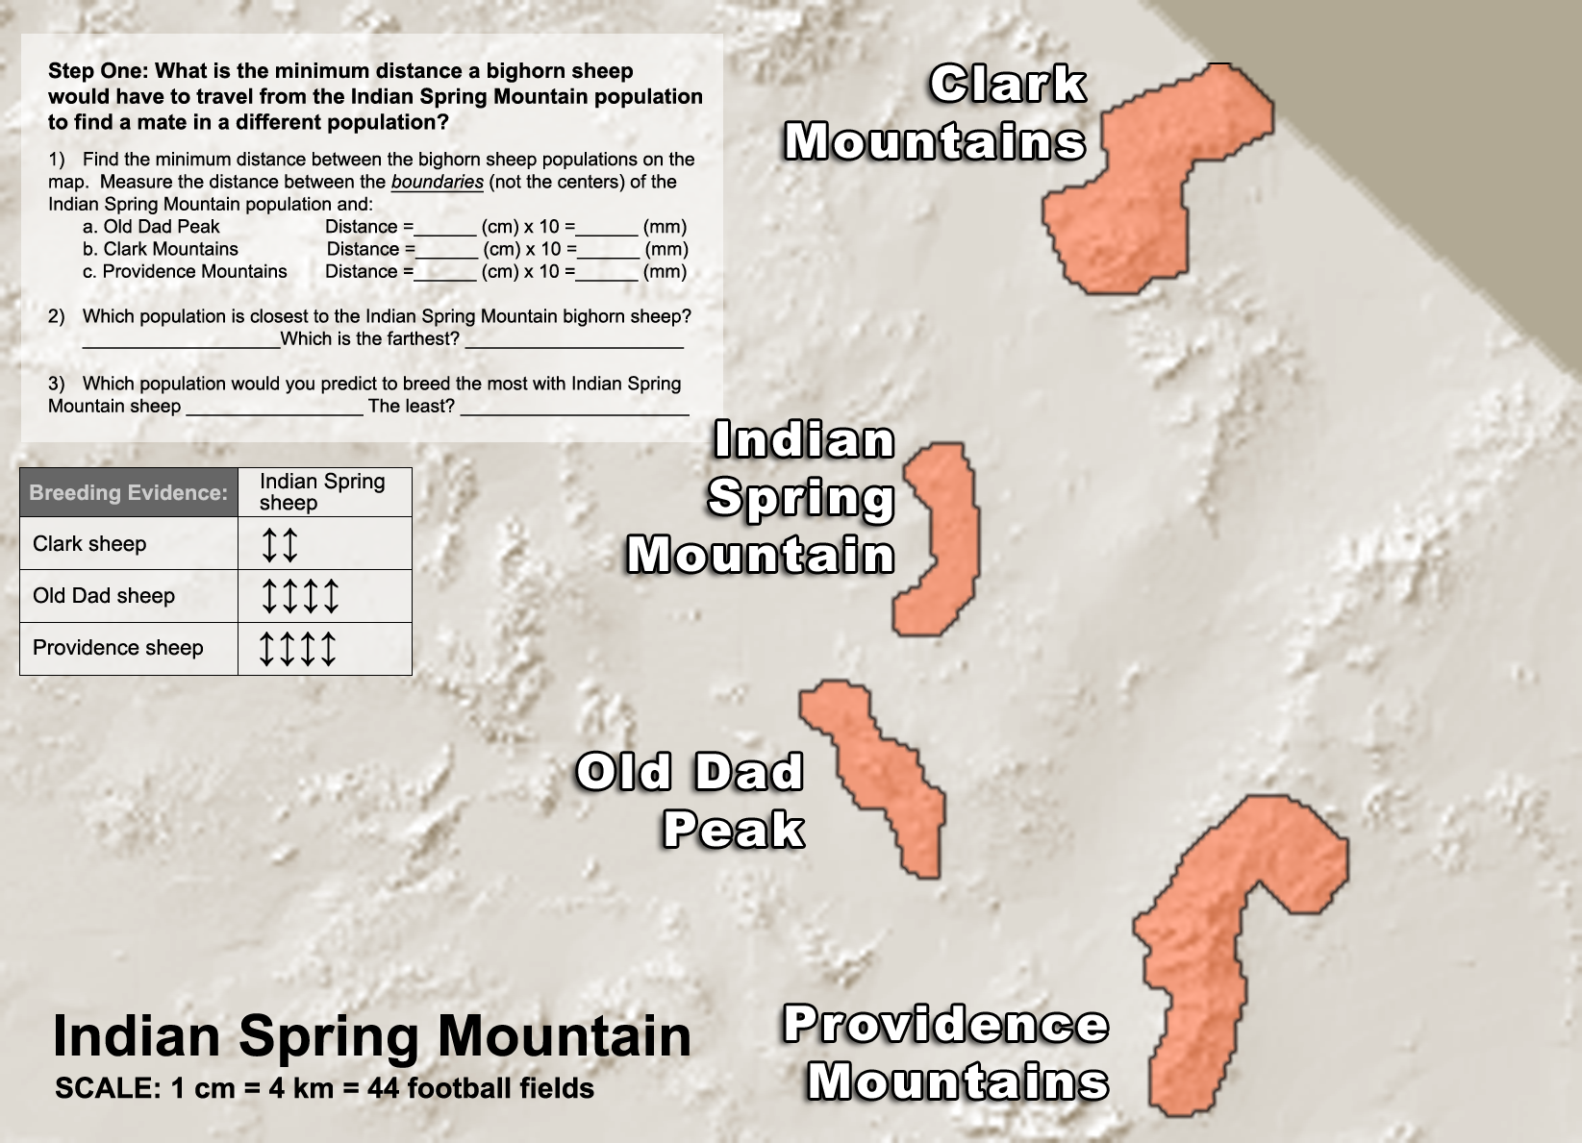

How much mating is taking place between sheep populations on neighboring mountains?

By looking at the genes of different populations, scientists can tell how much breeding takes place between neighboring populations.

The genetic data displayed as arrows on the map indicate breeding levels between different mountaintop sheep populations:
- Many arrows (↕↕↕↕↕↕↕↕) means that more breeding occurs between two populations
- Few arrows (↕) means that less breeding occurs between populations.

Step 2: Connecting sheep populations with double headed arrows

Draw double-headed arrows on the map to connect the sheep populations from different mountains
to one another. For instance, connect Clark Mountain and Indian Spring Mountain sheep with two double-headed arrows (arrow data on map).

Step 3: Compare your predictions from step 1 with the data from step 2:

Q1. The data show that Indian Spring Mountain sheep breed less frequently with Clark Mountain sheep than with Providence sheep. Why do you think this is so?
______________________________________________________________________________________________________________________

Q2. Predict where the highway is located and draw it onto the map.
______________________________________________________________________________________________________________________

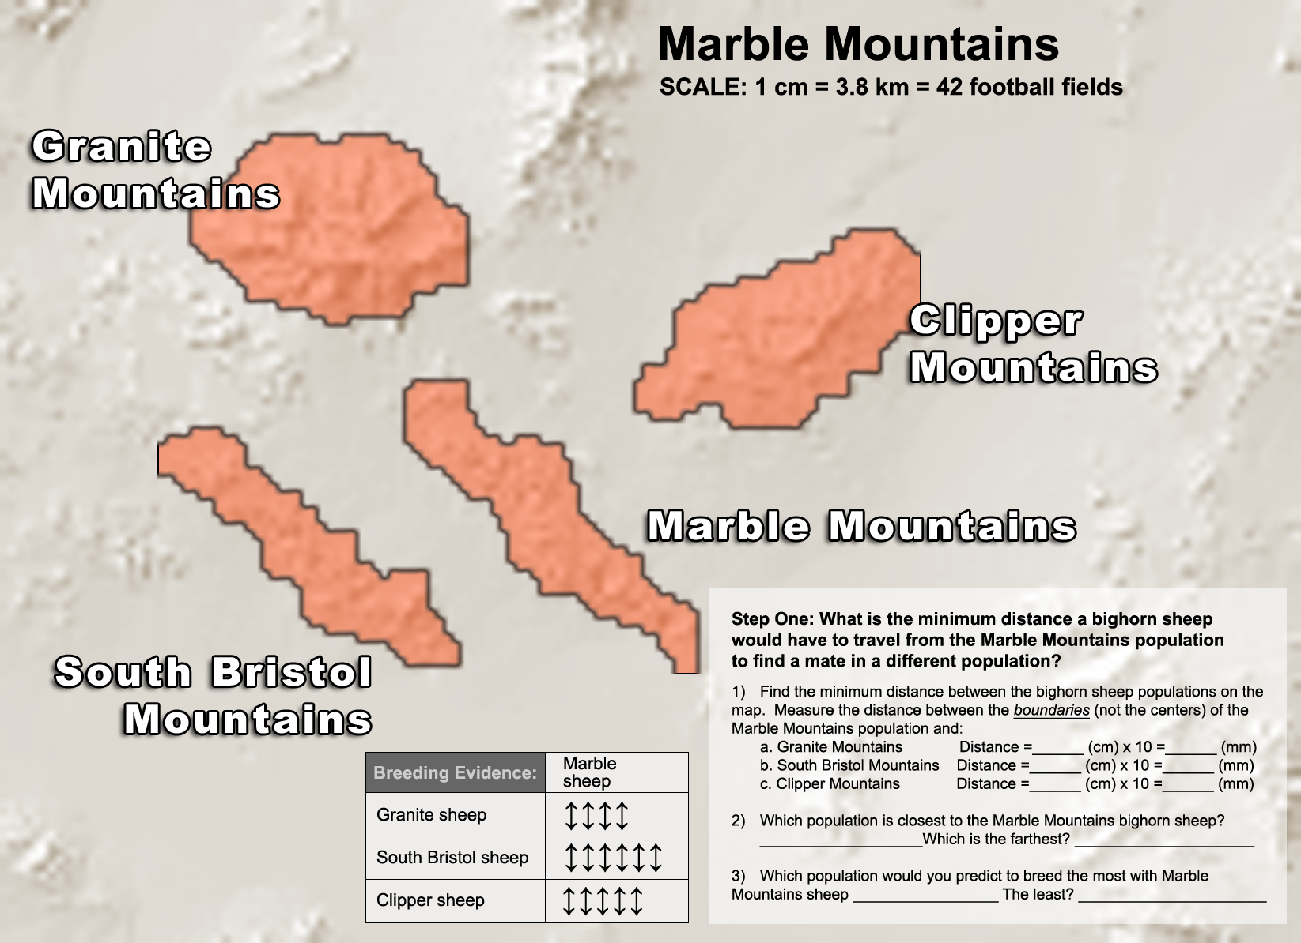

How much mating is taking place between sheep populations on neighboring mountains?

By looking at the genes of different populations, scientists can tell how much breeding takes place between neighboring populations.

The genetic data displayed as arrows on the map indicate breeding levels between different mountaintop sheep populations:
- Many arrows (↕↕↕↕↕↕↕↕) means that more breeding occurs between two populations
- Few arrows (↕) means that less breeding occurs between populations.

Step 2: Connecting sheep populations with double headed arrows

Draw double-headed arrows on the map to connect the sheep populations from different mountains
to one another. For instance, connect Marble Mountain sheep and Granite Mountain sheep with four
double-headed arrows (arrow data on map).

Step 3: Compare your predictions from step 1 with the data from step 2:

Q1. Based upon distance, what sheep population would you have expected Marble sheep to breed with
most frequently?
______________________________________________________________________________________________________________________

Q2. What do the genetic data show? With which population do they breed with most frequently?
______________________________________________________________________________________________________________________

Q3. Predict where the highway is located and draw it onto the map.
______________________________________________________________________________________________________________________

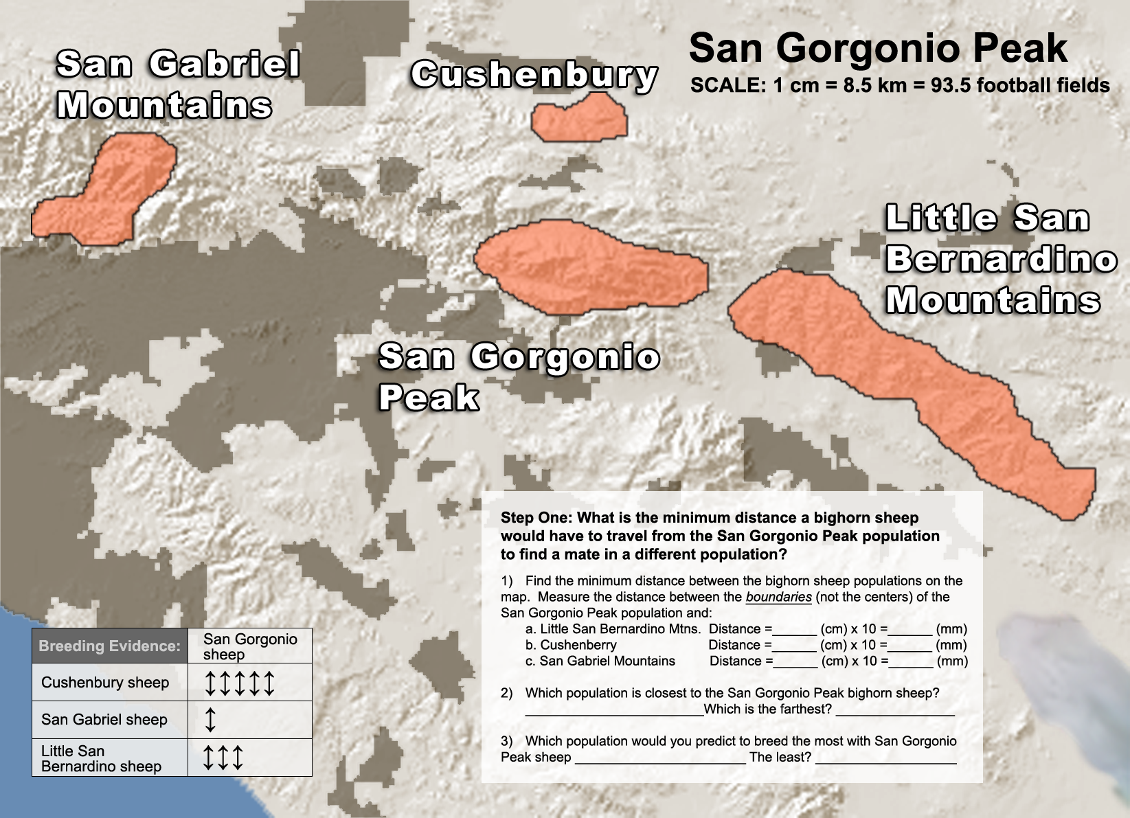
How much mating is taking place between sheep populations on neighboring mountains?

By looking at the genes of different populations, scientists can tell how much breeding takes place between neighboring populations.

The genetic data displayed as arrows on the map indicate breeding levels between different mountaintop sheep populations:
- Many arrows (↕↕↕↕↕↕↕↕) means that more breeding occurs between two populations
- Few arrows (↕) means that less breeding occurs between populations.

Step 2: Connecting sheep populations with double headed arrows

Draw double-headed arrows on the map to connect the sheep populations from different mountains
to one another. For instance, connect Cushenbury Mountain sheep and San Gorgonio Mountain sheep with use five double-headed arrows (arrow data on map).

Step 3: Compare your predictions from step 1 with the data from step 2:

Q1. The sheep from San Gorgonio Mountain live very close to the sheep from Little San Bernardino Mountain. Why do the data show that they breed with those sheep less frequently than they do with Cushenbury sheep?
__________________________________________________________________________________________________________________

Q2. Predict where the highway is located and draw it onto the map.
__________________________________________________________________________________________________________________

Lesson 3: Investigating, Representing, and Making Meaning from Data

1. After reviewing the data, what claim can you make about how roads affect bighorn sheep populations? Explain your evidence.

__________________________________________________________________________________________________________________
__________________________________________________________________________________________________________________
__________________________________________________________________________________________________________________
__________________________________________________________________________________________________________________

Complete the tables below:

Questions | Highways Block Bighorn Sheep | Roads Influence Animal Genes (European badger) | New Blood Gives New Life to Florida Panthers
1. How have people changed the habitat in this example?

2. Why do people change the habitat?  How does it help us? |  |  | )
3. How do the habitat changes impact populations in this area? | . |  | .
4. How do you know that the habitat is being changed and that local populations are affected?

Describe the evidence or data.
5. Suggest how to solve this problem.

Questions | Loggers Imperial Monarch Butterflies | Plastic Trash Threatens Remote Seabirds | Species and Sprawl: A Road Runs Through It
1. How have people changed the habitat in this example? | .
2. Why do people change the habitat?  How does it help us? | .
3. How do the habitat changes impact populations in this area?
4. How do you know that the habitat is being changed and that local populations are affected?  Describe the evidence or data. |  |  | .
5. Suggest how to solve this problem.

Final Thoughts

1. In this unit, you discussed examples of how we change habitats to make our own daily life better. Think of the examples we discussed (bighorn sheep, Florida panther, European badgers, monarch butterflies, seabirds, and wood turtles) and list three ways that changing habitats improves our living conditions.

Habitats We Change | Improves Our Living Conditions
Example: Add roads to desert landscape | Facilitates travel

2. State planners plan to build a new highway through a local mountain forest. You are worried that the highway might isolate skunk populations from different sides of the new highway. What data would you collect to determine whether the new highway, once built, is isolating skunk populations from each other?

________________________________________________________________________________
________________________________________________________________________________
________________________________________________________________________________

ANSWERS

Investigation Booklet: Bighorn Sheep

Lesson 1: Setting the Stage & the Scientific Process in Action

1. What is the research question for this unit?
How might being able to drive from Los Angeles to Las Vegas in just four hours put bighorn sheep
at risk?

2. What geographic area defines each bighorn sheep population?
By the mountaintop on which they live.

3. How have people changed bighorn sheep habitat and what is the economic motivation for making these changes?
People have built large highways that cut off different mountaintop populations from each other. These highways make travel for people much easier and quicker and have increased Las Vegas tourism revenue.

4. How do highways affect mating between different sheep populations?
They will not breed with sheep populations that are separated from them by a highway.

5. Clinton Epps made this statement in the video:
I have to be able to see the landscape to visualize the important questions. I have to experience the landscape to really be able to think well about what I want to study, how I want to study— I can’t do that studying at a desk.

Why do you think he feels this way?
He can’t really understand what is happening in wild populations without experiencing it for himself. Without the familiarity, he feels like he can miss something crucial.

6. From the allele frequency diagram below determine which two populations, A, B, or C breed most frequently with one another and explain your answer.
A and B breed most frequently b/c they have a similar frequency of alleles. Pop C is more isolated b/c although it has the same alleles. The allele frequencies are very different. For instance, it has many squares, whereas Pop A and Pop B, each have only one square. It also has fewer triangles and circles.

7. Use Xs and Os to draw two populations that show high levels of breeding.
Answers will vary but should show populations that have similar numbers of the same type of popsicle sticks (i.e., both groups will have about the same numbers of Xs and Os).

ANSWERS

Pop A Pop B
X X X O O O X | X X O X O O X
O O O O X X X | O O X X X O O
O O X X O O X | X X X O O O O

8. Instead of using shapes, use Xs and Os to draw two populations that show low levels of breeding.
Answers will vary but should show a population with little similarity in numbers of types of Popsicle sticks (i.e., one group will have mostly X type Popsicle sticks and one group will have mostly O type Popsicle sticks).

Pop A Pop B
X X X X X X X | O O O O O O O
X X X O X X X  X X X X X X O | O O O O O O O  X O O O O O O

ANSWERS

Lesson 2: Exploring the role of isolated populations in inbreeding.

 | Domestic Dogs | Florida Panthers | Thoroughbred Horses
Why has inbreeding occurred? | Dogs have been selectively bred for desired traits like herding, fetching & tracking skills. | Overhunting and habitat loss has led to a population of 70 panthers in South Florida. | Horses have been inbred for speed.
Describe the related health problems. | Hip, elbow, heart, and eye problems. | Heart defects and abnormal sperm. | Broken bones and reproductive problems.

 | Hapsburg Family | Amish People
Why has inbreeding occurred? | To keep pure bloodlines and concentrate power first cousins, uncles, and nieces were commonly married. | This group was founded by a very small group of people, which led to the marriage of closely related people.
Describe the related health problems. | The Hapsburg Jaw – where the lower jaw grows longer than the upper jaw. | Maple Syrup Disease, which can cause seizures, comas, and death.

1. Why is it important for individuals from different small populations to be able to breed with one another?
If individuals from small populations are not able to breed with individuals from outside the population, eventually the population may become inbred, which increases the likelihood that undesirable traits will occur.

ANSWERS
Optional F_{ST} Value Activity

1. Quickly scan the diagram on the previous page. Which population do you think is the most isolated? Why?
Population C. Although, it shares the same alleles as Populations A and B, it has a much different frequency for those alleles than do Populations A and B.

2. Would the pairwise F_{ST} value for Population C be high or low in relation to the other populations?
The F_{ST} value should be high.

3. To conclude that highways are a barrier to breeding between sheep populations, what would F_{ST} values be for the following conditions?
- Populations that are geographically close without a highway between them: Low F_{ST} values.

- Populations that are geographically close with a highway between them: They would have higher F_{ST} values than the populations without the highway.

4. Write a hypothesis statement for your predictions above.
F_{ST} values for geographically close populations that are separated by a highway will be higher than F_{ST} values for geographically close populations that are not separated by a highway if highways act as barriers to breeding between mountaintop populations.

5. What do the low values indicate (0.001) about breeding and connectivity between populations?
High levels of breeding and high connectivity. Individuals need to be able to migrate between populations for mating to occur.

6. What do the high values indicate (≥0.25) about breeding and connectivity between populations?
Low levels of breeding and low connectivity. Individuals that cannot migrate between populations will not mate.

7. Apply the scale to the bighorn sheep mountain top populations. Fill in the appropriate number of arrows ( ↕ ). A sample response is filled in for Old Dad and Cady Sheep.
Breeding Evidence of Cady Sheep
 | Cady Sheep (F_{ST}) | Cady Sheep ( ↕ )
Old Dad Sheep | 0.11 | ↕↕↕↕
Granite Sheep | 0.11 | ↕↕↕↕
Newberry Sheep | 0.26 | ↕

Breeding Evidence of Eagle-Buzzard Spring Sheep
 | Eagle Buzzard Spring Sheep (F_{ST}) | Eagle Buzzard Spring Sheep ( ↕ )
Little San Bernardino Sheep | 0.11 | ↕↕↕↕↕↕
Orocopeia Sheep | 0.11 | ↕↕↕
Eagle Lost Plains Sheep | 0.26 | ↕↕↕↕↕↕

ANSWERS

Breeding Evidence of Hackberry Sheep
 | Hackberry Sheep (F_{ST}) | Hackberry Sheep ( ↕ )
Wood Sheep | 0.02 | ↕↕↕↕↕↕
Piute Range Sheep | 0.08 | ↕↕↕↕↕
Providence Sheep | 0.06 | ↕↕↕↕↕

Breeding Evidence of Indian Spring Sheep
 | Indian Spring Sheep (F_{ST}) | Indian Spring Sheep ( ↕ )
Clark Sheep | 0.20 | ↕↕
Old Dad Sheep | 0.10 | ↕↕↕↕
Providence Sheep | 0.11 | ↕↕↕↕

Breeding Evidence of Marble Sheep
 | Marble Sheep (F_{ST}) | Marble Sheep ( ↕ )
Granite Sheep | 0.10 | ↕↕↕↕
South Bristol Sheep | 0.04 | ↕↕↕↕↕↕
Clipper Sheep | 0.05 | ↕↕↕↕↕

Breeding Evidence of San Gorgonio Sheep
 | San Gorgonio Sheep (F_{ST}) | San Gorgonio Sheep ( ↕ )
Cushenbury Sheep | 0.07 | ↕↕↕↕↕
San Gabriel Sheep | 0.27 | ↕
Little San Bernardino Sheep | 0.15 | ↕↕↕

Lesson 3: How Do You Investigate and Represent Data?

On the following pages you measure and record the geographic distance between populations and draw the number of arrows that show breeding connectivity between populations. Answer questions below to explain how knowing geographic distance and DNA connectivity among populations helps understanding bighorn sheep breeding.

1. What is the purpose of measuring the geographic distance between the bighorn sheep populations?
Sheep from nearby mountaintops should show evidence of high gene flow (high levels of breeding). Measuring the geographic distance quantifies how much sheep from nearby mountains need to travel to mate with sheep from other populations.

2. If two bighorn sheep populations breed frequently, would you expect them to share many or few DNA arrows? Many arrows would indicate high genetic connectivity and few arrows would indicate low genetic connectivity. Explain your answer.
Sheep populations that breed frequently are expected to share many DNA arrows, which would indicate high genetic connectivity due to their frequent breeding.

ANSWERS
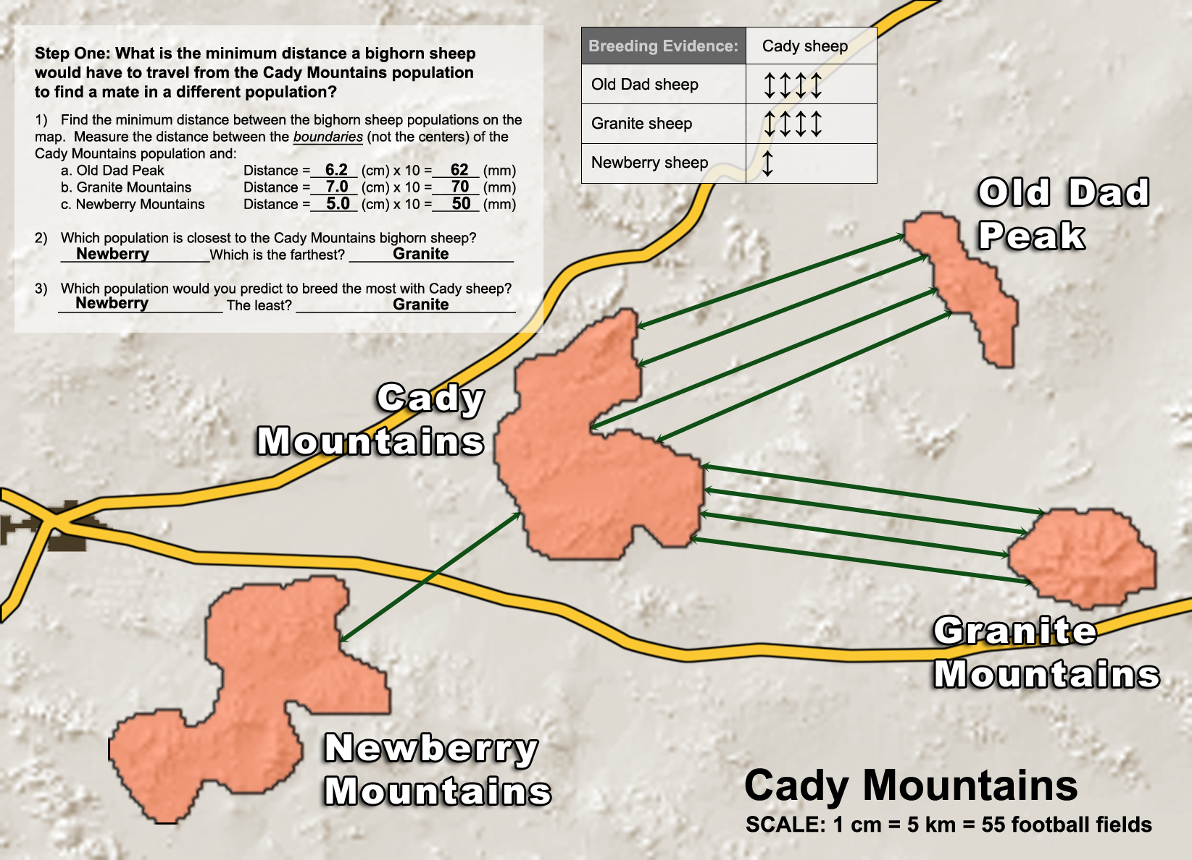
Step 1 and Step 2: On map

Step 3: Compare your predictions from step 1 with the data from step 2:

Q1. Based upon distance, what sheep population would you have expected Cady Mountain sheep to breed with most frequently? Newberry

Q2. What do the genetic data show? Which population do they breed with most frequently?
Old Dad and Granite Mountains Sheep

Q3. Predict where the highway is located and draw it onto the map. The highway should be between Cady Mountains and Newberry Mountains. Drawn on map.

ANSWERS
Step 1 and Step 2: On map
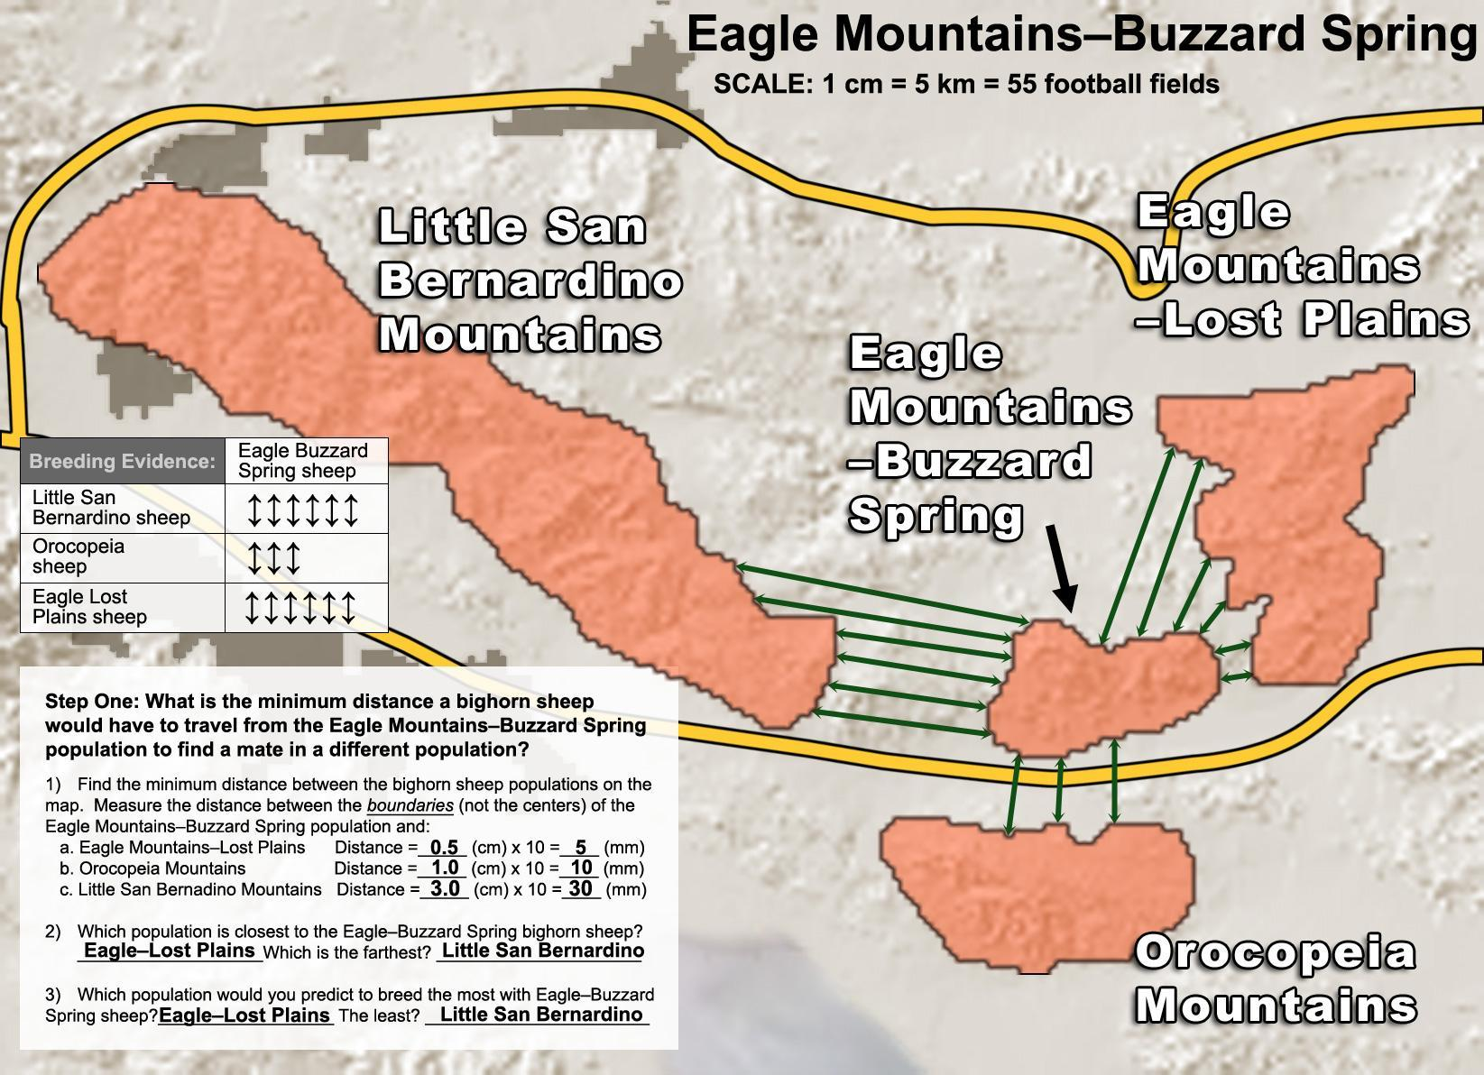

Step 3: Compare your predictions from step 1 with the data from step 2:

Q1. Based upon distance, what sheep population would you expect Eagle-Buzzard Spring sheep to breed with least often? Little San Bernardino Mountains
Q2. What do the genetic data show? With what sheep population do they show the least signs of breeding? Orocopeia Mountains
Q3. Predict where the highway is located and draw it onto the map. The highway should be between Eagle Mountains-Buzzard Spring and Orocopeia Mountains. Drawn on map.

ANSWERS

Step 1 and Step 2: On map
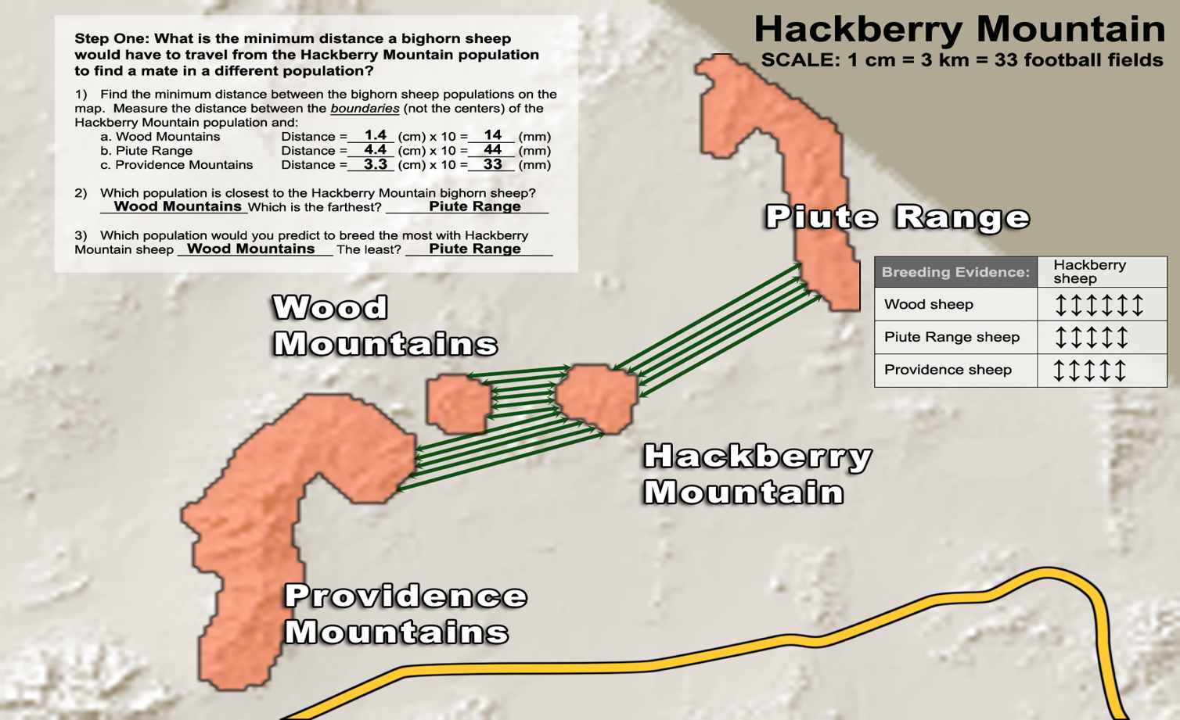

Step 3: Compare your predictions from step 1 with the data from step 2:

Q1. Based upon distance, what sheep population would you have expected Hackberry sheep to breed with most frequently? Wood Mountains
Q2. What do the genetic data show? Which population do they breed with most frequently?
Wood Mountains

Q3. Predict where the highway is located and draw it onto the map. The highway would not separate Hackberry Mountains from any of the other mountains shown.

ANSWERS

Step 1 and Step 2: On map

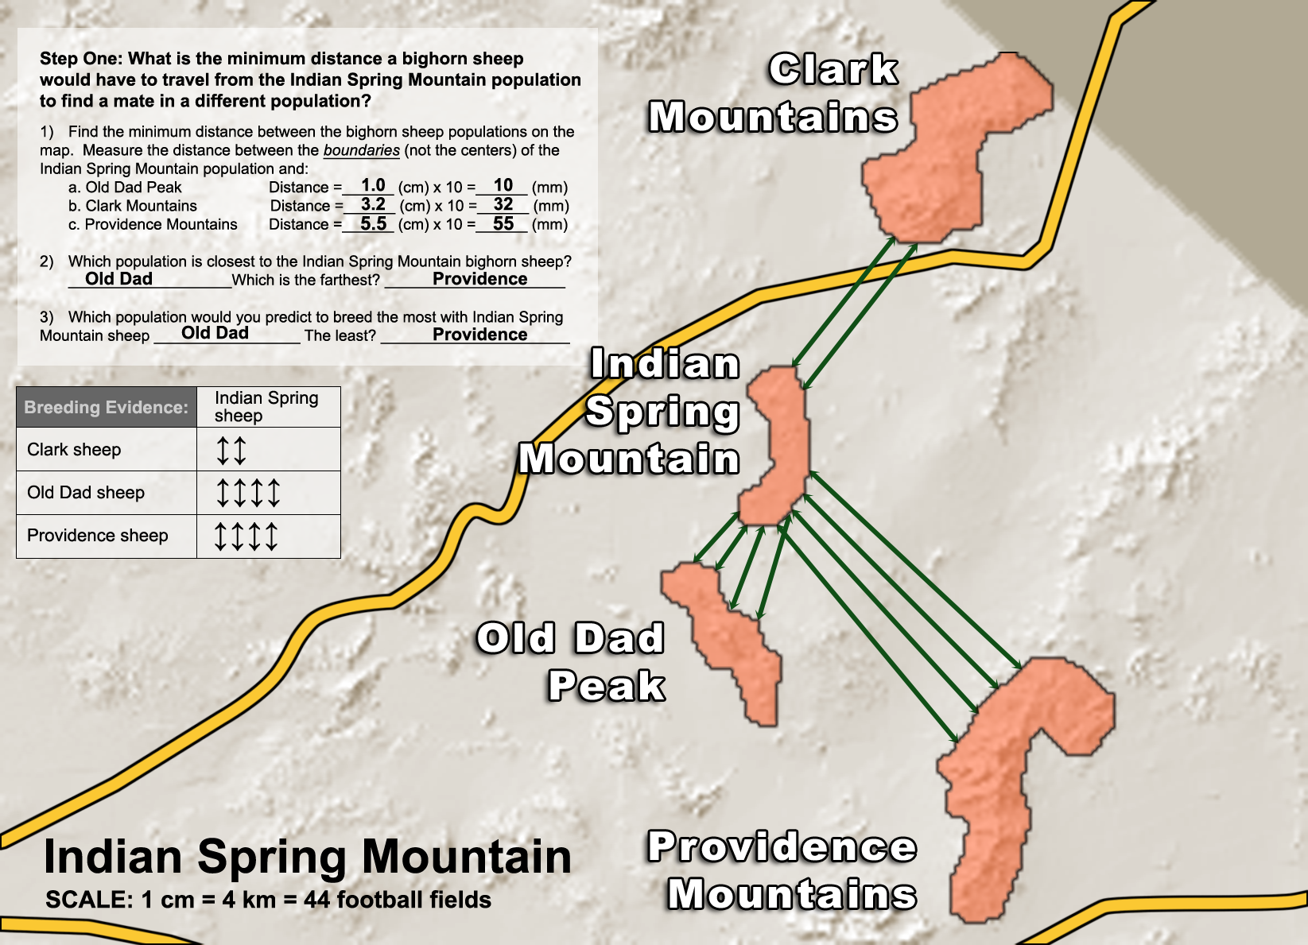

Step 3: Compare your predictions from step 1 with the data from step 2:

Q1. The data show that Indian Spring Mountain sheep breed less frequently with Clark Mountain sheep than with Providence sheep. Why do you think this is so? Because Clark and Indian Spring Mountains are separated by a highway, whereas Providence Mountains is not separated by a highway from Indian Spring Mountain.

Q2. Predict where the highway is located and draw it onto the map. The highway should be between Clark and Indian Spring Mountains. Drawn on map.

ANSWERS

Step 1 and Step 2: On map

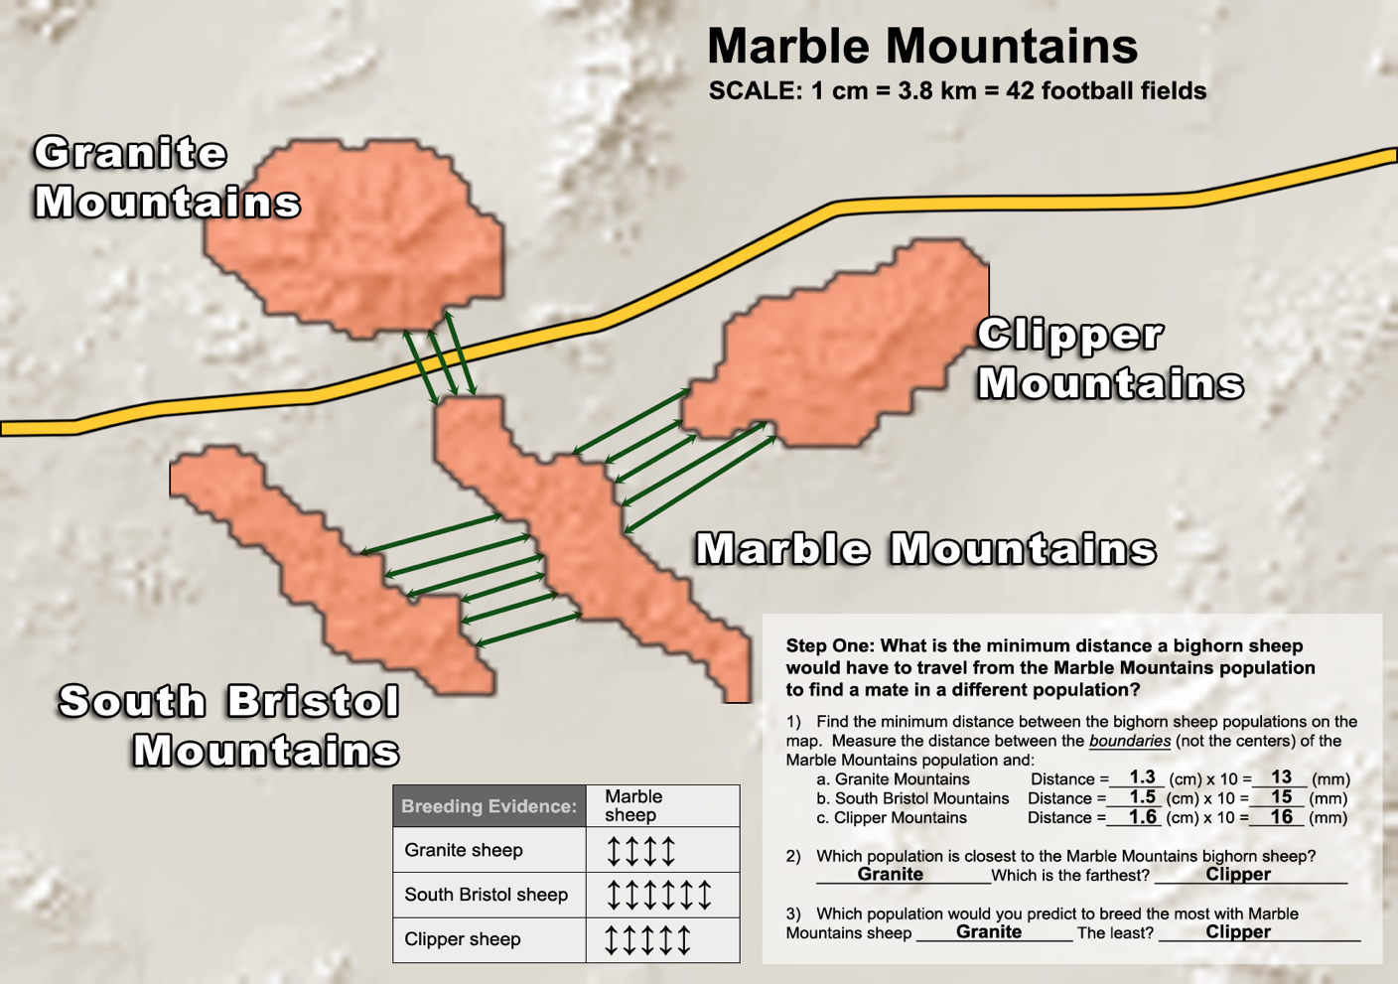

Step 3: Compare your predictions from step 1 with the data from step 2:

Q1. Based upon distance, what sheep population would you have expected Marble sheep to breed with most frequently? Granite Mountains

Q2. What do the genetic data show? With which population do they breed with most frequently? South Bristol Mountains

Q3. Predict where the highway is located and draw it onto the map. The highway should be between Marble and Granite Mountains. Drawn on map.

ANSWERS
Step 1 and Step 2: On map

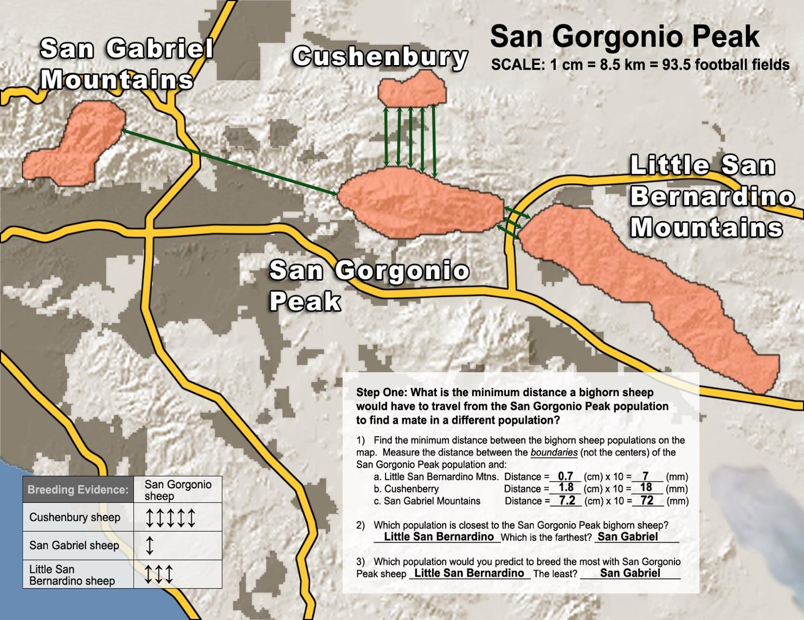

Step 3: Compare your predictions from step 1 with the data from step 2:

Q1. The sheep from San Gorgonio Mountain live very close to the sheep from Little San Bernardino Mountain. Why do the data show that they breed with those sheep less frequently than they do with Cushenbury sheep? There must be a highway separating San Gorgonio Mountain from Little San Bernardino Mountain, but no highway separating San Gorgonio Mountain from Cushenbury Mountain.
Q2. Predict where the highway is located and draw it onto the map. The highway should be between San Gorgonio Mountain and Little San Bernardino Mountain. Drawn on map.

--------------- Final Summary Question ------------------------
1. After reviewing the data, what claim can you make about how roads affect bighorn sheep populations? Explain your evidence.
Roads cut off bighorn sheep populations from each other leading to inbreeding.
Evidence: Bighorn sheep populations that are separated from each other by a highway show less genetic similarity than sheep of equal or greater geographic distance.
ANSWERS
Complete the tables below:

Questions | Highways Block Bighorn Sheep | Roads Influence Animal Genes (European badger) | New Blood Gives New Life to Florida Panthers
1. How have people changed the habitat in this example? | Building highways and fences | They build roads. | They destroyed the habitat. Unclear not stated.
2. Why do people change the habitat?  How does it help us? | To make travel quicker between LA and Las Vegas, which helps the Las Vegas economy. | The roads are important for travel. | To live our lives, build homes, agriculture (from packet)
3. How do the habitat changes impact populations in this area? | It isolates bighorn sheep mountaintop populations leading to inbreeding, which causes health issues. | They reduced European badger numbers. | It causes Florida panther inbreeding, which leads to low fertility, physical deformities, heart abnormalities, many parasites.
4. How do you know that the habitat is being changed and that local populations are affected?  Describe the evidence or data. | Scientists studied DNA evidence from different populations of bighorn sheep. They found that populations separated by roads showed less interbreeding than those without highways between them. | Badger roadkill. Up to 35% of badgers were road victims in the 1970s. | Not discussed, but inbreeding issues found in the Florida panther.
5. Suggest how to solve this problem. | Build tunnels under the fences and highways for the animals to travel. Elevate the highway. Construct animal highway overpasses. Introduce new bighorn sheep into existing populations to increase genetic diversity. | The installation of 600 tunnels allows gene flow and keeps badger genetic diversity stable. | Bring panthers from Texas, which has tripled the Florida panther population 15 years later.

ANSWERS

Questions | Loggers Imperial Monarch Butterflies | Plastic Trash Threatens Remote Seabirds | Species and Sprawl:  A Road Runs  Through It
1. How have people changed the habitat in this example? | Loggers are illegally cutting down trees that are the winter habitat of monarch butterflies. | Plastic is not biodegradable, and when thrown away improperly can end up in large areas in the Pacific Ocean. These areas are the habitats of seabirds, which mistake the plastic for food. | Suburban sprawl (the increased development around urban areas) has broken up the wood turtle habitat with roads, malls, single-family homes, etc. This has led to the death of many wood turtles (roadkill).
2. Why do people change the habitat?  How does it help us? | Loggers respond to the human want/need for building materials, paper, & other wood products, which leads to illegal logging. These loggers provide for their families by cutting down these trees. | People use plastic for everything from food containers to shoes. Plastic makes our lives much easier, and it is a large part of our daily lives. | To travel from place to place and to live our lives.
3. How do the habitat changes impact populations in this area? | The monarch butterflies are now dying during the winter months because they are no longer protected from the cold by the Oyamel trees. | The adult seabirds feed the plastic to their offspring, causing the offspring to die. | The turtles are killed by cars when they try to crossroads to move between different parts of their habitat. Their numbers are at an all-time low.
4. How do you know that the habitat is being changed and that local populations are affected?  Describe the evidence or data. | Satellite data of habitat (trees) show declining number of trees and survey data (of monarchs) by scientists show monarch deaths. | Scientific research on the Pacific Garbage Patch has shown higher mortality of seabird young with plastic in their gullets. Surveys in the area show high levels of plastic trash. | Historic evidence that wood turtles were once very common, but now people and scientists rarely find them. Recent surveys show that few turtles remain.
5. Suggest how to solve this problem. | Protect more of the Oyamel forests and plant new trees. Police the forests better so that there is less illegal logging. Improve tourism so that there is an alternative source of income. | Decrease the amount of plastic we produce and use, recycle, properly dispose of plastic trash, and clean up the Pacific Garbage Patches. | Move roads away from stream/riverbeds so that roads do not fragment wood turtle habitat.

ANSWERS

Final Thoughts

1. In this unit, you discussed examples of how we change habitats to make our own daily life better. Think of the examples we discussed (bighorn sheep, Florida panther, European badgers, monarch butterflies, seabirds, and wood turtles) and list three ways that changing habitats improves our living conditions.

Habitats We Change | Improves Our Living Conditions
Example: Add roads to desert landscape | Facilitates travel
1. Cut down trees | Provides subsistence and wood products
2. Plastic trash | Plastic shopping bags, plastic toys, plastic containers, ease of disposable goods.
3.Roads | Easier travel and bigger homes

2. State planners plan to build a new highway through a local mountain forest. You are worried that the highway might isolate skunk populations from different sides of the new highway. What data would you collect to determine whether the new highway, once built, is isolating skunk populations from each other?
I would analyze DNA from skunks that live in the area before the highway was built and then do a long-term analysis of DNA from skunks on both sides of the highway after the highway was built. If they share less DNA that would mean that the highway is isolating the skunk populations.

