Use the illustration and paragraph below to answer the following questions.
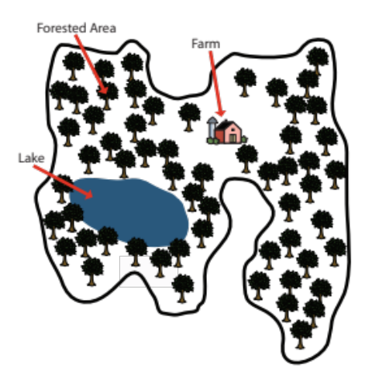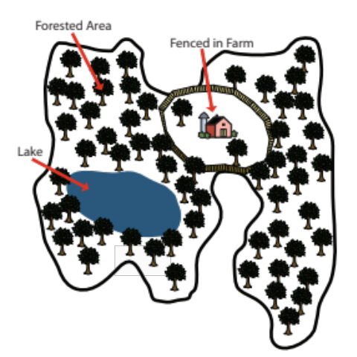
Farm in Upstate New York Farm in Upstate New York with a new fence

The forested mountains of upstate New York are filled with sugar maples, oaks, and yellow birch trees. They are also home to predators like bobcats. These animals live alone and wander over large areas to search for food and to mate and breed with other bobcats. Recently, a dairy farmer who lives in the area and who supplies milk to New York City residents decided to build a fence around his farm in order to prevent his grazing cows from wandering off. The farmer is happy with these changes because they allowed him to increase milk production.

- How is the upstate habitat being changed?

A fence is being built that isolates one part of the habitat.

- Explain how building a fence on the farm can affect the bobcat population.

The fence isolates the bobcat population, so it will have a hard time searching for food and mates.

- What data would scientists collect to support the claim that the fence is harming the bobcat population?

Scientists can collect DNA samples from bobcats from before (or immediately after) the fence is built and then compare the level of breeding in those bobcats with the level of breeding in bobcats from a long time after the fence is built. Lower levels of breeding in the bobcat populations from a long time after the fence is built would show that the fence is preventing the bobcat from mating.

- Describe one other example (other than cutting down trees) where changes people have made to habitats have unexpectedly harmed wildlife populations. Make sure you include in your answer the change to the habitat and how that change harms wildlife populations.

Plastic trash in the Pacific is harming baby seabirds.
Roads are separating wood turtles from their vernal pools required for breeding and living.
Oil spills are killing sea animals.

