Name:_________________________________________ Date:_______________ PD: _____

Malaria is an infectious disease that is transferred to humans through mosquitoes. Infected female mosquitoes will bite humans and transfer the parasite through their saliva directly into a person’s circulatory system. Malaria is widespread in tropical and subtropical regions, including places like South Africa and South America.

DDT is a pesticide used to kill insects including mosquitoes. It has had many uses since it was first synthesized in 1874, but was primarily used to control agricultural pests. In 1972, it was banned in the United States because of the harmful ecological effects it has on the environment.

South Africa historically used DDT to control the spread of malaria by going inside houses and spraying the entire indoor area. In 1996, they replaced DDT with another insecticide considered to be less toxic than DDT. In 2001, South Africa reintroduced DDT as a house spray to control malaria.

Below you will see two graphs visually representing the correlation between malaria and DDT in South Africa as well as countries in South America.

**Answer questions 1-3 using the graph below.**

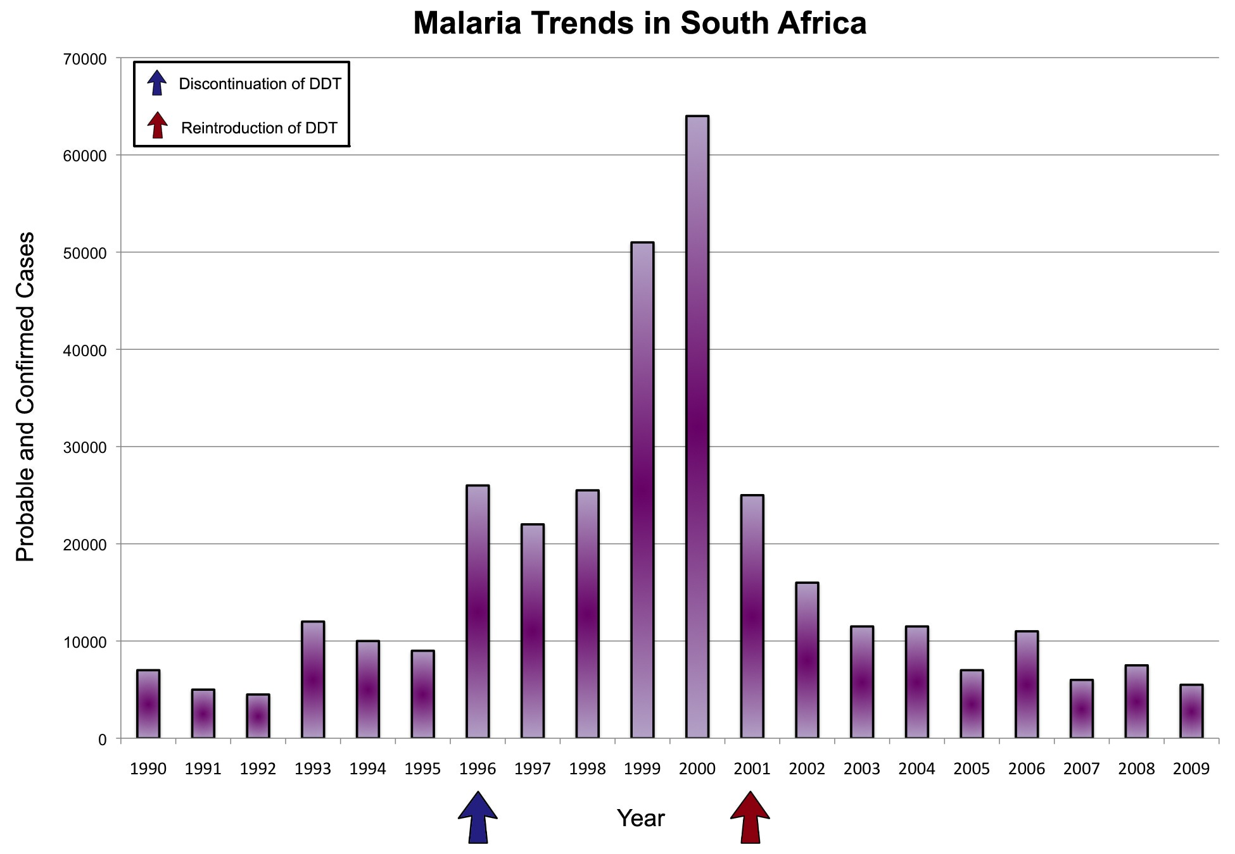

Data from Prenatal exposure to DDT in malaria endemic region following indoor residual spraying and in non-malaria coastal regions of South Africa

1. What is the trend of malaria cases from 1990 to 2000?

______________________________________________________________________

2. What is the trend of malaria cases from 2001-2009?

______________________________________________________________________

3. How did the events of 1996 and 2001 affect the number of malaria cases?

______________________________________________________________________

**Use the graph below to answer questions 4-6.**

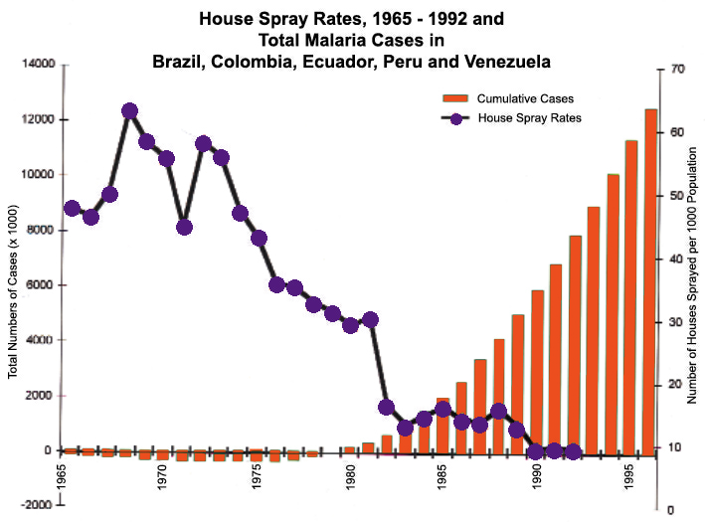

Data from: Comparison of house spraying and insecticide-treated nets for malaria control

4. How did the cumulative cases of malaria change from 1955 to 1995?

______________________________________________________________________

5. How did the house spray rates change from 1955 to 1995?

______________________________________________________________________

______________________________________________________________________

6. What can you determine is the relationship between the cumulative cases of malaria and house spraying rates?

______________________________________________________________________

Insecticide-treated mosquito nets are also used to combat malaria. These nets form a protective barrier around sleeping humans by killing mosquitoes and other insects.

The table below shows the percentage of people affected in areas with treated nets and untreated nets. Use the table below to answer question 7.

|  |  |  |
| --- | --- | --- |
| **Study Area** | **Treated Nets** | **No Nets** |
| Cameroon | 18% | 28% |
| Sierra Leone | 33% | 46% |

7. How does having treated nets affect the number of individuals affected with malaria?

______________________________________________________________________

8. How would spraying houses with insecticide affect the abiotic factors in a local environment?

______________________________________________________________________

9. Would treated nets have the same effect?

______________________________________________________________________

10. If you had to choose between spraying your house with insecticide or using insecticide-treated nets, what would you choose? Why?

______________________________________________________________________

______________________________________________________________________

______________________________________________________________________