**Evolution of Urban Birds**

by Jessica Genter

**TEACHER EDITION**

Birds living in cities are living in different ecosystems than their forest-dwelling counterparts. One team of researchers wanted to understand the affect of artificial light at night on bird reproduction. They compared the reproductive cycles between city and forest-dwelling blackbirds to understand when blackbirds were reproducing and for how long. Students will walk through data to understand the research question, the experimental design and the research outcome.

**Students Will be Able To:**

* Understand the impact of light pollution on urban environments
* Analyze research design and experimental setup
* Create graphs based on current research
* Interpret graphs to understand data
* Analyze conclusions based on current data
* Ask questions and create a hypothesis based on the data

Worksheet #1:

Name: ___________________________ Date: __________________ PD: _________

**People in Cities**

Cities are the fastest-growing land type covering the earth. They are rapidly expanding to accommodate the daily needs of the increasing numbers of people on the planet. Cities need streets on which to walk and drive, buildings to in which to live and do business, and artificial light at night so that people can see where they’re going and what’s around them.

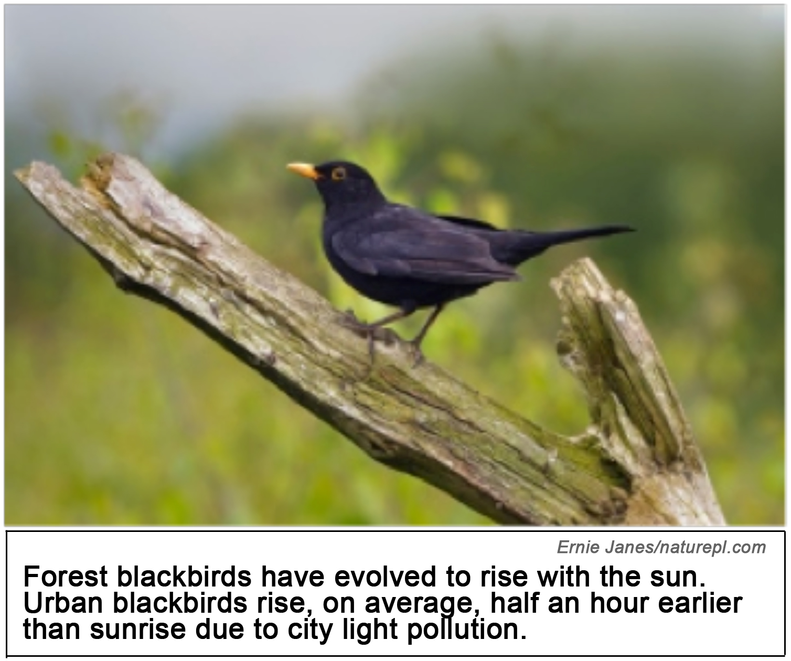

**Cities, Bird Reproduction, & Light Pollution**

As urban areas spread, the native habitat for many plants and animals is reduced. Sometimes the organisms that live there respond to human-caused environmental changes in unexpected ways. This worksheet describes a study designed to understand how city blackbirds respond to the longer “days” created by artificial light at night. Like many animals, birds use seasonal changes in temperature and light as signals that guide migration and mating. Scientists, Davide Dominoni, Michael Quetting and Jesko Partecke, were interested in studying how city lights affect birds’ reproductive calendar (e.g. the optimal time to lay an eggs so they hatch when the most amount of food is available). They knew that light stimulation was effective and used in poultry science in creating an environment in which chickens laid eggs all the time. But they wanted to look specifically at how the light that permeates our cities at night affects birds’ reproductive cycles.

They decided to compare birds that lived in an urban environment and birds that lived in a forest environment. They created an urban environment in a lab that simulated the low levels of light found in cities. In the lab, they also created a forest environment that simulated the low levels of light found in forests.

1. Why do you think sunlight affects birds’ reproductive cycles? (Hint: How does sunlight change with the seasons?)

*________________________________________________________________________________*

*________________________________________________________________________________*

*________________________________________________________________________________*

2. The benefit or harm of earlier rising is dependent on the availability of food.How could rising half an hour earlier be helpful for urban birds? How could it be harmful?

*________________________________________________________________________________*

*________________________________________________________________________________*

*________________________________________________________________________________*

3. How would we be able to tell if rising earlier is helpful or harmful for urban blackbirds?

*________________________________________________________________________________*

*________________________________________________________________________________*

*________________________________________________________________________________*

4. Why would the researchers create an urban environment and a forested environment in order to test their hypothesis? Why wouldn’t they just use a city and a forest? Why might an artificial lab setting be more useful for studying this question than actual urban and forested environments?

*________________________________________________________________________________*

*________________________________________________________________________________*

*________________________________________________________________________________*

Worksheet #2:

Name: ___________________________ Date: __________________ PD: _________

**forest urban birds 2.pdfResearch Setting**

|  |
| --- |
| *Jessica Genter*  In order to study the effect city lights have on forest-dwelling birds and the effect the nighttime forest has on urban-dwelling birds, Dominoni, Quetting and Partecke created two environments and placed both urban-dwelling and forest-dwelling birds in an urban environment. They also placed both urban-dwelling and forest-dwelling birds in a forested environment. |

Dominoni, Quetting and Partecke wanted to understand if the urban birds’ reproductive cycle changed due to the increased light at night in cities. In order to study this question, the researchers created two environments, one “forest environment” designed to mimic light conditions in forests and one “urban environment” designed to mimic light conditions in cities. They controlled for other variables, by keeping the environments identical for all other factors that could affect their behavior like food, temperature, and space.

They then captured 20 city-dwelling blackbirds and 20 forest-dwelling blackbirds and put 10 city birds and 10 forest birds into the urban environment. They put the remaining birds (10 city, 10 forest) into the forest environment.

1. What type of bird and how many of each type are in the forest environment for this experiment?

*________________________________________________________________________________*

2. The Dominoni team studied how cities affect birds that have migrated there. However, by putting urban birds back in a forested environment, the Dominoni team also studied what happens when urban birds migrate out of the city. Why do you think that’s important?

*________________________________________________________________________________*

*________________________________________________________________________________*

3. Why would bird behaviors change if they lived in a city?

*________________________________________________________________________________*

*________________________________________________________________________________*

4. Why do you think it is important that we study the effect cities have on animal life?

*________________________________________________________________________________*

*________________________________________________________________________________*

Worksheet #3:

Name: ___________________________ Date: __________________ PD: _________

**How to Test Male Blackbirds’ Reproductive Functionality**

Male blackbirds do not always have the same size testes throughout the year. In the winter, when they are trying to mate with females, their testes are smaller, because their sperm production is lower. Once spring arrives, male blackbirds’ testes start to grow because they are getting ready to mate with females. Hormones such as testosterone trigger this growth in the blackbirds’ endocrine system.

Once the testes grow to 5mm in width, they are considered “functional” and the blackbirds can mate successfully with females. As spring progresses, blackbird testosterone production decreases, and their testes get smaller. Once the testes are smaller than 5mm in width, they are considered nonfunctional again.

**Research Data**

Dominoni, Quetting and Partecke decided to use this information to test their hypothesis. They reasoned that the reproductive hormones that control birds’ reproductive cycle would be triggered earlier in the year due to the increased amount of light in the urban environment. They also hypothesized that these changes developed over a long period of time, meaning that an urban bird would not be able to quickly adjust their reproductive hormones to match the lower night light conditions of the forest. They would therefore still begin testes growth early even in the lower night light conditions of the lab forest environment.

To test this hypothesis, they measured each of the blackbirds’ testes in both the urban and forest environment. Below are their results. The dates are an average of each blackbird in that group reaching 5mm in testicular width.

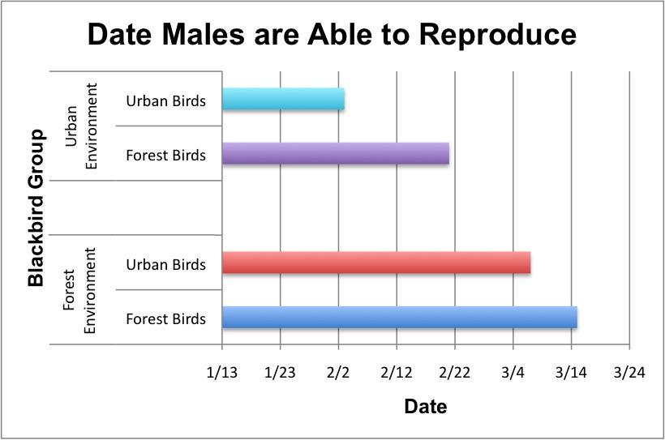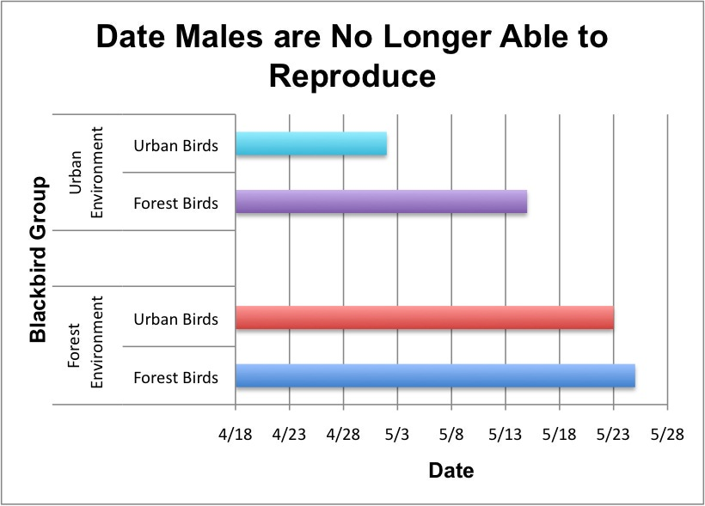

1. Which blackbird group was able to reproduce the earliest? Circle the correct answer.

*A. The Urban Birds in the Urban Environment*

*B. The Forest Birds in the Forest Environment*

*C. The Urban Birds in the Forest Environment*

*D. The Forest Birds in the Urban Environment*

2. Which blackbird group was the earliest to no longer be able to reproduce? Circle the correct answer.

1. *The Forest Birds in the Forest Environment*
2. *The Urban Birds in the Forest Environment*
3. *The Forest Birds in the Urban Environment*
4. *The Urban Birds in the Urban Environment*

3. How many days earlier were urban birds able to reproduce than forest birds in the urban environment?

*________________________________________________________________________________*

4. How many days earlier were urban birds in the urban environment no longer able to reproduce than forest birds in the forest environment?

*________________________________________________________________________________*

5. What do these two graphs tell us about when city and forest birds are beginning their seasonal reproductive changes?

*________________________________________________________________________________*

*________________________________________________________________________________*

6. Do you think it is significant that the city birds in the forest setting began their seasonal reproductive changes later than the city birds in the urban setting? Why or why not?

*________________________________________________________________________________*

*________________________________________________________________________________*

7. Do you think it is better for the birds to begin their reproductive changes earlier in the year in cities? Why or why not?

*________________________________________________________________________________*

*________________________________________________________________________________*

Worksheet #4:

Name: ___________________________ Date: __________________ PD: _________

Dominoni, Quetting and Partecke didn’t want to just look at when their blackbirds began and ended their reproductive times. They also wanted to look at how long these birds were functionally reproductive in order to understand in which scenario blackbirds stayed reproductively functional the longest.

Using the data they gained by looking at testicular width, they created a table for the reproductive duration of the blackbirds. By using January 1st as the beginning of their number sequence, they were able to give each day an ascending number. For instance, if January 1st = 1, then January 2nd = 2. In this way, they were able to establish a number for each date, allowing them to easily see how long each bird was reproductively functional. The table is below.

|  |  |  |  |
| --- | --- | --- | --- |
| Length of Time of Working Testes | Urban Environment | City Birds | 88 days |
| Forest Birds | 83 days |
| Forest Environment | City Birds | 77 days |
| Forest Birds | 71 days |

Using the blank template below, answer the following questions to create your own bar graph of the duration of functional testes.

1. Write the title of your graph above the graph itself.

*________________________________________________________________________________*

2. Your graph is going to look a lot like other graphs on these worksheets. In previous graphs on these worksheets, which way are the bars? Horizontal or vertical?

*________________________________________________________________________________*

3. In the previous graphs, is the independent or the dependent variable on the x-axis?

*________________________________________________________________________________*

4. Is this the same or different than when you make a vertical bar graph? Why?

*________________________________________________________________________________*

5. Based on questions 2-4, what data should go on the x-axis? Put the description of that data below the graph.

*________________________________________________________________________________*

6. Decide on a numerical range and intervals for the x-axis. Your range should start at 0 and go past the highest number in your data set (e.g. your range shouldn’t be 0-80, because some of your data is larger than 80). Each vertical line in the graph represents an interval for you to establish. Intervals should evenly space your range along the graph, so it is easy to read (e.g. your intervals shouldn’t read 0, 20, 50, 60, 65, 70).

*________________________________________________________________________________*

7. What data should go on the y-axis? Put that data to the left of the graph. (Hint: The y-axis should look similar to the graphs you looked at in Worksheet #3.)

8. You are creating a bar graph, so you need to create a bar for each data set on the y-axis. Then you need to elongate it to the appropriate numerical value on the x-axis based on the data given.

9. Once you’ve created your bars, check to make sure that your data is consistent with the data in the table.

Name: _____________________________

Class: _____________________________

Date: ______________________________

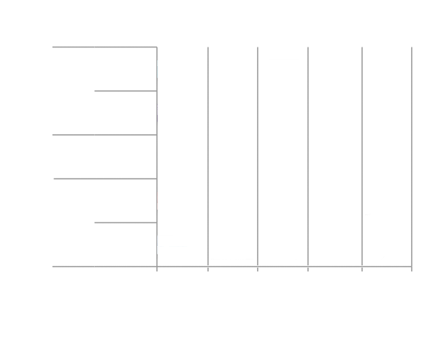

Worksheet #5:

Name: ___________________________ Date: __________________ PD: _________

Based on the data below and the resulting graph, Dominoni, Quetting and Partecke concluded that urban birds in an urban setting had the longest duration of functional testes, indicating the longest reproductive cycle.

|  |  |  |  |
| --- | --- | --- | --- |
| Duration of functional testes | Urban Environment | Urban Birds | 88 days |
| Forest Birds | 83 days |
| Forest Environment | Urban Birds | 77 days |
| Forest Birds | 71 days |

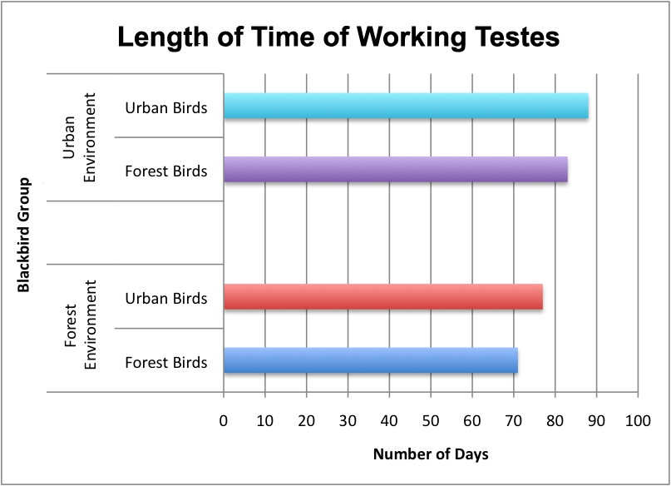

However, they concluded that this doesn’t necessarily mean that urban birds, if left in their habitat, will produce the largest number of offspring. They point out that reproductive growth costs a lot for the blackbirds in terms of energy output. If they’re putting their energy into reproduction, they might be compromising their ability to fly to find food or their immune system.

1. Why might starting a reproductive cycle earlier in the year be helpful to urban birds? Why might it be harmful to urban birds? Do we know if it helps or hurts urban birds?

*________________________________________________________________________________*

*________________________________________________________________________________*

*________________________________________________________________________________*

2. Why might having a very long reproductive cycle be helpful to urban birds? Why might it be harmful to urban birds? Do we know if it helps or hurts urban birds?

*________________________________________________________________________________*

*________________________________________________________________________________*

*________________________________________________________________________________*

3. Dominoni, Quetting and Partecke also caution against reading into this data the fact that urban birds really begin reproduction earlier. Based on this data alone (which only looked at male birds), there is no way of knowing how many offspring these birds are reproducing.

What other factors would you need to examine in order to answer that question?

*________________________________________________________________________________*

*________________________________________________________________________________*

4. Speciation can occur when some individuals in a population move to a new environment that has different selective pressures than the original environment. These pressures sometimes make it impossible to mate because they sometimes select for morphological or behavioral changes that make reproduction impossible. Do you think if, many years from now, researchers were to bring the city birds and forest blackbirds into contact again, would speciation have occurred? Referencing the data, why or why not?

*________________________________________________________________________________*

*________________________________________________________________________________*

*________________________________________________________________________________*

*________________________________________________________________________________*

5. This experiment answered many questions, but it also raised a few more. Can you think of a research question they should ask next? What would be your hypothesis?

*________________________________________________________________________________*

*________________________________________________________________________________*

*________________________________________________________________________________*

*________________________________________________________________________________*

*________________________________________________________________________________*

*________________________________________________________________________________*

*________________________________________________________________________________*

*________________________________________________________________________________*

*________________________________________________________________________________*