The Yellowstone Food Webs:
Illustrating the Interactions Amongst Carnivores, Herbivores and Plants

by Renee Thorne
edited by Jessica Genter

In 1992, Yellowstone National Park reintroduced wolves into the local ecosystem. This reintroduction affected the elk population as well as its food source, the aspen population. Students will use data and graphs to better understand trophic levels and the importance of key species in ecosystems.

Students Will Be Able To:
- understand the nature of food webs
- manipulate data, charts and graphs
- understand trophic levels
- create their own trophic pyramid

HANDOUT #1

Name: ________________________________ Date: _________________ PD: ________
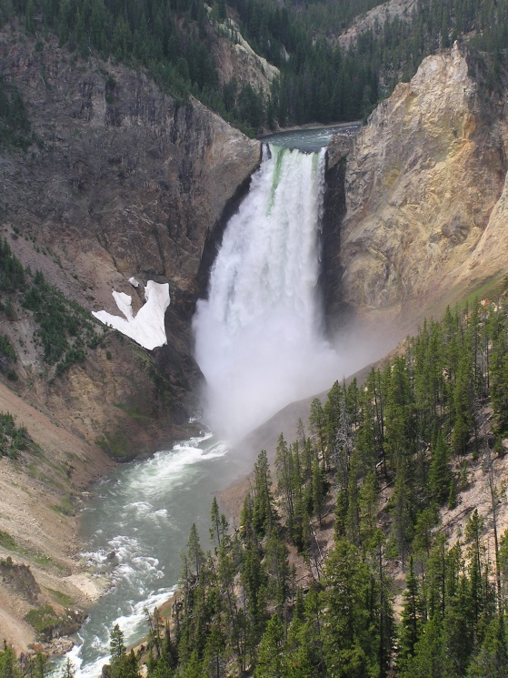

Yellowstone National Park

Yellowstone National Park, the first national park established by President Grant in 1872, is well known for its wildlife and geothermal features such as Old Faithful Geyser. It is one of the most popular national parks in the Unites States and saw a record breaking 975,000 tourists in July of 2010. The park spans a total of three states (Wyoming, Montana, and Idaho) and is home to grizzly bears, wolves, and herds of bison and elk.

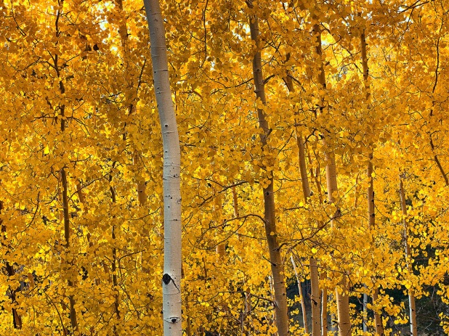
The Elk and Aspen of Yellowstone National Park
Aspen (Populus tremuloides) are deciduous trees that are commonly 20 to 80 feet tall and grow best in moist soils with plentiful sunshine. Aspen trees, known for their beautiful leaf color, reproduce by sprouting young aspen from their already existing roots. Young aspen are genetically identical to the trees they sprouted from and share all of the same characteristics.

Scientists William J. Ripple and Robert L. Beschta, professors at Oregon State University, first noticed the decrease in numbers of aspen trees in Yellowstone National Park in 1997, but could not determine what was causing their decline. Ripple, Beschta, and a team of college students set out to explain the decline of aspen trees. Their first step was to conduct a tree ring analysis, which allowed them to determine the age of the trees that were still present in Yellowstone. This tree ring analysis led the scientists to the conclusion that the aspen had stopped reproducing new trees some time during the first half of the 1900s.

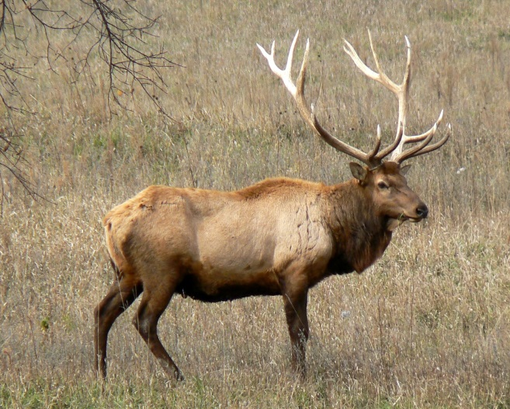
Despite having an approximate timeline, Ripple, Beschta, and colleagues were still confused as to why the aspen were no longer reproducing. They considered possibilities such as climate change before settling upon the idea that elk (Cervus elaphus), which enjoy feeding on young aspen clones, were to blame for the decline in aspen populations. They also realized that the timeline for the decline of the aspen correlated with the extirpation (or complete removal) of the wolves from Yellowstone park in the 1920s.

- How did conducting a tree-ring analysis help the scientists discover what was causing the decline in aspen trees?

The analysis allowed scientists to understand when trees stopped reproducing and connect that information to elks’ feeding habits.

- What occurred in the first half of the 1900s that would explain why the aspen stopped reproducing?

The wolves were removed from Yellowstone National Park.

- What affect do you think the removal of wolves from Yellowstone Park had on the ecosystem?

The elk weren’t being eaten anymore, so there were more elk in Yellowstone National Park.

HANDOUT #2

Name: ________________________________ Date: _________________ PD: ________

Introducing a Predator
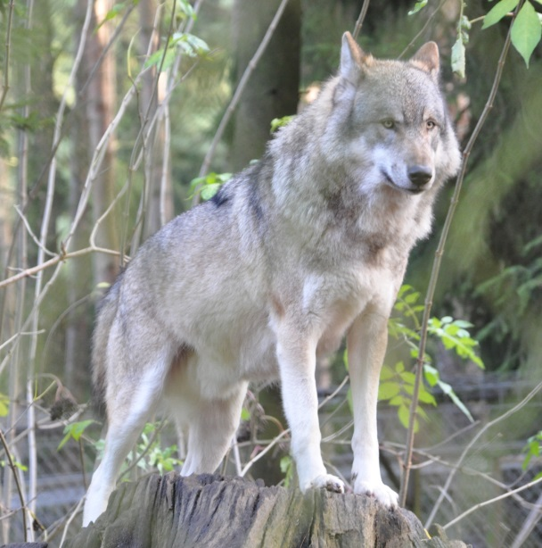
When Yellowstone National Park was created in 1872, Northern Rocky Mountain wolves (Canis lupus) were native to the ecosystem. By the 1920s however, Yellowstone’s ecosystem was severely altered by the extirpation of wolves due to government predator control programs that permitted all wolves in Yellowstone Park to be killed. The removal of wolf predators that occurred in the 1920s allowed for an increase in populations of herbivorous species such as the elk. Beginning in the 1920s, after the complete removal of wolves from Yellowstone, elk foraged the northern winter range of the park without fear of a predator. Though wolves were reintroduced to Yellowstone Park in 1995 and 1996, approximately 70 years of damage to the ecosystem was already done.

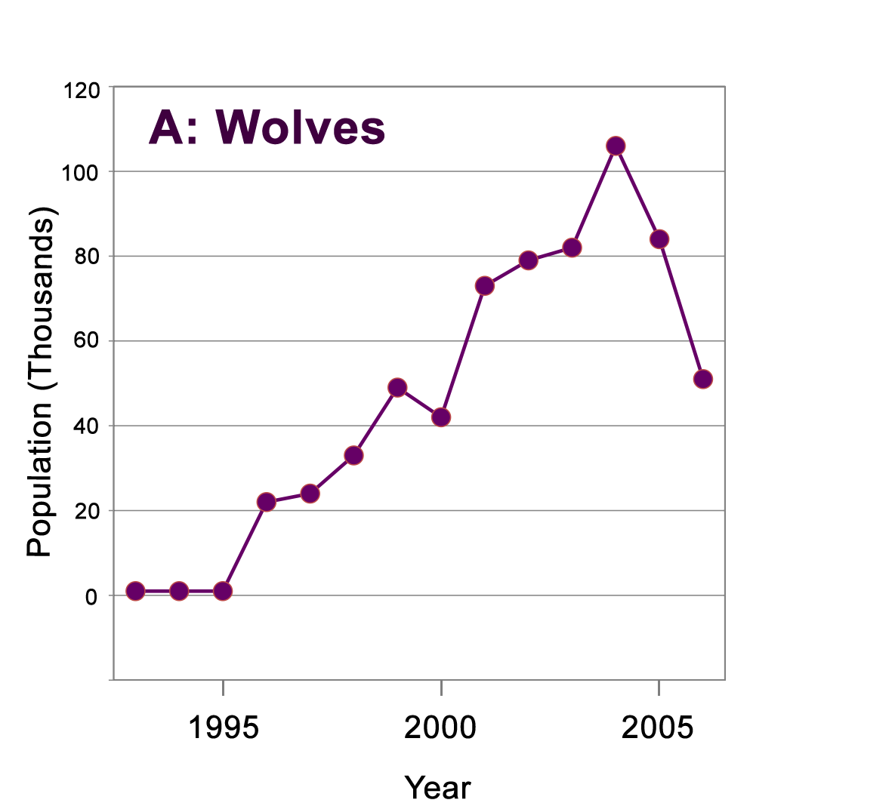
Ripple and Beschta collected data on wolf and elk populations from 1993 until 2006. Their data is shown in the graphs below. Graph A shows the number of wolves in Yellowstone, and graph B shows the number of elk in thousands.
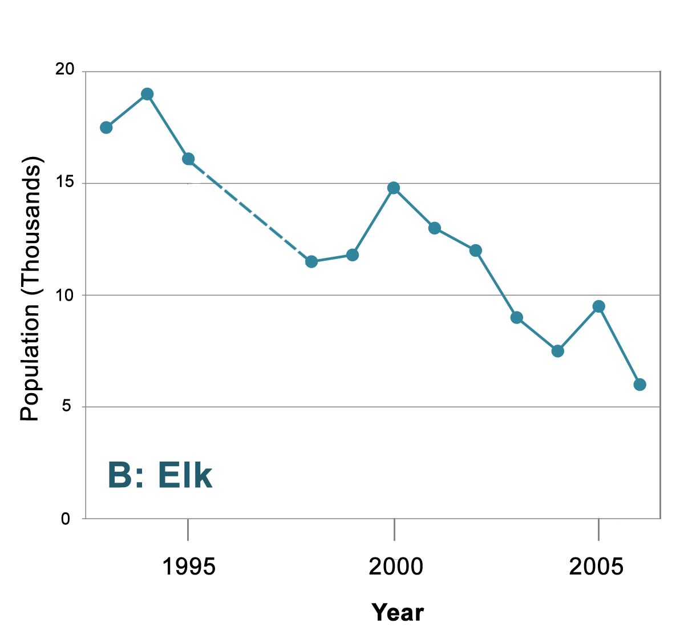

- Write a sentence to describe the pattern you observe in the data from graphs A and B.

As the wolf population increases, the elk population decreases.

- Why were elk populations so high before 1995?

Because there were no wolves.

- How did the reintroduction of wolves affect the elk population? Why do you think this happened?

The elk population decreased, because the wolves started eating the elk.

- Write a statement that best describes the relationship between the wolf and elk populations.

The elk population is in an inverse relationship with the wolf population. As the wolf population increases, the elk population decreases, and vice versa.

Ripple and Beschta added a third set of data that showed the measurements of young aspen heights in centimeters from 1998 to 2006.

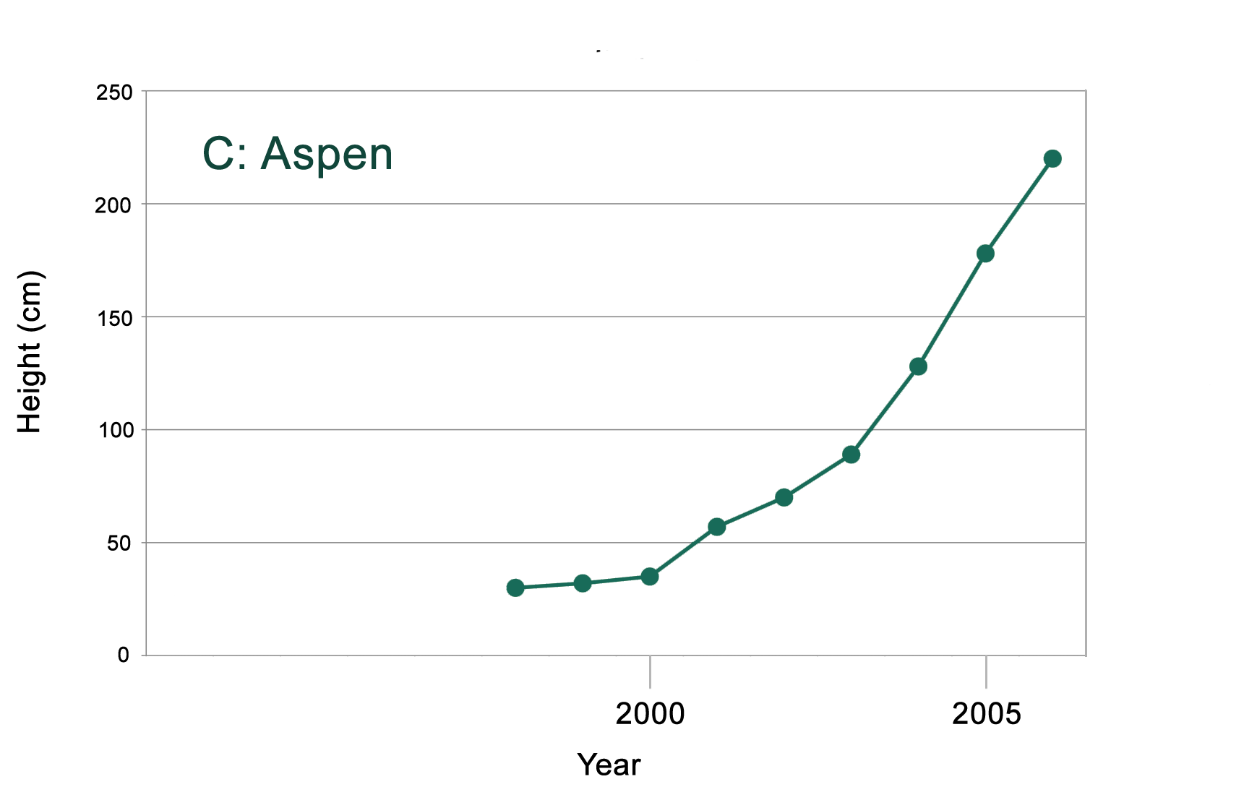

- Write a sentence to describe the pattern in data you observe from graphs A, B, & C.

As the wolf population increases, the elk population decreases and the height of aspen trees increases.

- Why did the height of young aspen begin to increase around the year 2000?

Because there were less elk eating them.

- Write a statement that describes the relationship between elk and aspen.

As the elk population decreases, the aspen can live longer and grow taller.

- How did the reintroduction of wolves affect aspen height?

The reintroduction of wolves allowed the aspen to grow more.

HANDOUT #3

Name: ________________________________ Date: _________________ PD: ________

The Effects of Predation on Plant-life

It has long been apparent to scientists that predators can directly alter herbivorous prey populations in a particular area by hunting and eating them, decreasing the overall number of prey in the region. However, it has also been suggested that another less explored mechanism by which predators can alter prey populations in a region exists. This second mechanism does not involve killing the prey, but affecting the behavior of the prey. It is possible that the fear of a predator alone may be enough to decrease the population of prey found in particular habitat types.

The assumption is that prey will make different decisions about habitat use and how they forage for food based on whether or not a predator is present in a particular landscape. This idea may be compared to how the level of crime in a particular neighborhood may influence where people live or visit. People are less likely to wish to live in or visit neighborhoods where there is a greater risk of being harmed due to the presence of criminals. While criminals are present in a neighborhood, people are less likely to visit these neighborhoods and may choose to avoid them altogether. The same can be said of prey: if there are predators present, they may choose to limit the time they spend foraging for food in a certain area or avoid the area altogether.

Decisions made under the influence of fear of predators will differ from decisions made without the fear of a predator. Therefore, Ripple and Besctha hypothesized that fear-induced changes in habitat use and foraging may then impact the plants occurring in a particular landscape. In order to test this hypothesis, Ripple and Beschta studied the effects of predation on plants in the Lamar Valley of Yellowstone National Park's northern winter range.

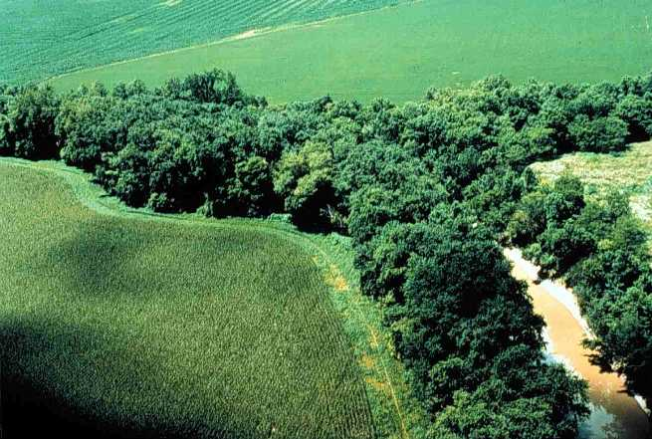

In August of 2006, Ripple and Beschta surveyed Lamar Valley in search of riparian areas where seven or more young aspen trees lived. For every riparian region they surveyed, Ripple and Beschta also surveyed a nearby region that was upland and away from the water. They then categorized these two regions of study, riparian and upland, as either having or lacking logs. They measured the changes in percentage of young aspen eaten by elk (the percent browsed) in each region between 1998 and 2006.
A riparian region occurs at the meeting of land and a river or stream.

The graphs below show their data. Graph A shows the number of wolves present in Yellowstone between 1993 and 2006, while graph B shows the percentage of aspen browsed between 1998 and 2006.
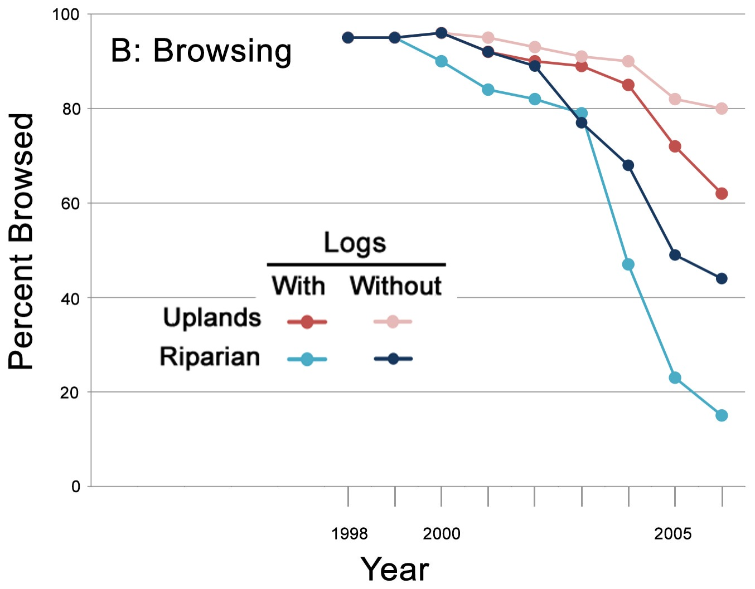

- Describe the pattern you observe in graph B. Why did the percentage of aspen browsed begin to decrease in the year 2000?

Because the wolves changed the behavior of the elk, and the elk no longer browsed these areas.

- How long after the reintroduction of the wolves did the percentage of aspen browsed begin to decrease? Why do you think the changes in percentage browsed did not occur sooner?

2000. Because the elk didn’t immediately respond to the small reintroduction of their predator.

- Which region showed the greatest decrease in percentage of aspen browsed, riparian or upland?

Riparian.

- In riparian regions, which areas showed a lower percentage of aspen browsed, those with or without logs? What about in upland regions?

Riparian regions - those with logs. Upland regions - those with logs.

- Why would the presence of logs in an area cause the percentage of aspen browsed to be lower in both riparian and upland regions? How might the presence of the logs give the wolves an advantage?

The wolves can use the logs to hide. It’s also not as easy for the elk to run away quickly.
HANDOUT #4

Name: ________________________________ Date: _________________ PD: ________

Trophic Cascades in Yellowstone and the Top-Down Effect
A trophic cascade occurs when the decline in the population of one species due to predation allows the population of another species of a lower trophic level to increase. This phenomenon may also be referred to as a top-down effect. A species’ trophic level can be defined as the position it occupies in the food chain. If an organism is low on the food chain, it is considered to have a low trophic level. If it is high on the food chain, it is considered to be a high trophic level species (see figure below).

Since plants like the aspen are producers and a source of energy for all other species, they are at the lowest trophic level. Since herbivorous species eat plants, they are considered to be at the next trophic level. Herbivores are also identified as primary consumers since they are the first group of species to consume another species. A step above the herbivores are carnivores that eat herbivores and are therefore considered secondary consumers. Species that prey on secondary consumers are considered to be tertiary consumers and so on. At the very top of every food chain are those species that eat all species below them. These species are considered to be the top predators or carnivores of their food chain.

Below is an example of trophic levels:
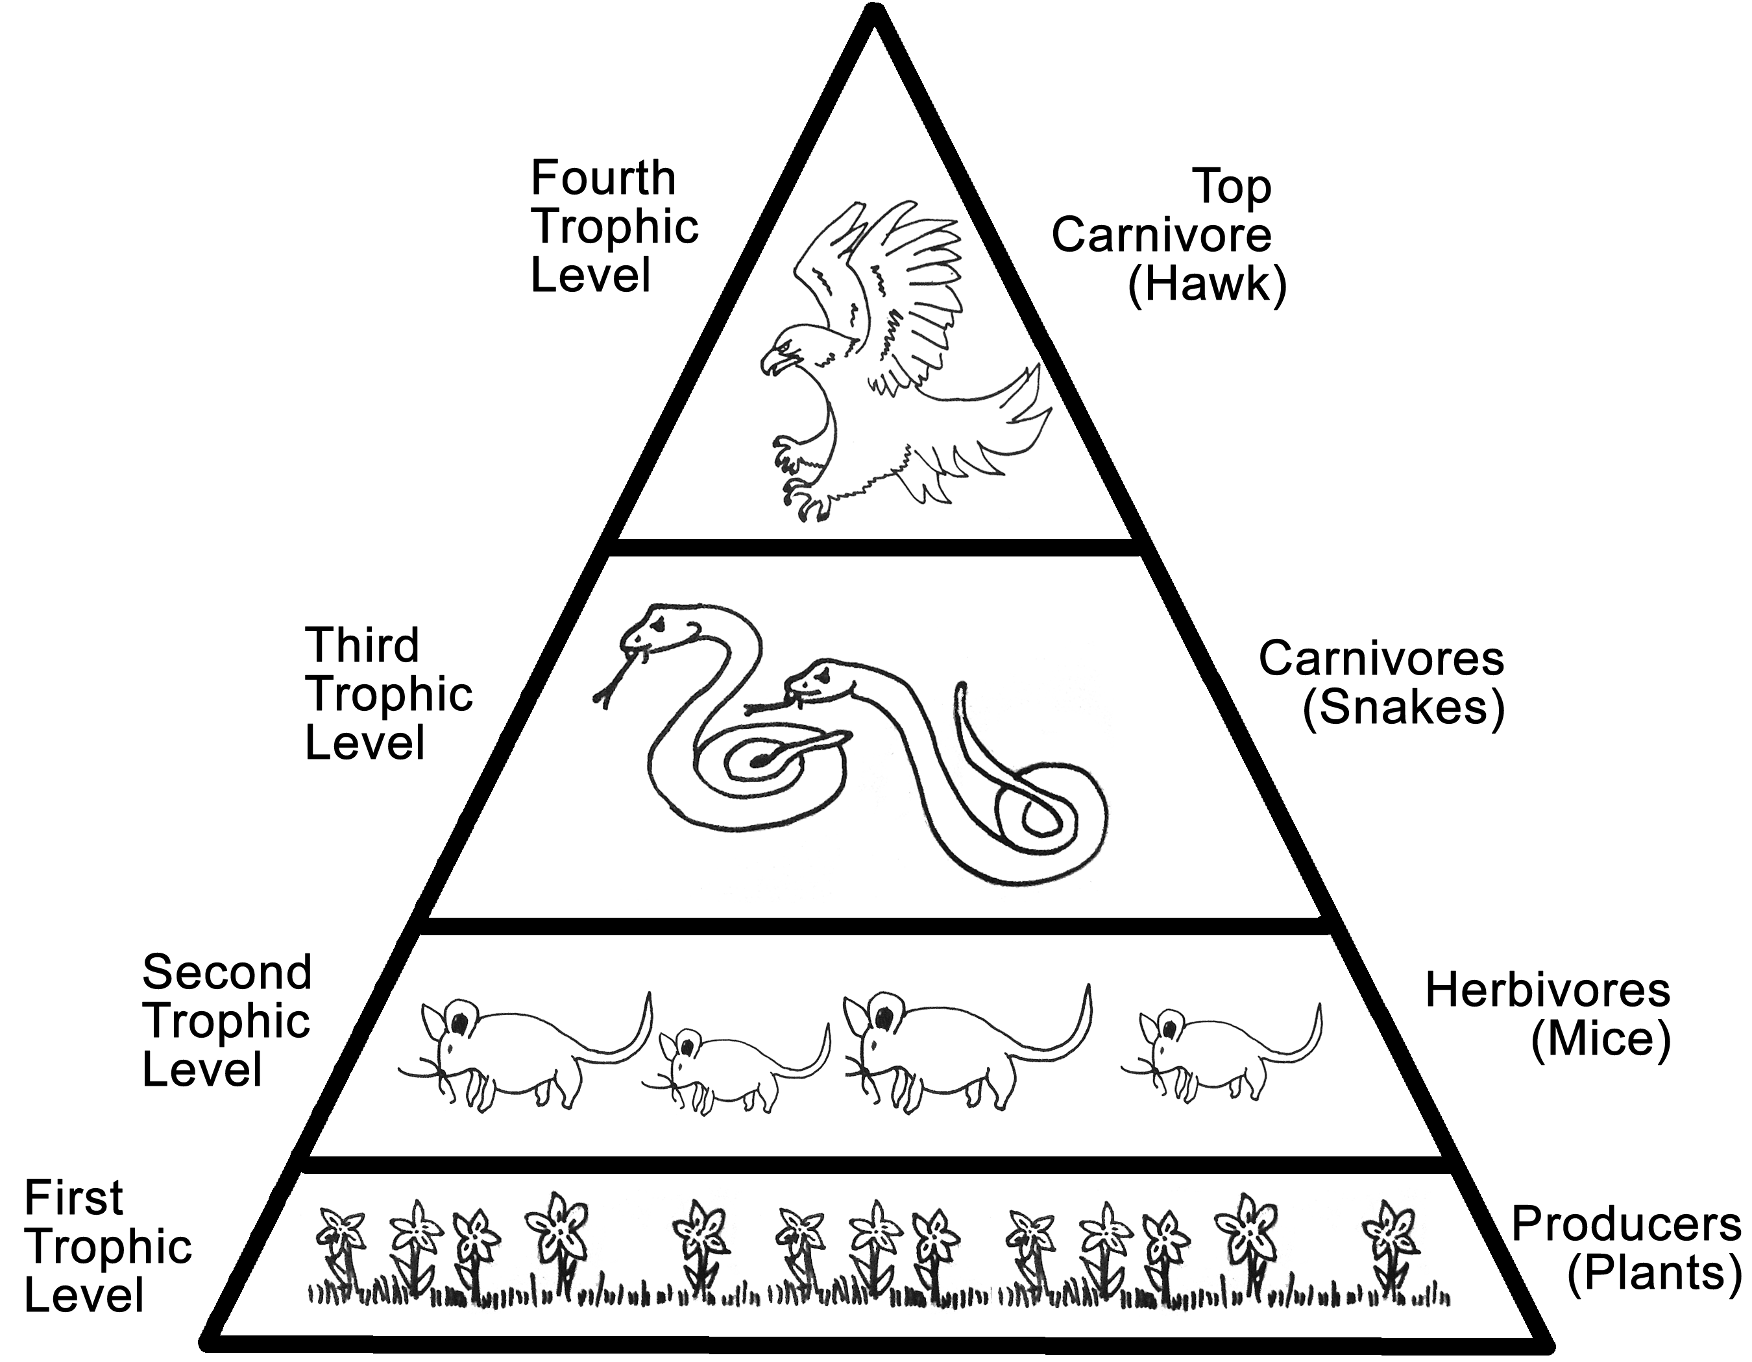
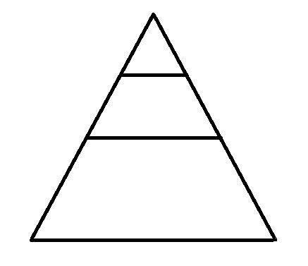

1) Fill in the empty trophic pyramid by placing wolves, aspen, and elk in the correct order by their trophic level and position in the food chain. Identify the producer, the primary consumer, and the secondary consumer.

2) Based on what you now know about elk browsing/foraging patterns, the absence of wolves between the 1920s and 1990s, and the timing of the halt of aspen reproduction, do you think there is evidence of a trophic cascade in Yellowstone park? Why or why not? If so, how did human influence alter this trophic cascade?

______________________________________________________________________

______________________________________________________________________

______________________________________________________________________

______________________________________________________________________

______________________________________________________________________

______________________________________________________________________

______________________________________________________________________

______________________________________________________________________

______________________________________________________________________

______________________________________________________________________

______________________________________________________________________

______________________________________________________________________

