T. rex: The Ultimate Predator

ACTIVITIES FOR GRADES 6-8
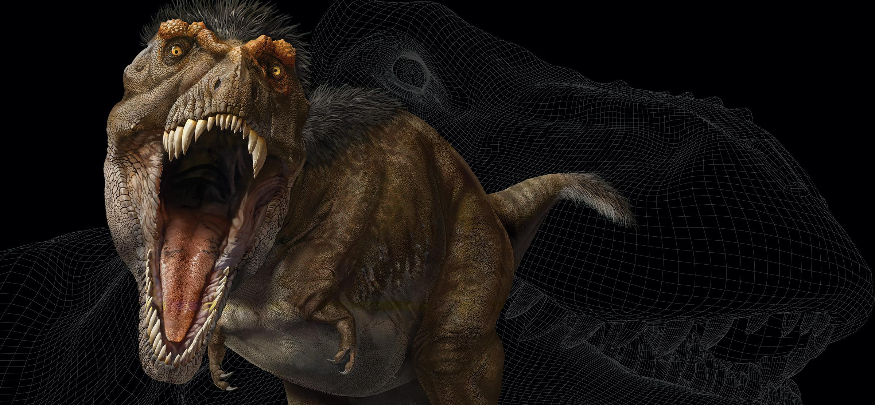

TABLE OF CONTENTS
FOR EDUCATORS | PAGE
Activity Overview .………………………………………………………………………………………….............................. | 2
Correlation to Standards ………………………...…………………………………………………………….…………....…. | 2
Before the Visit ……………………………………………………………………………....................................................... | 3
At the Museum ……………………………………………………………………………........................................................ | 4
Back in the Classroom …………………………………………………………………………….…….................................. | 5
Student Worksheet: Answer Key & Notes to Educators …………………………………………….…...…….. | 7
FOR STUDENTS
Student Worksheets .….……………………………………………………………………………………………................... | 12

Activity Overview
Fossils show how animals changed over time and how they are related to one another. While fossils also reveal what ancient animals looked like, they keep us guessing about the animals’ colors, sounds, and most of their behavior. So scientists observe animals living today for clues to what ancient animals may have looked like, how they may have moved and behaved, and how they may have interacted with other animals in the ecosystem.

In this three-part activity, students will engage in the practice of obtaining, evaluating, and communicating information and apply the crosscutting concept of structure and function to explore the phenomenon that ancient animals in the fossil record have similarities to and differences from modern animals.

- Before the Visit: Through videos, a reading, and an online quiz, students are introduced to the exhibition and its major themes. Students then generate questions about the evidence scientists use to understand T. rex, including similarities and differences between ancient and modern animals.

- At the Museum: In four sections of the exhibition, students use worksheets to help them record observations of fossils and models, as well as other information to explore similarities and differences between T. rex, its ancient and living relatives, and other living animals for clues about this predator.

- Back in the Classroom: Students process and share what they’ve learned at the Museum about T. rex and the similarities and differences between ancient and living animals. They will also make connections between the information gathered and what they have been learning in class.

This activity supports the following Next Generation Science Standards:
Science & Engineering Practices
- Obtaining, Evaluating, and Communicating Information
Crosscutting Concepts
- Structure and Function

This activity can serve as a connector to the following Next Generation Science Standards:
Disciplinary Core Ideas:
- LS4.A: Evidence of Common Ancestry and Diversity
- LS4.B: Natural Selection
- LS4.C: Adaptation

Before the Visit
Through short videos, a reading, and an online pre-assessment quiz, students are introduced to the T. rex: The Ultimate Predator exhibition and its major themes. Students then generate questions about the evidence scientists use to understand T. rex, including similarities and differences between ancient and modern animals.

TIME | 40 minutes
PREPARATION | - Review the Educator’s Guide to see how themes in the exhibition connect to your curriculum and to get an advance look at what your students will encounter.  - Review this three-part activity and decide how you would like students to engage with the content before, during, and after the visit.
PROCEDURE | - Students become familiar with the exhibition content by exploring one or more of the following resources:  - Video: What did a baby T. rex look like? (6:20)  amnh.org/explore/videos/exhibits/growing-up-tyrannosaurus-rex  Students see that the giant, ferocious T. rex began as a small, helpless hatchling.  - Video: How long did a T. rex live? (3:10)  amnh.org/explore/videos/dinosaurs-and-fossils/how-long-did-t-rex-live  Students learn the methods and evidence paleontologists use to determine the age and lifespan of dinosaurs, including T. rex.  - Article: Tyrannosaurus rex  amnh.org/dinosaurs/tyrannosaurus-rex  Students gain a basic understanding of T. rex, including what it ate, where and when it lived, and how big it grew.  - Quiz: What do you know about T. rex?  amnh.org/explore/ology/paleontology/what-do-you-know-about-t.-rex  Students take this 10-question pre-assessment quiz that covers the major themes of the exhibition.  - In response to the resources, students generate questions about the evidence scientists use to understand T. rex, including similarities and differences between ancient and modern animals. Questions can be recorded on a class or small-group chart so that students can revisit the questions after their trip to the Museum.

At the Museum
In four sections of the T. rex: The Ultimate Predator exhibition, students use worksheets to help them record observations of fossils and models, as well as other information to explore similarities and differences between Tyrannosaurus rex, its ancient and living relatives, and other living animals for clues about this predator.

TIME | 40 minutes
PREPARATION | - Familiarize yourself with the student worksheet, answer key, notes to educators, and the map of the exhibition.  - Decide how students will explore the exhibition using the worksheets. For example, students can explore all four sections of the exhibition in pairs, with each student completing their own worksheet; or students can be divided into groups of four, with each student responsible for one of four locations.
PROCEDURE | - Explain the goal of the Museum visit to students. They will explore:  - what fossil evidence reveals about how animals change over time, how they are related to one another, and what they looked like  - how scientists observe animals living today for clues to the appearance, movement, behavior, and interaction of ancient animals  - Distribute and review the worksheet and map with students. Clarify the information they should collect, and where they can find it in the exhibition.

Back in the Classroom
Students process and share what they’ve learned at the Museum about T. rex and about the similarities and differences between ancient and living animals. They will also make connections between the information gathered at the Museum and what they have been learning in class.

TIME | 40 minutes
PREPARATION | - Review the answer key to worksheets.  - Plan how you will help students process and share information collected.  - Make connections between the exhibition content and what students have been learning in your class.
PROCEDURE | - As a class or in small groups, students share and discuss the information they collected on their worksheets. Their findings can be recorded on a three-column chart (suggested column titles: “What do scientists know about T. rex and other ancient animals?” “How do scientists know this from fossils?” “How do scientists know this by studying living animals?”).  - Students make connections between the exhibition findings and what they have been learning in class (e.g. evolution, natural selection, adaptation, process of scientific inquiry). Suggested prompts:  - How does what you learned about T. rex connect to what we’ve been learning in class about _________?  - How would you use your existing knowledge about _________ to explain what you learned about T. rex?  - Students revisit the list of questions they generated before their Museum visit to see which questions have been answered and which unanswered ones they would like to investigate further.  - Students construct an explanation for T. rex based on their understanding of fossil evidence and the study of living animals. Ideas include:  - Exhibition review  - Science magazine article  - PowerPoint  - Social media post
Ideas for further exploration:
- Students investigate their unanswered questions through research.
- Students go deeper into related concepts such as geologic time, common ancestry, comparative anatomy, evolution, and the bird-dinosaur connection.
- Students explore careers in science and questions such as: Who put this exhibition together? How do you become a scientist, an exhibition designer, a science writer, or a visual artist (models, graphics, interactive media)?

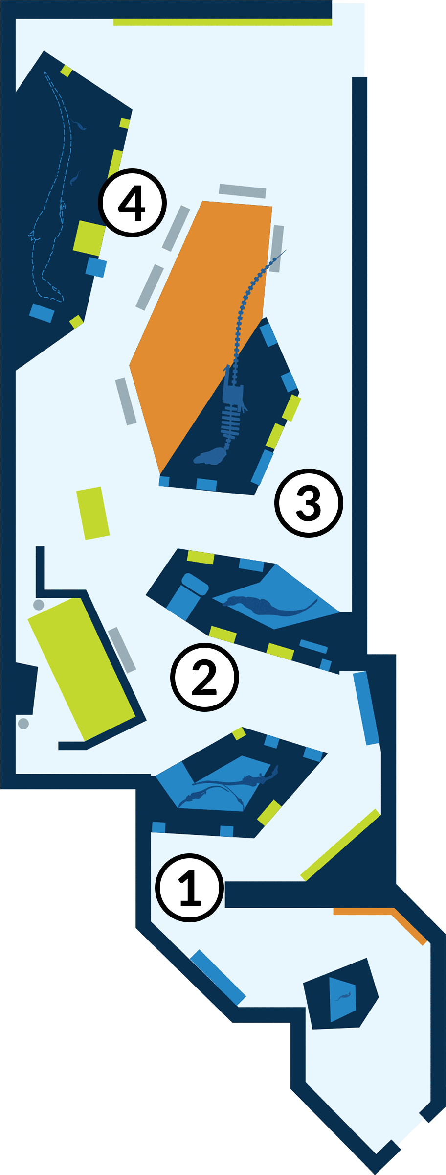
Student Worksheet NAME: _______________________________________________

ANSWER KEY & NOTES TO EDUCATORS

Welcome to the American Museum of Natural History! Fossils show how animals changed over time and how they are related to one another. While fossils also reveal what ancient animals looked like, they keep us guessing about the animals’ colors, sounds, and most of their behavior. So scientists also observe animals living today for clues to what ancient animals may have looked like, how they may have moved and behaved, and how they may have interacted with other animals in the ecosystem.

In the T. rex: The Ultimate Predator exhibition, you will explore similarities and differences between Tyrannosaurus rex, its ancient and living relatives, and other living animals for clues about this predator.

These stops are highlighted in the worksheets:

STOP 1: “Meet the Family” Section

STOP 2: “Getting Big” Section

STOP 3: “Getting Bad” Section

STOP 4: “Sensitive Side” Section

STOP 1: “Meet the Family” Section

- Observe the model of Dilong paradoxus and read the “Fierce and Feathered” panel. Why do scientists think that this animal’s entire body may have been covered with simple feathers?

Answers may include: Scientists found fossil evidence of primitive, hairlike feathers on the tail, so they think that similar feathers also covered most of this species’ body. They based this hypothesis on the evidence that birds—living dinosaurs—also have simpler, fuzzy feathers called down.
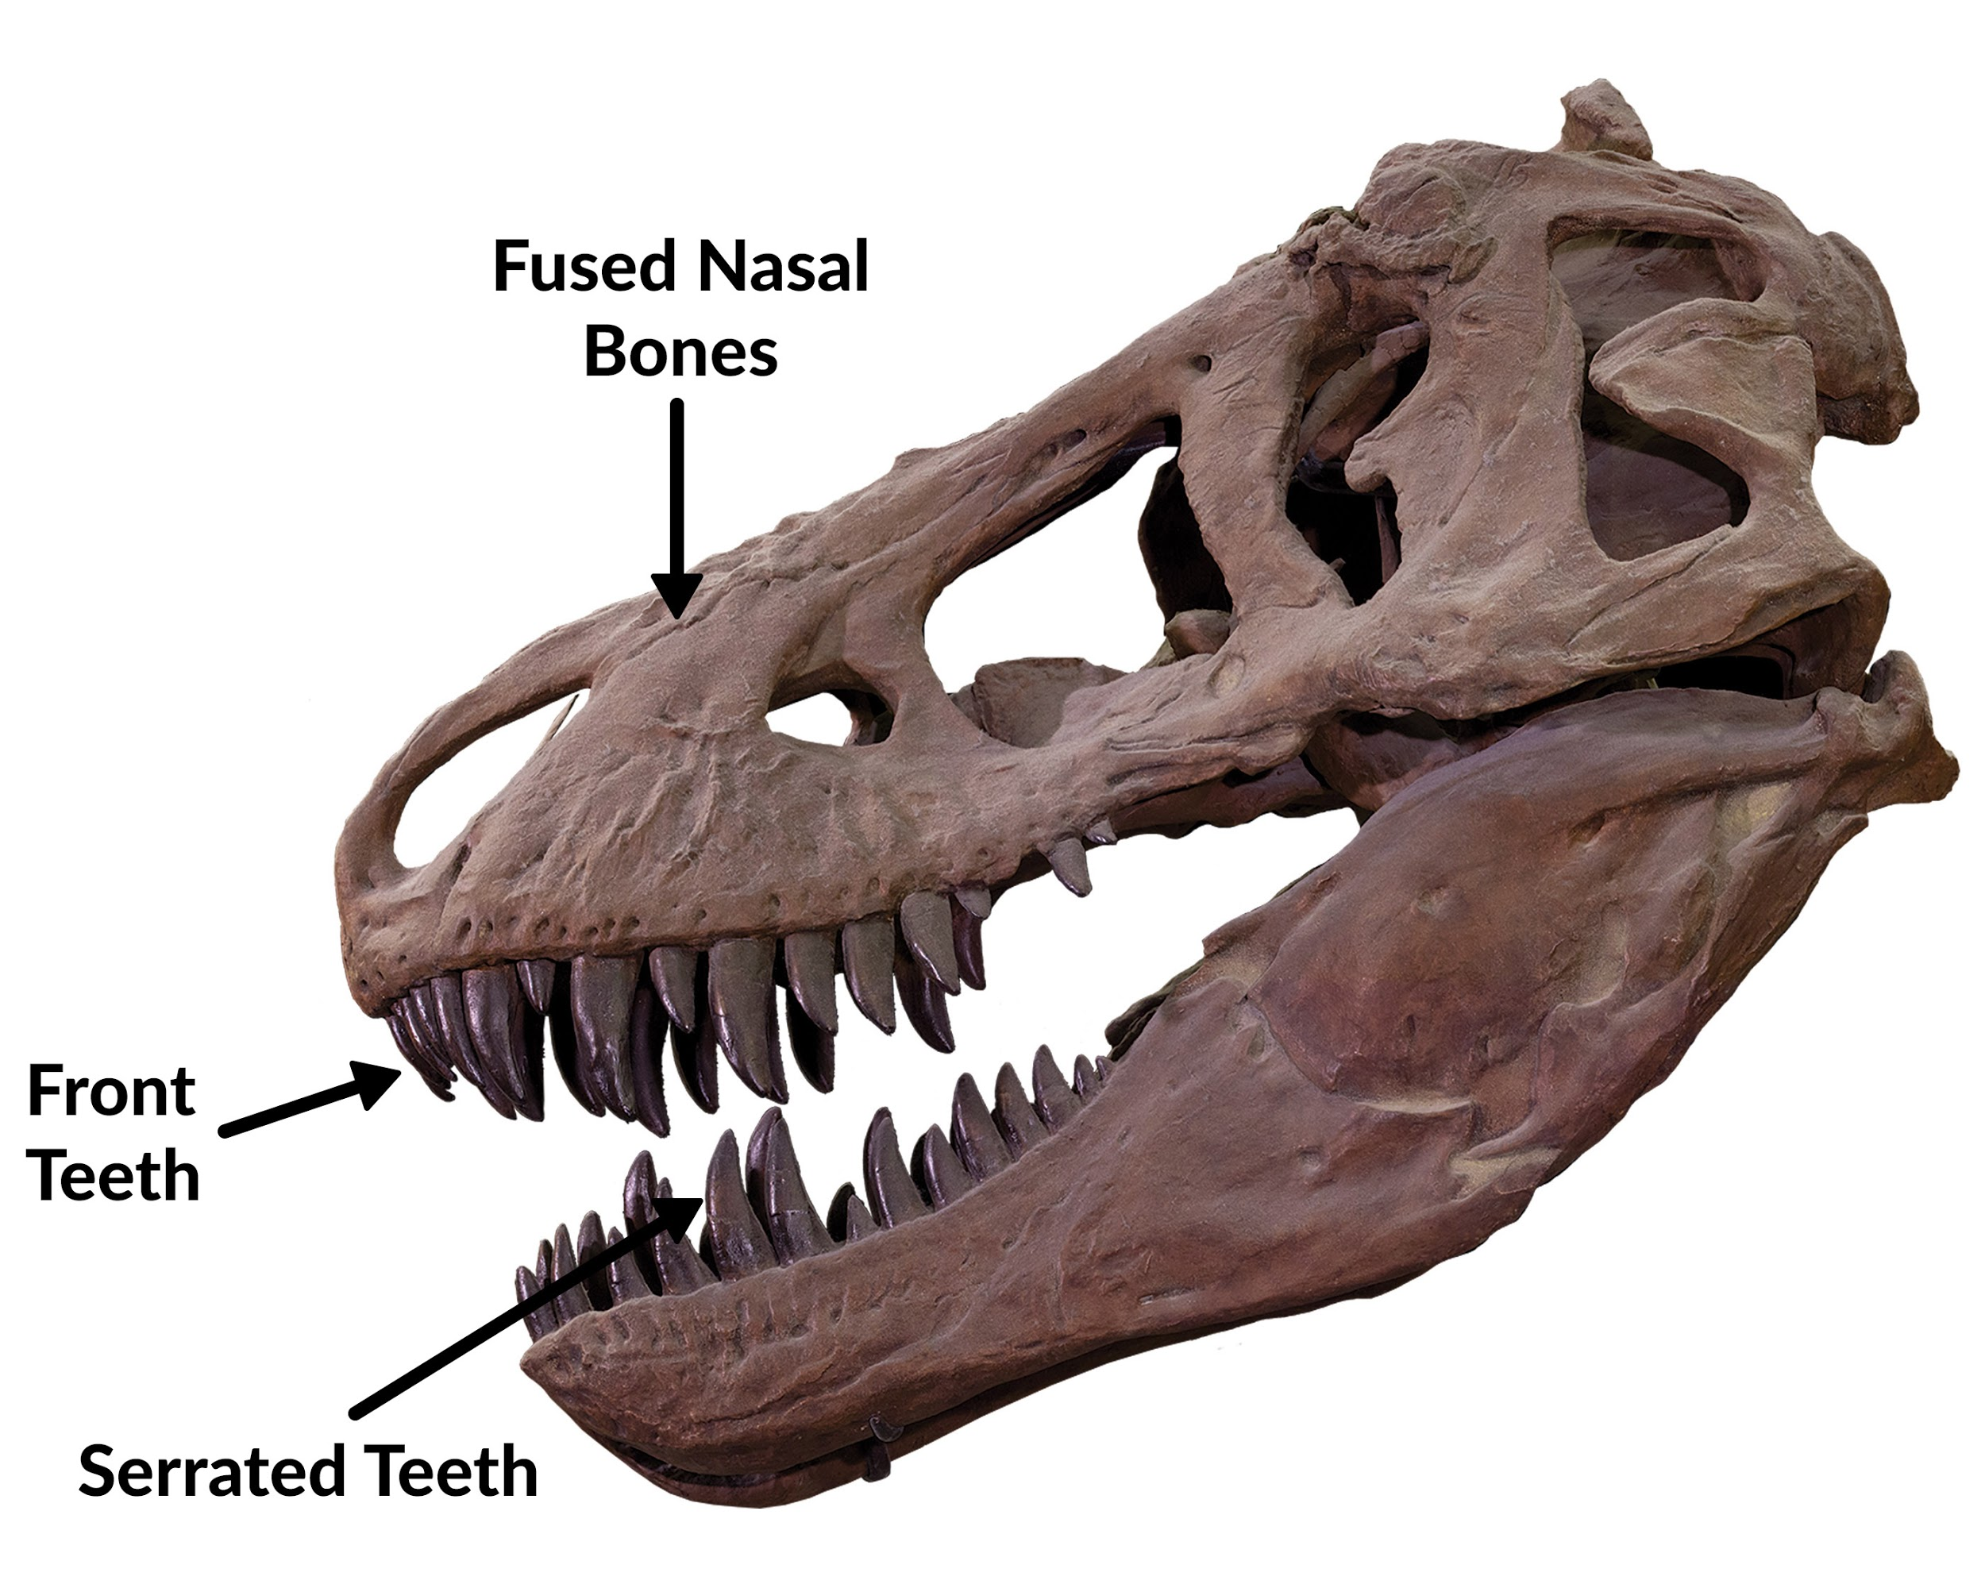
- Observe the “T. rex Traits” wall. Related species often look similar because they share a common ancestor, from whom they inherited similar traits. This is true of tyrannosaurs. What three traits do all tyrannosaurs share? Label them on the skull.

Labels on skull: fused nasal bones; front teeth are D-shaped in cross-section; serrated teeth

- Try the “Tail Balance” interactive and read the “Bodies in Balance” panel. What evidence do scientists use to hypothesize about how T. rex used its tail?

Answers may include: Scientists observe living animals that also use their tails for balance, such as the roadrunner and kangaroo, for clues to how tyrannosaurs like T. rex may have moved. Also, paleontologists can calculate, based on where muscles may have attached to the bone, how strong and big each muscle had to be to move the body.

STOP 2: “Getting Big” Section

- Examine the Tarbosaurus adult skull and juvenile skeleton. Sketch each specimen in the boxes below.

adult skull | juvenile skeleton

Scientists think that Tarbosaurus, like T. rex, lived a very different life as a juvenile than it did as an adult. Compare the adult and juvenile specimens. What does each specimen tell you about how the animal may have hunted at different ages?

Answers may include: The adult was much larger, with heavy, bone-crushing jaws and teeth that were used to eat large animals. The juvenile had a small and agile body, which helped it escape large predators and hunt fast, small animals; it also had thin, bladelike teeth that were good for catching small vertebrates and insects.

STOP 3: “Getting Bad” Section

- Examine fossils of teeth.
Sketch a T. rex tooth.

Read the “Tough Teeth” panel. How do the teeth of modern day lion compare to the teeth of T. rex?

Answers may include: The lion’s fangs are well placed for stabbing and grabbing, while T. rex teeth were well suited for crushing bone.

- Read the “Room at the Top” panel. Scientists think that T. rex was not the only top predator in its ecosystem; it shared this title with Alioramus and Tarbosaurus. How could these animals have coexisted?

Answers may include: Scientists think these dinosaurs, despite all being top predators, probably specialized on different types of prey. They could have avoided direct competition by behavior alone, e.g.: hunting at night or day; hunting alone or in packs; pursuing big, slow animals or small, fast ones.

What are some top predators that coexist today?

Answer: Lion leopard and cheetah.

- Explore the coprolite and related panels. T. rex could digest bone. How do scientists know that?

Answers may include: We know this from the CT scans, X-ray fluorescence, and microprobe analysis of T. rex dung (coprolite). The scans show bone fragments in the coprolite.

STOP 4: “Sensitive Side” Section

- Read the “Eyes of a Killer” panel. T. rex may have seen into the ultraviolet spectrum. What animals living today share a common ancestor with T. rex and can also see into the UV range ?

Answers may include: Birds and crocodiles—the closest living relatives of tyrannosaurs—can see all the colors humans can see, as well as into the UV range of the spectrum (invisible to humans). Tyrannosaurs likely had color vision similar to birds due to genes inherited from a common ancestor.

What are the similarities between the eyes of T. rex and the mountain lion? How does this evidence support the idea that T. rex was a predator?

Answers may include: Both T. rex and the mountain lion have both eyes facing forward. This placement of the eye gives the animal better depth perception for hunting.

- Sketch the Daspletosaurus jawbone and mark the small holes.
What do scientists think these small holes in the jawbone (also found in T. rex) were used for?

Answers may include: Sense organs. Tiny holes on this tyrannosaur skull are nearly identical in number and location to those on an alligator. Alligators have highly sensitive faces; Daspletosaurus likely did as well.

- Read the “Headgear,” “Scales and Feathers,” and the “Hear Me Roar!” sections. Record one interesting information about T. rex appearance or sound

Answers may include:

Scales, crests, or horns could have been attached to the rough surfaces. Many living animals that have horns also have skulls with a rough texture at the place of attachment.

Fossils of T. rex relatives, such as Caudipteryx and Yutyrannus, were found with feathers on their entire bodies. T. rex may have had some feathers.

Scientists study its closest living relatives, crocodiles and birds, as well as other large animals. Larger animals make lower-frequency sounds, so it is likely that T. rex also had a low roar.

Student Worksheet NAME: _______________________________________________

Welcome to the American Museum of Natural History! Fossils show how animals changed over time and how they are related to one another. While fossils also reveal what ancient animals looked like, they keep us guessing about the animals’ colors, sounds, and most of their behavior. So scientists also observe animals living today for clues to what ancient animals may have looked like, how they may have moved and behaved, and how they may have interacted with other animals in the ecosystem.

In the T. rex: The Ultimate Predator exhibition, you will explore similarities and differences between Tyrannosaurus rex, its ancient and living relatives, and other living animals for clues about this predator.

These stops are highlighted in the worksheets:

STOP 1: “Meet the Family” Section

STOP 2: “Getting Big” Section

STOP 3: “Getting Bad” Section

STOP 4: “Sensitive Side” Section

STOP 1: “Meet the Family” Section

- Observe the model of Dilong paradoxus and read the “Fierce and Feathered” panel. Why do scientists think that this animal’s entire body may have been covered with simple feathers?

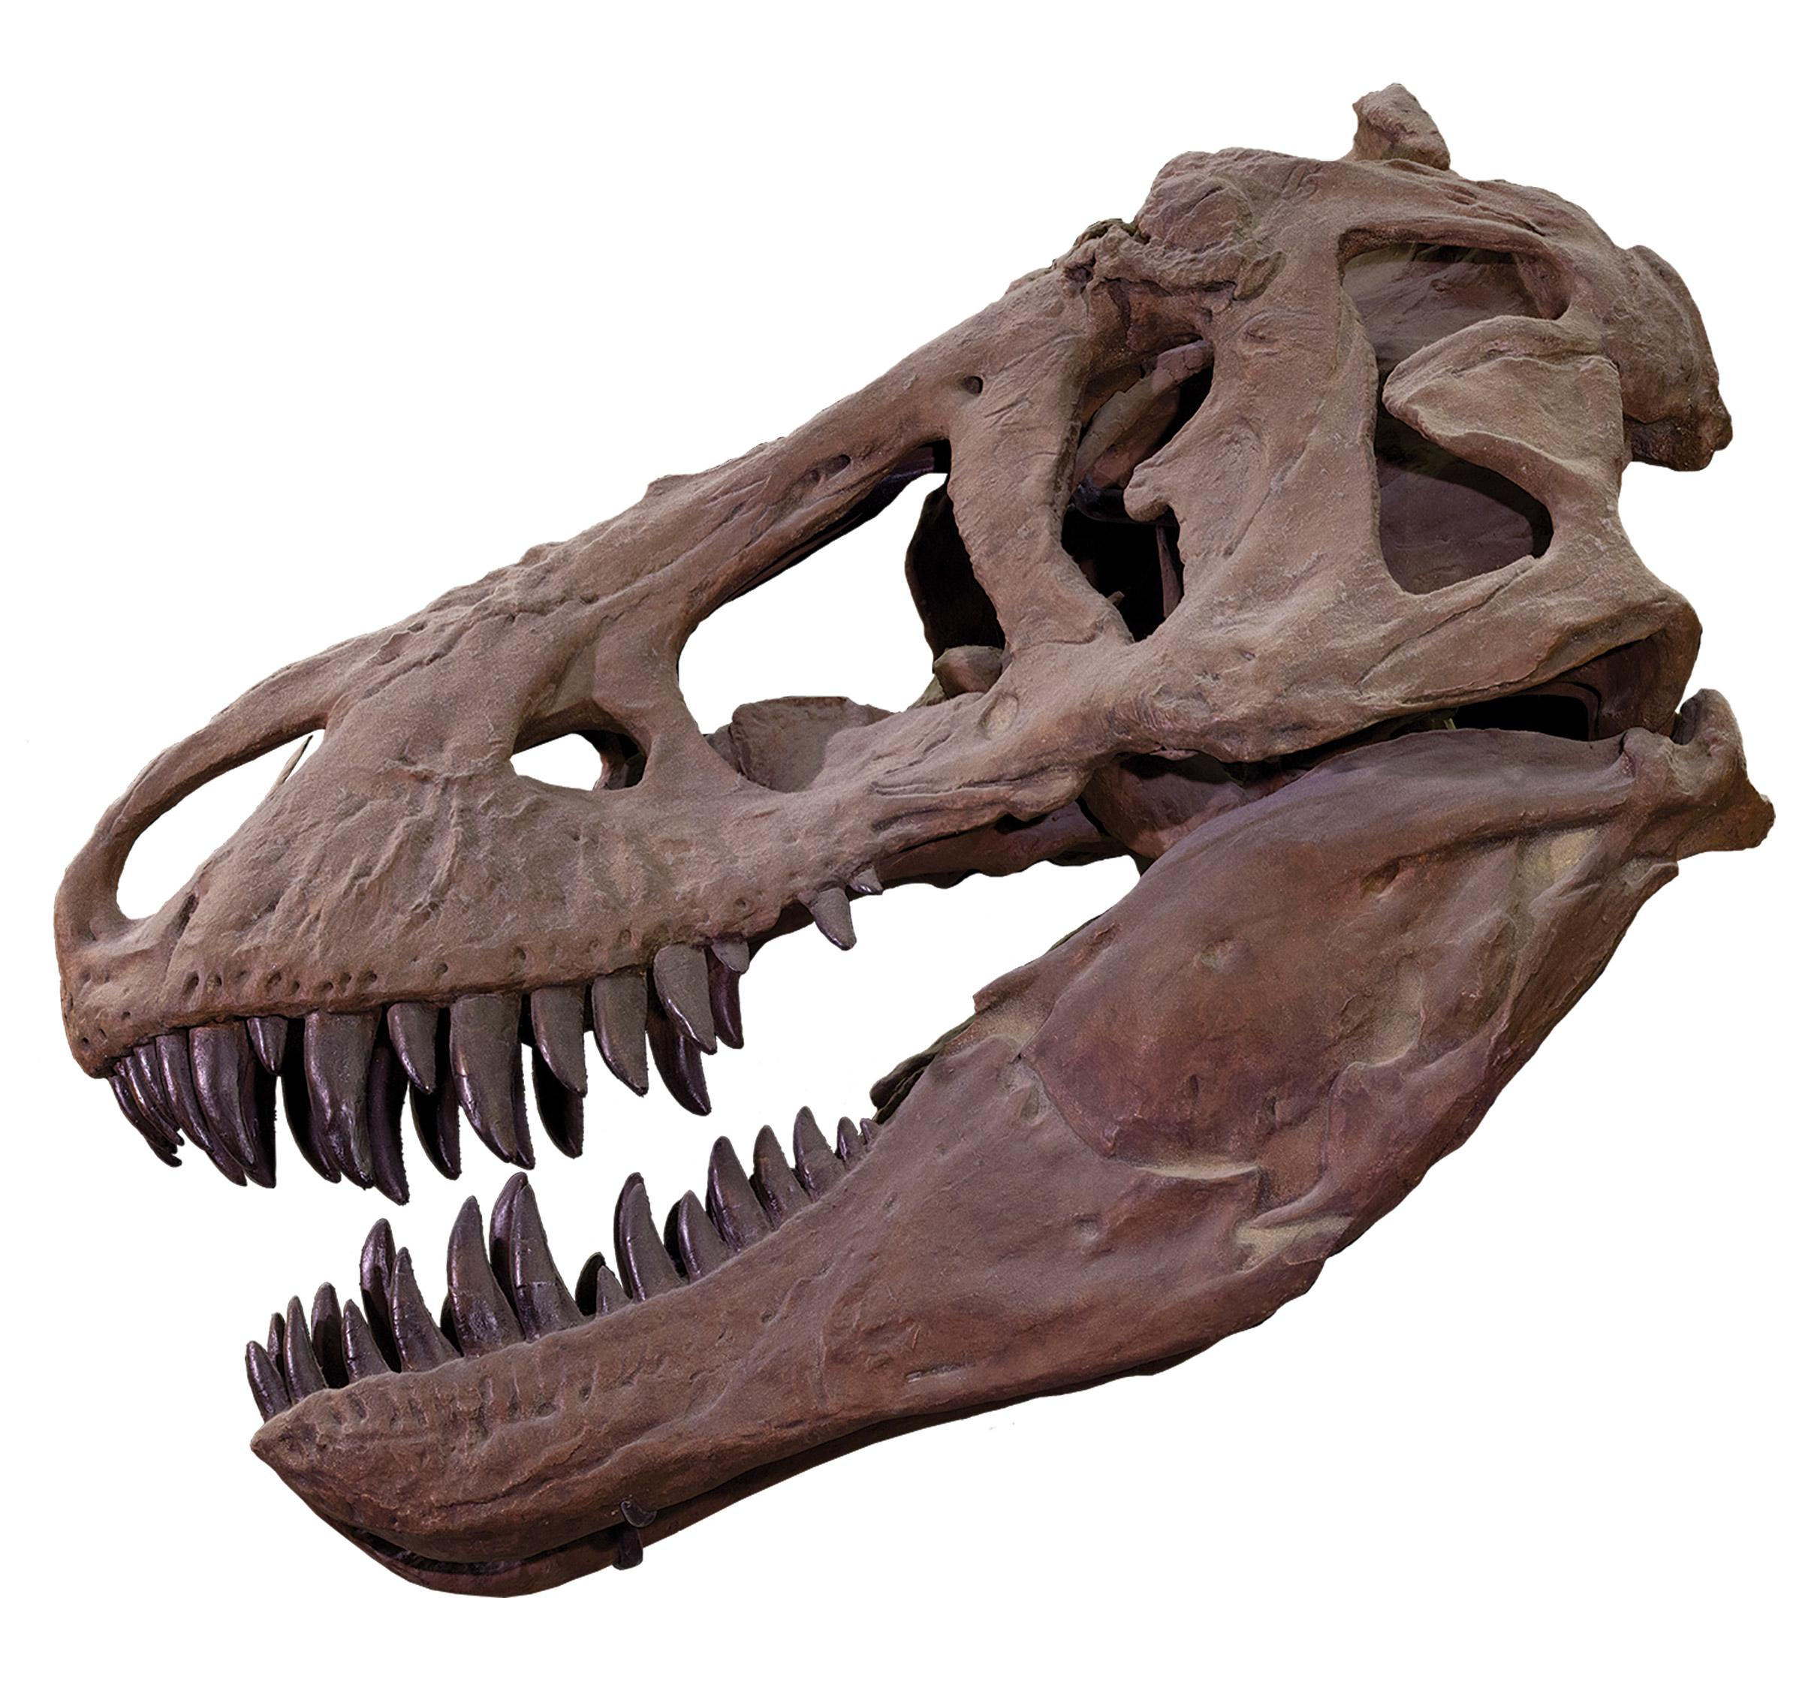

- Observe the “T. rex Traits” wall.
Related species often look similar because they share a common ancestor, from whom they inherited similar traits. This is true of tyrannosaurs. What three traits do all tyrannosaurs share?
Label them on the skull.

- Try the “Tail Balance” interactive and read the “Bodies in Balance” panel. What evidence do scientists use to hypothesize about how T. rex used its tail?

STOP 2: “Getting Big” Section

- Examine the Tarbosaurus adult skull and juvenile skeleton. Sketch each specimen in the boxes below.

adult skull | juvenile skeleton

Scientists think that Tarbosaurus, like T. rex, lived a very different life as a juvenile than it did as an adult. Compare the adult and juvenile specimens. What does each specimen tell you about how the animal may have hunted at different ages?

STOP 3: “Getting Bad” Section

- Examine fossils of teeth.
Sketch a T. rex tooth.

Read the “Tough Teeth” panel. How do the teeth of modern day lion compare to the teeth of T. rex?

- Read the “Room at the Top” panel. Scientists think that T. rex was not the only top predator in its ecosystem; it shared this title with Alioramus and Tarbosaurus. How could these animals have coexisted?

What are some top predators that coexist today?

- Explore the coprolite and related panels. T. rex could digest bone. How do scientists know that?

STOP 4: “Sensitive Side” Section

- Read the “Eyes of a Killer” panel. T. rex may have seen into the ultraviolet spectrum. What animals living today share a common ancestor with T. rex and can also see into the UV range ?

What are the similarities between the eyes of T. rex and the mountain lion? How does this evidence support the idea that T. rex was a predator?

- Sketch the Daspletosaurus jawbone and mark the small holes.

What do scientists think these small holes in the jawbone (also found in T. rex) were used for?

- Read the “Headgear,” “Scales and Feathers,” and the “Hear Me Roar!” sections. Record one interesting information about T. rex appearance or sound

