FIELD GUIDE FOR THE GEOLOGY OF CENTRAL PARK AND NEW YORK CITY
Lab: Rock Identification

Learning Target
- I can make observations about the characteristics of rocks and classify them as igneous, sedimentary, or metamorphic.

Introduction
Geologists classify rocks as igneous, sedimentary, or metamorphic based on a rock’s method of formation. Each group of rocks is further distinguished according to the different textures and compositions of the rocks within that group. Texture does not refer to how a rock feels, but rather the size, shape & arrangement of the materials the rock is composed of. The different textures found within the three major groups of rocks represent distinguishing characteristics that result from their respective process of formation. Using these characteristics, almost any rock sample can be identified as belonging to one of these three groups.

Part I: Using your knowledge of Earth Science, the Rock Cycle in Earth’s Crust diagram on page 6 of the ESRT and the Rock Identification tables on pages 6 & 7 of the ESRT complete the graphic organizer below by identifying the appropriate term in each blank space. Be sure to provide one example of each rock type in the triangles at the bottom.
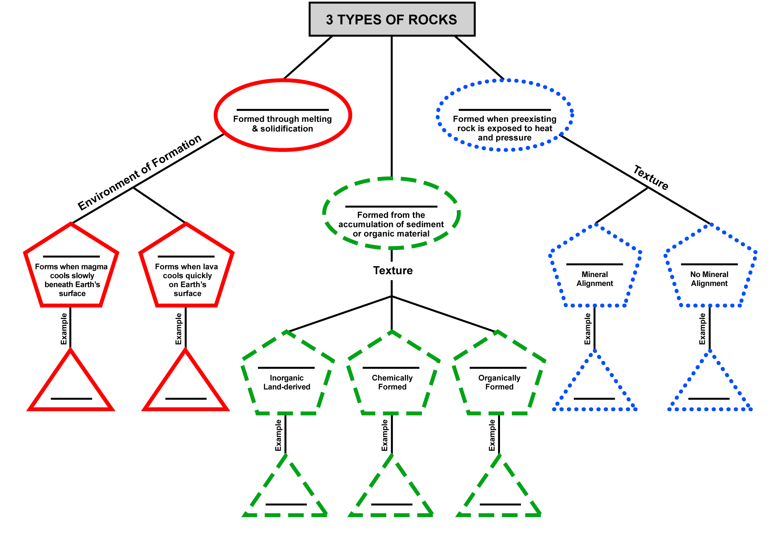

Part II: The table below includes some distinguishing characteristics that can be used to classify a rock into one of the three major groups. Using this table, follow the lab directions to classify the rocks at each station.
I know a rock is... | Igneous | Sedimentary | Metamorphic
if... | it has intergrown crystals | it has horizontal layers | it has folds
if... | it has a glassy texture | it contains fossils | it contains garnets or mica
if... | it has a vesicular texture (gas pockets) | it is composed of fragments or sediments | it has visible mineral alignment (banding)

Station 1 Directions
Step 1: Observe the rock samples.
Step 2: Classify the samples as igneous, sedimentary or metamorphic based on your observations.
Step 3: Using the table above, give at least one piece of evidence to support your classification.
Step 4: Use the clues provided at each station and information in the ESRT to identify the specific rock name.

Station 1:
Sample | Rock Type  (Igneous, Sedimentary, or Metamorphic) | Evidence  (vocabulary from ESRT) | BONUS: Rock Name
A
B
C
D
E
F

Station 2: Barrovian Sequence of Metamorphic Rocks

Instructions: Use the information at your table to identify the correct sample for each rock type. Put the letter of the sample next to the name.
Shale: ______ → Slate: ______ → Phyllite: ______ → Schist: ______ → Gneiss: ______
Some of these rock samples came from New York City. Have you seen any of these rocks in your daily life? If yes, where? If no, why do you think you have not seen them?

________________________________________________________________________________________________________________________________________________________________

Station 3: Texture, Crystal Size, and Environment of Formation (Rate of Cooling)

Sample | Texture | Crystal Size | Environment of Formation
A. | - glassy  - fine  - coarse  - very coarse | - non-crystalline  - less than 1 mm  - 1 mm to 10 mm  - 10 mm or larger | - extrusive (fast cooling)  - intrusive (slow cooling)
B. | - glassy  - fine  - coarse  - very coarse | - non-crystalline  - less than 1 mm  - 1 mm to 10 mm  - 10 mm or larger | - extrusive (fast cooling)  - intrusive (slow cooling)
C. | - glassy  - fine  - coarse  - very coarse | - non-crystalline  - less than 1 mm  - 1 mm to 10 mm  - 10 mm or larger | - extrusive (fast cooling)  - intrusive (slow cooling)
D. | - glassy  - fine  - coarse  - very coarse | - non-crystalline  - less than 1 mm  - 1 mm to 10 mm  - 10 mm or larger | - extrusive (fast cooling)  - intrusive (slow cooling)

Station 4: Clastic Sedimentary Rock

Instructions: Use the information at your table to identify the correct sample for each rock type. Put the letter of the sample next to the name.
Conglomerate: ______ → Sandstone: ______ → Siltstone: ______ → Shale: ______

Station 5: Geologic Interpretation

Instructions: Use the diagram at your table to answer the following questions.
Which rock formation was originally limestone? How do you know?

What process changed it from a sedimentary rock to a metamorphic rock?

The rock types shown on the left side of this geologic cross section were mainly the result of
- heat and pressure exerted on previously existing rock
- melting and solidification of crustal rocks at great depths
- tectonic plate boundaries diverging at the mid-ocean ridge
- compaction and cementation of sediments under ocean waters

The portion of the Palisades sill that contains large crystals of plagioclase feldspar and pyroxene is considered to be similar in texture and composition to
- obsidian
- granite
- basalt glass
- gabbro

Comprehension Questions:

- Rocks are classified as igneous, sedimentary or metamorphic. How do geologists classify a rock into one of these three major groups?
________________________________________________________________________________________________________________________________________________________________________________________________________________________________________________
- Igneous rocks are further distinguished based on the environment of formation of the rock, and therefore classified as either intrusive or extrusive. Describe at least two differences between intrusive and extrusive igneous rocks.
________________________________________________________________________________________________________________________________________________________________________________________________________________________________________________
- Sedimentary rocks are further distinguished based on texture. There are three major classifications of sedimentary rocks based on texture: clastic, crystalline, and bioclastic. Clastic sedimentary rocks are those composed of inorganic sediment cemented together. What characteristic makes the clastic sedimentary rocks distinguishable from one another? In other words, what makes sandstone different from shale?
________________________________________________________________________________________________________________________________________________________________________________________________________________________________________________
- Metamorphic rocks are further distinguished by texture. On this basis, metamorphic rocks are classified as either foliated or non-foliated. Describe the difference between these two types of metamorphic texture.
________________________________________________________________________________________________________________________________________________________________________________________________________________________________________________
- Fossils are the remains of living organisms. Fossils are only found in sedimentary rocks. Explain why fossils are not found in igneous or metamorphic rocks. Hint: think about the method of formation for each type of rock.
________________________________________________________________________________________________________________________________________________________________________________________________________________________________________________

- Based on what we have learned about rocks, what would finding the following rock types tell us about the environment in which they formed?
Sedimentary: ___________________________________________________________________
Igneous: ______________________________________________________________________
Metamorphic: __________________________________________________________________

Station 1: Rock Identification

Step 1: Observe the rock samples.
Step 2: Classify the samples as igneous, sedimentary or metamorphic based on your observations.
Step 3: Using the table below, give at least one piece of evidence to support your classification.
Step 4: Use the clues provided at each station and information in the ESRT to identify the specific rock name.

I know a rock is... | Igneous | Sedimentary | Metamorphic
if... | it has intergrown crystals | it has horizontal layers | it has folds
if... | it has a glassy texture | it contains fossils | it contains garnets
if... | it has a vesicular texture (gas pockets) | it is composed of fragments or sediments | it has visible mineral alignment (banding)

Station 2: Barrovian Sequence of Metamorphic Rocks

The best known and most commonly seen metamorphic rocks are those produced by Barrovian (also called regional) metamorphism. Beginning with a shale parent, Barrovian metamorphism produces a sequence of metamorphic rocks that goes through slate, and then through phyllite, schist, and gneiss. It can be hard to imagine at first that all these very different looking rocks can come from the same sedimentary parent, but we know that they do based on evidence found in the rock record around the world.

Line up the rocks at this station in the following order:

Shale------------Slate------------Phyllite------------Schist------------Gneiss

Fill in the number of the correct rock sample on your lab for each rock type.

Hints
Shale | Slate | Phyllite | Schist | Gneiss
a fine-grained sedimentary rock comprised of clay particles. | a fine-grained, foliated metamorphic rock that is created by the alteration of shale or mudstone by low-grade regional metamorphism. Most slates are gray in color and range in a continuum of shades from light to dark gray.  Slate has a dull luster, it can be split into thin sheets along the parallel mineral alignments. | a foliated metamorphic rock that is made up mainly of very fine-grained mica. The surface of phyllite is typically lustrous or silky and sometimes wrinkled. It is intermediate in grade between slate and schist | a foliated metamorphic rock made up of plate-shaped mineral grains that are large enough to see with an unaided eye. Mica schist is easily identifiable due to its sparkly appearance which results from the platy muscovite mica crystals in its composition. | a high-grade metamorphic rock in which mineral grains recrystallized under intense heat and pressure. This alteration increased the size of the mineral grains and segregated them into bands, a transformation which made the rock and its minerals more stable in their metamorphic environment. Gneiss is a foliated metamorphic rock identified by its bands.

Station 3: Texture, Crystal Size, and Environment of Formation (Rate of Cooling)

The samples at this station show various igneous textures from glassy to very coarse. Geologists use the texture of a rock sample to determine its environment of formation (rate of cooling). Use the chart below to determine the texture, crystal size, and rate of cooling for each of the samples.

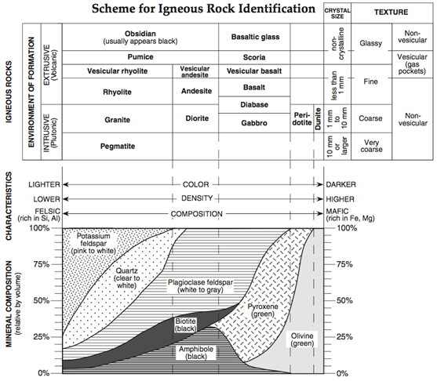

Station 4: Clastic Sedimentary Rocks

Clastic sedimentary rocks are rocks composed of sediment that has been compacted and cemented. All clastic sedimentary rocks have the same mineral composition. What makes these clastic sedimentary rocks different from one another is the grain size of the sediment that they are composed of.

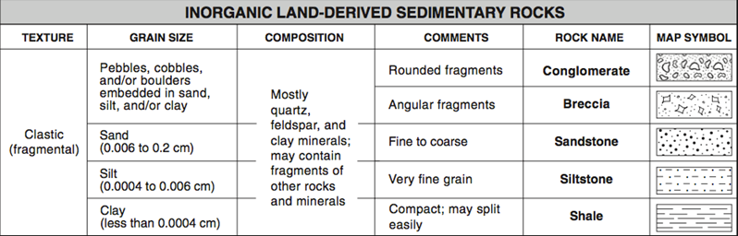

Line up the rocks at this station according to grain size,
from the largest grain size to the smallest.
Conglomerate------------Sandstone------------Siltstone------------Shale

Fill in the number of the correct rock sample on your lab for each rock type.

Station 5: Geologic Interpretation

Clastic sedimentary rocks are rocks composed of sediment that has been compacted and cemented. All clastic sedimentary rocks have the same mineral composition. What makes these clastic sedimentary rocks different from one another is the grain size of the sediment that they are composed of.

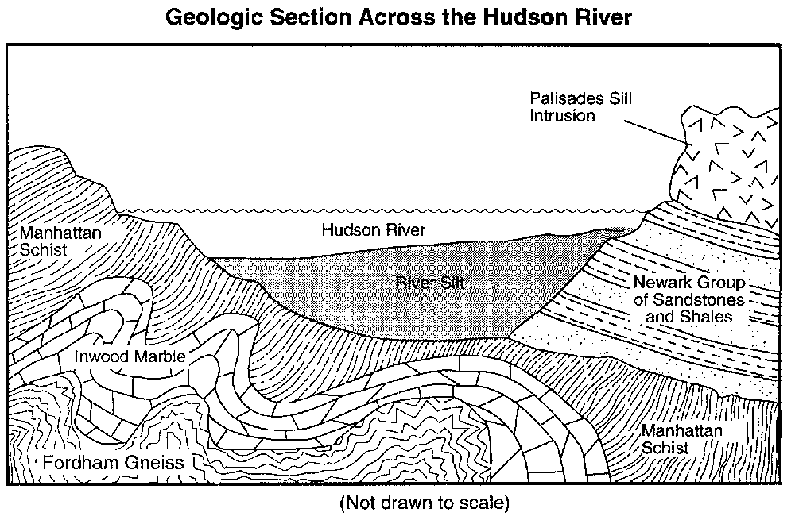
Use this diagram and your understanding of rock formation
to answer questions about local geology.

