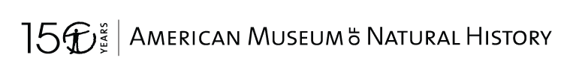  Field Guide for  The Geology of  Central Park and  New York City  FIELD JOURNAL  © 2022 American Museum of Natural History. All rights reserved | 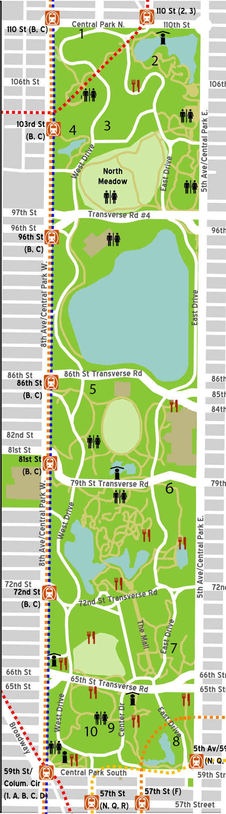

• STOP 1: This stop is known as 110th Street.

What kind of rock is this?

What minerals do you see?

Is there any evidence of past glacial activity here?

Observations:
Inferences:

• STOP 2: This stop is known as Harlem Meer.

How many rock types are here?

What kind of rock (or rocks) is this?

How might these rocks have formed?

Observations:
Inferences:

• STOP 3: This stop is known as the Loch.

What kind of rock is this?

What minerals can you see in this rock?

How might these rocks have formed?

Observations:
Inferences:

• STOP 4A: This stop is known as the Pool (A).

How does this rock relate to other rocks in Central Park?

How might it have gotten here?

Observations:
Inferences:

• STOP 4B: This stop is known as the Pool (B).

How many rock types are here?

What do cross-cutting relationships tell us about how this rock formed?

Observations:
Inferences:

• STOP 5: This stop is known as the Rock of No Hope.

How many rock types are at this outcrop?

What kind of rock (or rocks) is this?

How might the rocks here have formed?

What kinds of structures are present in the rocks?

Observations:
Inferences:

• STOP 6: This stop is known as E79th Street (Cedar Hill).

What kind of rock (or rocks) is this?

How might the rocks here have formed?

What kinds of structures are present in the rocks?

Observations:
Inferences:

• STOP 7: This stop is known as the Rouche Mountonee.

What kind of rock is this?

What evidence of past glacial activity do we see here?

What direction did the ice move?

Observations:
Inferences:

• STOP 8: This stop is known as Overlook Rock.

What kind of rock (or rocks) is this?

How might the rocks here have formed?

What kinds of structures are present in the rocks?

Observations:
Inferences:

• STOP 9: This stop is known Heckscher Playground.

How does this rock relate to other rocks in Central Park?

How might it have gotten here?

Observations:
Inferences:

• STOP 10: This stop is known as Umpire Rock.

What kind of rock (or rocks) is this?

How might the rocks here have formed?

What kinds of structures are present in the rocks?

Observations:
Inferences:

