Full Name_________________________ Class___________ Date_________
Investigation Booklet
Setting the Stage & the Scientific Process in Action

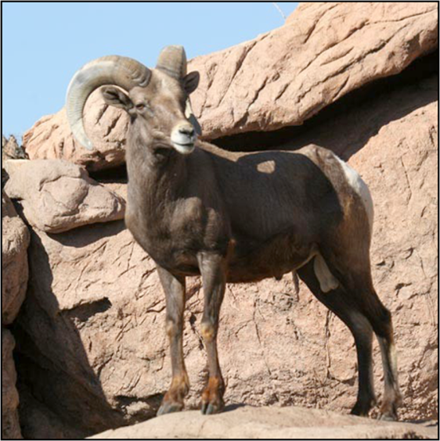

Lesson 1: Setting the Stage & the Scientific Process in Action

1. What is the research question for this unit?

2. What geographic area defines each bighorn sheep population?

3. How have people changed bighorn sheep habitat and what is the economic motivation for making these changes?

4. How do highways affect mating between different sheep populations?

5. Clinton Epps made this statement in the video:

I have to be able to see the landscape to visualize the important questions. I have to experience the landscape to really be able to think well about what I want to study, how I want to study— I can’t do that studying at a desk.

Why do you think he feels this way?

Use the population breeding activity as your guide to answer the next two questions (refer to the diagram of three populations with three geometric shapes):

6. Use Xs and Os as your alleles to draw two populations that show high levels of breeding.

7. Use Xs and Os as your alleles to draw two populations that show low levels of breeding.

