Boundaries and Isolation discussion
This discussion explores the difference between natural and human-made boundaries and their effect on isolated populations.

Discussion

Key Idea: Boundaries can be natural or human-made.

Question: What are some boundaries with which you are familiar? Are they Natural? Are they human-made? Or both?
Answers: (The following examples are taken from some northeastern and mid-Atlantic states.)
- Natural Boundaries:
  - National
    - Lake Ontario separates Buffalo from Toronto.
  - State
    - New York State from New Jersey by the Hudson River.
    - New Jersey from Pennsylvania by the Delaware River.
  - New York City - Water is a natural barrier that defines the different boroughs.
      - Staten Island is separated from all the other boroughs by the New York New Jersey Harbor Estuary,
      - Brooklyn from Queens by the Newtown Creek,
      - Manhattan from Queens and Brooklyn by the East River,
      - Manhattan from the Bronx by the Harlem River.
      - The case of Marble Hill: It defies the boundary made by water. Marble Hill is a neighborhood in the borough of Manhattan that sits on the other side of the Harlem River connected to the Bronx. What happened? At one point the Harlem River flowed north of Marble Hill, but people rerouted the River, cutting off Marble Hill from the rest of the borough, but linking it to the Bronx. (see figure below left).

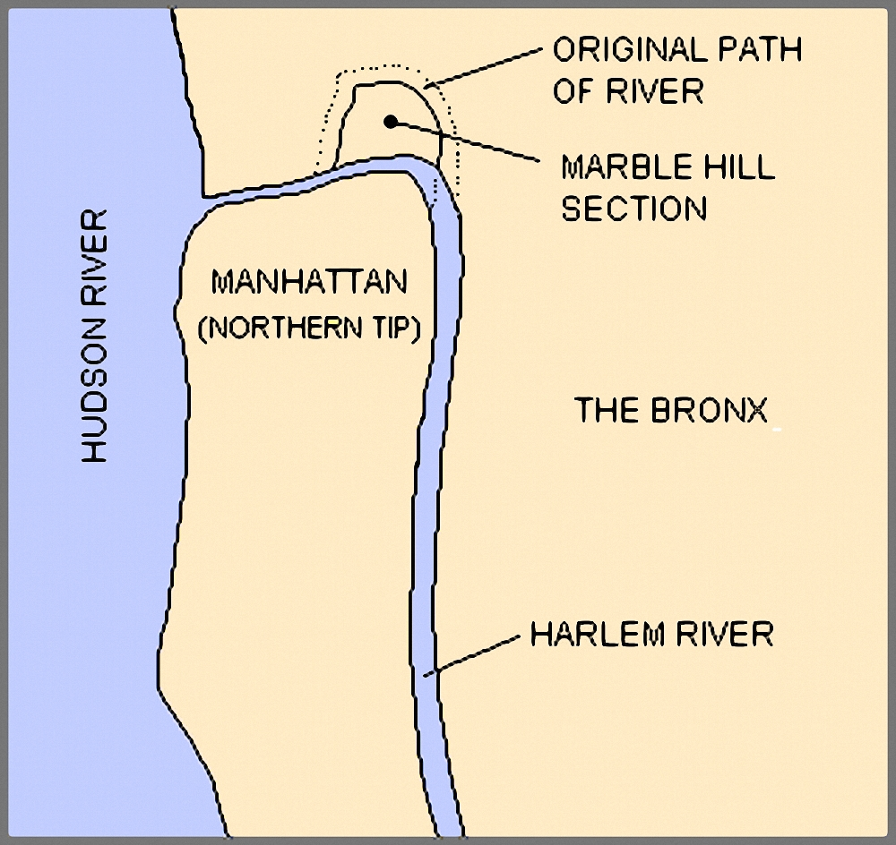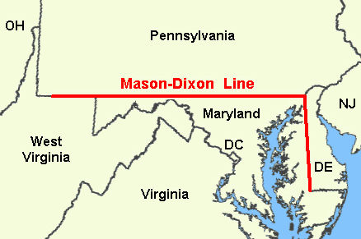

- Human-Made Boundaries
  - Some of the US border with Mexico or Canada
  - The rectangular boundaries of the Western states as compared to the jagged borders of the original 13 colonies.
  - Mason Dixon Line is a line that beginning in 1820 began to be seen as marking the cultural boundary between northern and southern states. States north of the line were considered to be northern and states south of the line were considered to be southern (see figure above right).

Question: What are some boundaries in your neighborhood? What marks the borders of where you walk? Is there a big road, a highway, train tracks, a park, a large open space, a big building, water, or something else that limits your movement in your neighborhood?
Answer: Answers will vary depending upon their neighborhood. For example, in New York City, big cross streets like Houston St, 14th St, 34th St. etc. can act as barriers to movement. Hills can also act as borders. Big highways like the Cross Bronx or the BQE are also barriers. Parks often separate neighborhoods too.
Map of Manhattan Courtesy of GFDL

Map of Mason-Dixon Line Courtesy of United States Department of the Interior

Extension

Key Idea: Just like habitats, neighborhoods can be separated from each other by imperceptible boundaries.

Instructions: Get into a group with 3 other students that live in your neighborhood. Discuss the different boundaries of your neighborhood, and then present your ideas to the class. Maps are a great way to represent your ideas to the class. [You can draw the boundaries of your neighborhood.]

Discussion

Key idea: Artificial boundaries can decrease mate choice and isolation.

Question: If you and your neighbors never crossed out of the boundary of your neighborhood and people in nearby neighborhoods did the same, how would that affect the people in your neighborhood?
Answers: It would limit food, mate, and entertainment choices. People would be isolated.

Question: Why is it so bad for populations to be isolated? How would you feel about only being allowed to date the people in this class?
Answers: Limited mate choice – bad for people and other animals! Limited mate choice can lead to having to pick less attractive and/or less healthy mates.

Key Idea: Highways act as barriers preventing the movement of bighorn sheep, leading to limited mate choice.

Question: So we think isolated populations can lead to limited mate choice. How might highways limit mate choice in the bighorn sheep?
Answers: Highways act as barriers to the movement of bighorn sheep between mountaintops. Sheep have limited mate choice because they cannot cross highways to find new mates.

