Full Name ___________________________ Class _______ Date ________

Investigation Booklet
Setting the Stage

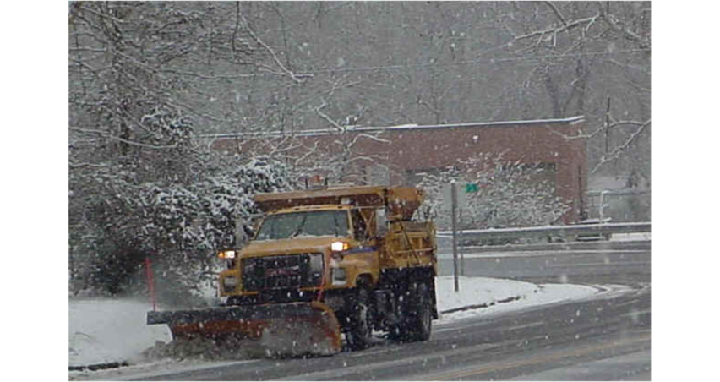

1. What is the research question for this unit?

2. What is the purpose of using salt in relation to the quality of life for people?

3. What was Dr. Sujay Kaushal’s motivation for doing this research?

4. During snowy and icy months, which nearby streams do you think will have the highest levels of salt: urban, suburban, or forested? Why?

