Full Name ___________________________ Class _______ Date ________

Investigation Booklet
Setting the Stage

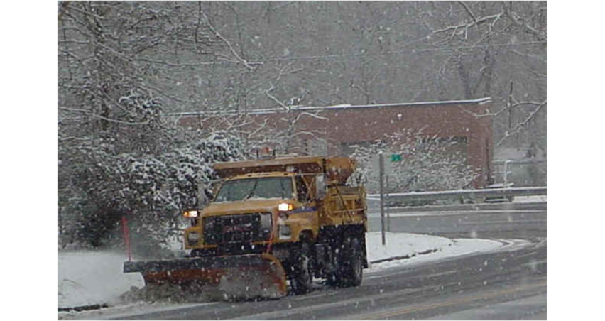

1. What is the research question for this unit?

How might snowy and icy roads affect Baltimore area’s water supply?

2. What is the purpose of using salt in relation to the quality of life for people?

Humans use salt to melt snow and ice to decrease the number of car accidents and make travel during snowy and icy times easier.

3. What was Dr. Sujay Kaushal’s motivation for doing this research?

Dr. Kaushal felt connected to streams and water since his early childhood in rural Tennessee when he hiked up his local stream to discover its headwaters. As an adult, he began to look more closely at the power of stream water. He saw how even small streams can move large items such as motorcycles, which caused him to begin think about how water moves other smaller materials like salt into streams and rivers.

4. During snowy and icy months, which nearby streams do you think will have the highest levels of salt: urban, suburban, or forested? Why?

Urban areas because they have a lot of roads and a lot of people, so they will use more salt during winter months.

