Seasonal Average Salt Levels
in an Urban Area Baltimore County Stream

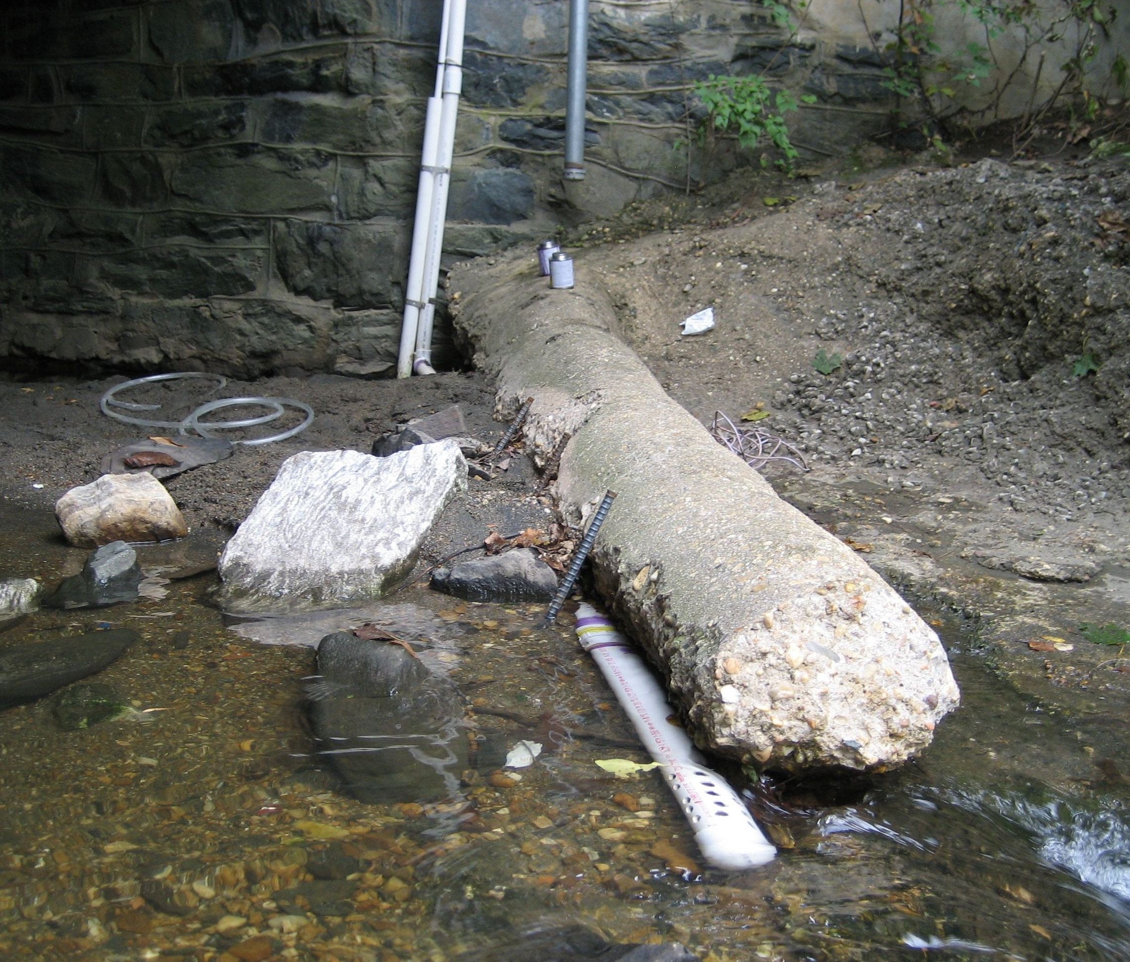
USGS

Dead Run at Franklintown, MD

Population density:
8050 people/mile²

Year | Season | Average Salt Content in mg/L
2001 | winter | 668.40
2001 | spring | 157.91
2001 | summer | 91.46
2001 | fall | 131.04
2002 | winter | 504.91
2002 | spring | 137.46
2002 | summer | 107.15
2002 | fall | 292.55
2003 | winter | 1033.70
2003 | spring | 216.22
2003 | summer | 120.85
2003 | fall | 239.08
2004 | winter | 1346.58
2004 | spring | 169.75
2004 | summer | 146.72
2004 | fall | 168.08
2005 | winter | 1774.62
2005 | spring | 523.39
2005 | summer | 174.14
2005 | fall | 615.38
2006 | winter | 565.31
2006 | spring | 913.23
2006 | summer | 530.22
2006 | fall | 141.43
2007 | winter | 1039.32
2007 | spring | 378.62
2007 | summer | 530.22
2007 | fall | 141.43
2008 | winter | 681.67
2008 | spring | 216.52
2008 | summer | 168.36
2008 | fall | 183.44
2009 | winter | 1907.54
2009 | spring | 273.54
2009 | summer | 530.22
2009 | fall | 141.43
2010 | winter | 1170.27
2010 | spring | 244.50

