Seasonal Average Salt Levels
in a Suburban Area Baltimore County Stream

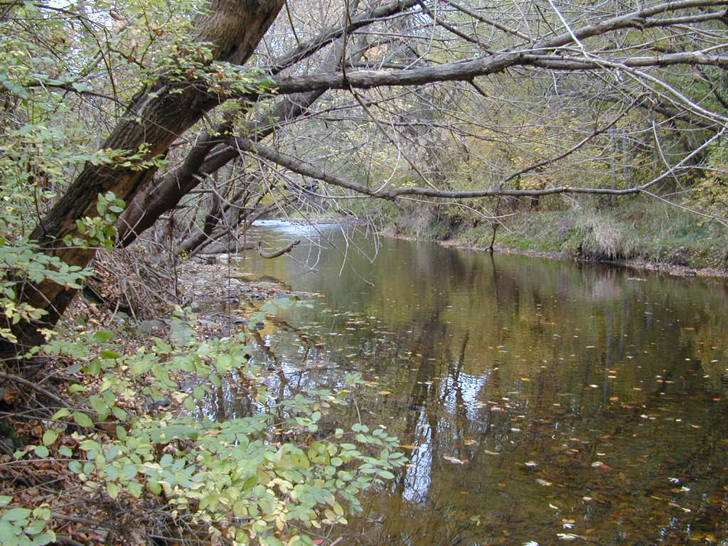
USGS

Gwynns Falls near Villa Nova Road, MD

Population density:
3000 people/mile²

Year | Season | Average Salt Content in mg/L
2001 | winter | 171.89
2001 | spring | 45.61
2001 | summer | 39.69
2001 | fall | 39.38
2002 | winter | 183.23
2002 | spring | 50.38
2002 | summer | 42.08
2002 | fall | 77.08
2003 | winter | 242.00
2003 | spring | 68.31
2003 | summer | 48.69
2003 | fall | 63.46
2004 | winter | 274.57
2004 | spring | 64.54
2004 | summer | 53.23
2004 | fall | 58.07
2005 | winter | 419.62
2005 | spring | 78.85
2005 | summer | 61.42
2005 | fall | 156.00
2006 | winter | 199.49
2006 | spring | 78.58
2006 | summer | 65.72
2006 | fall | 65.12
2007 | winter | 256.04
2007 | spring | 120.95
2007 | summer | 71.72
2007 | fall | 65.12
2008 | winter | 221.42
2008 | spring | 81.03
2008 | summer | 72.80
2008 | fall | 75.88
2009 | winter | 470.16
2009 | spring | 100.78
2009 | summer | 80.55
2009 | fall | 76.62
2010 | winter | 470.13
2010 | spring | 100.26

