Seasonal Average Salt Levels
in a Forested Area Baltimore County Stream

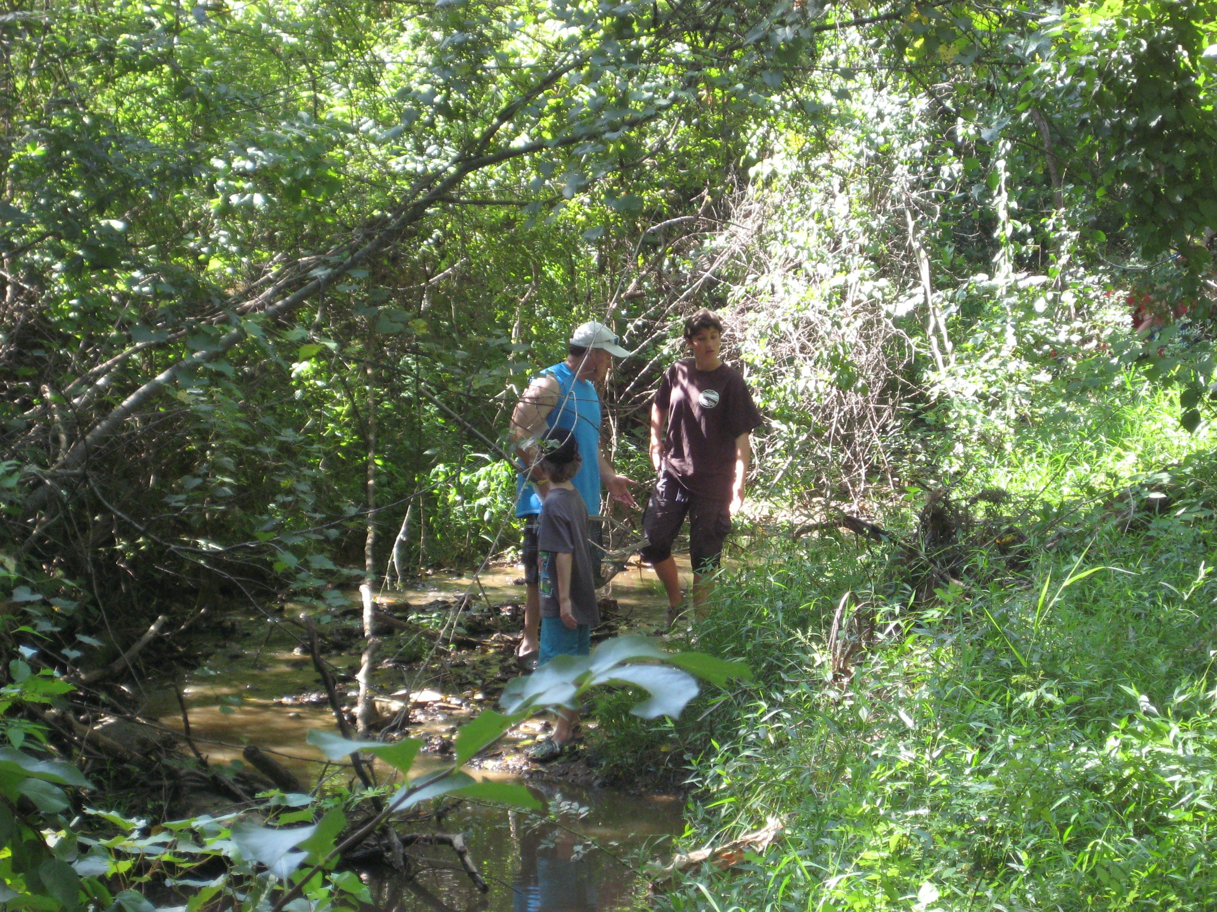
USGS

Pond Branch at Oregon Ridge, MD

Population density: 0 people/mile²

Year | Season | Average Salt Content in mg/L
2001 | winter | 2.77
2001 | spring | 2.66
2001 | summer | 2.88
2001 | fall | 2.38
2002 | winter | 2.14
2002 | spring | 2.01
2002 | summer | 3.06
2002 | fall | 2.52
2003 | winter | 3.19
2003 | spring | 2.36
2003 | summer | 2.64
2003 | fall | 2.66
2004 | winter | 2.72
2004 | spring | 2.71
2004 | summer | 3.02
2004 | fall | 2.73
2005 | winter | 2.71
2005 | spring | 2.64
2005 | summer | 2.79
2005 | fall | 2.50
2006 | winter | 2.43
2006 | spring | 2.62
2006 | summer | 2.77
2006 | fall | 2.65
2007 | winter | 2.69
2007 | spring | 2.72
2007 | summer | 3.18
2007 | fall | 2.93
2008 | winter | 2.83
2008 | spring | 2.69
2008 | summer | 3.10
2008 | fall | 2.82
2009 | winter | 3.10
2009 | spring | 2.92
2009 | summer | 3.11
2009 | fall | 2.92
2010 | winter | 2.82
2010 | spring | 2.81

