 | Forested Area | Suburban Area | Urban Area
 | Population Density  0 people/mile² | Population Density  3000 people/mile² | Population Density  8050 people/mile²
 | 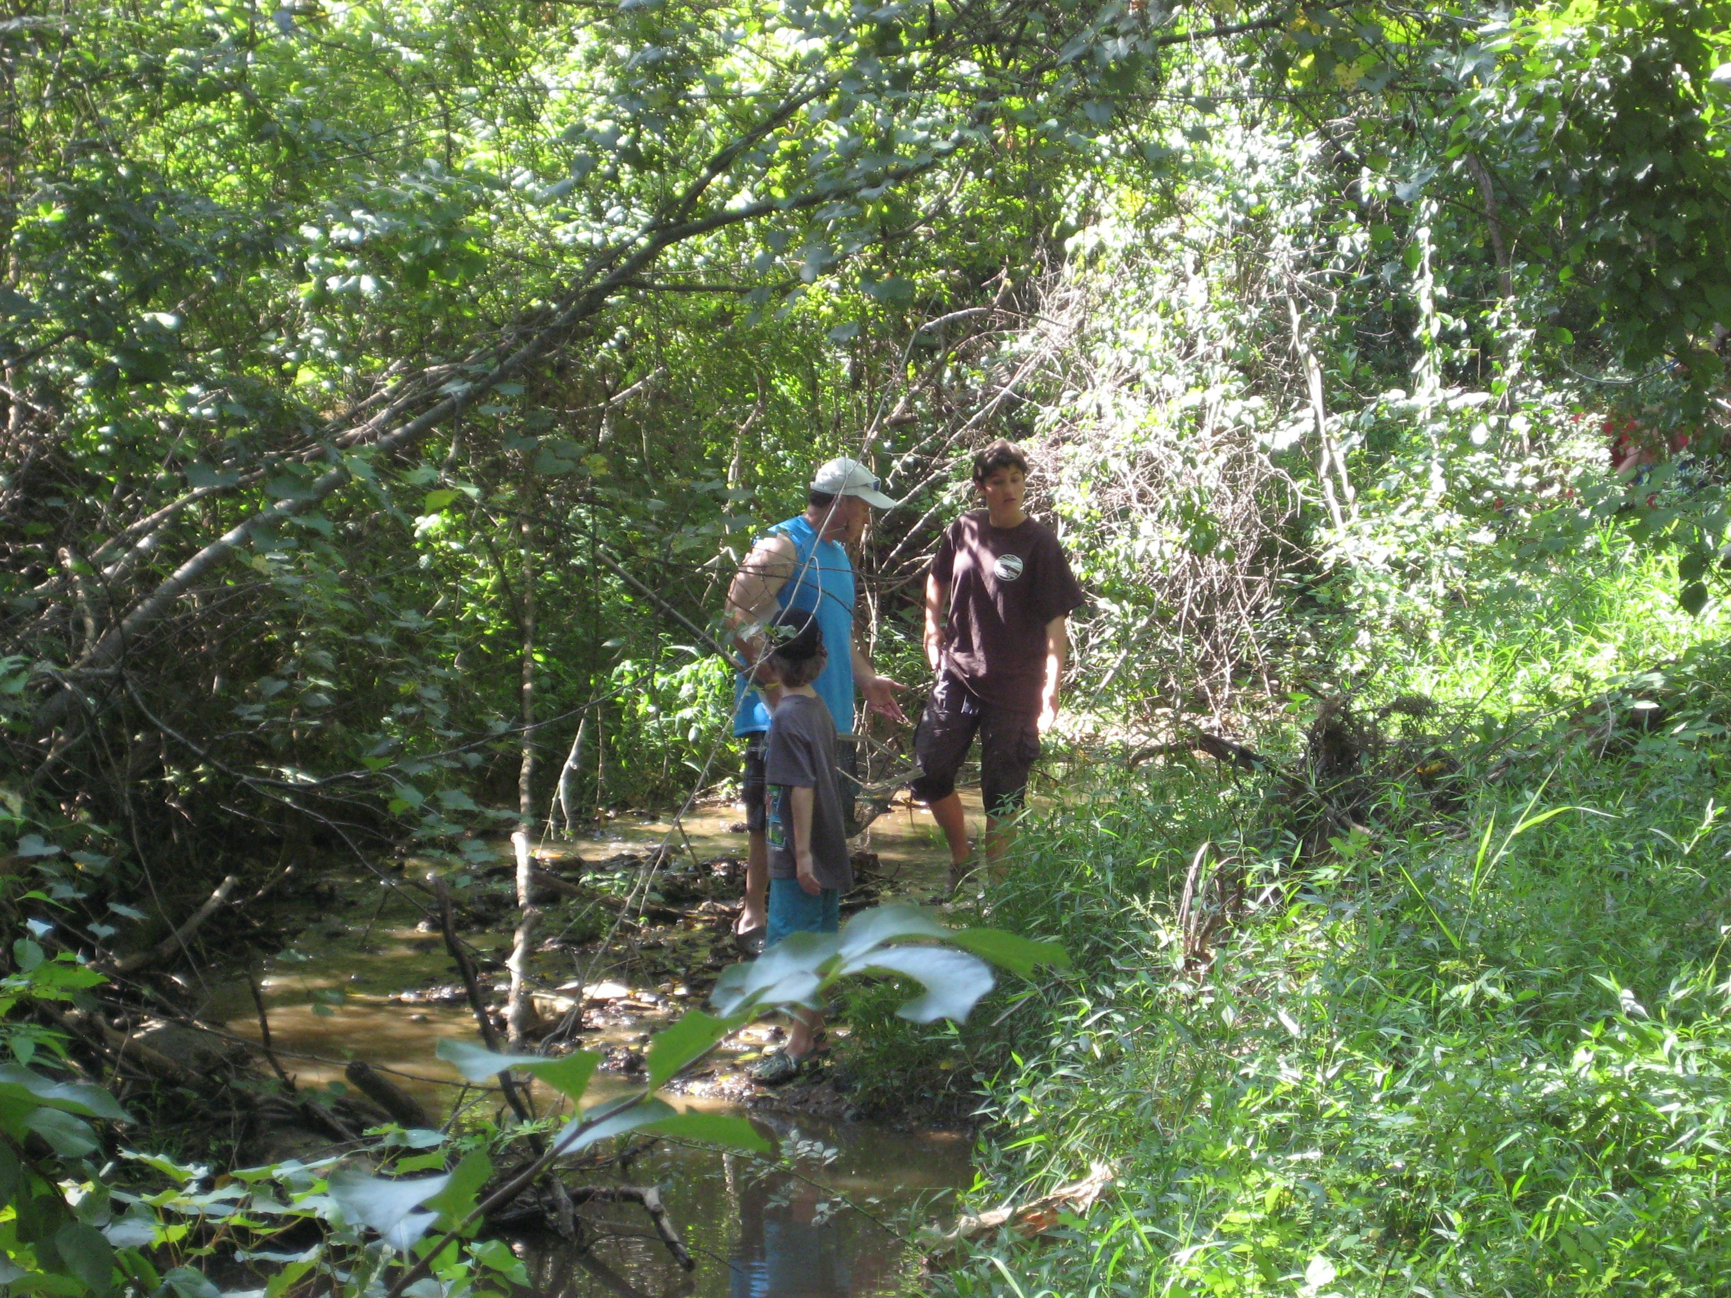  USGS | 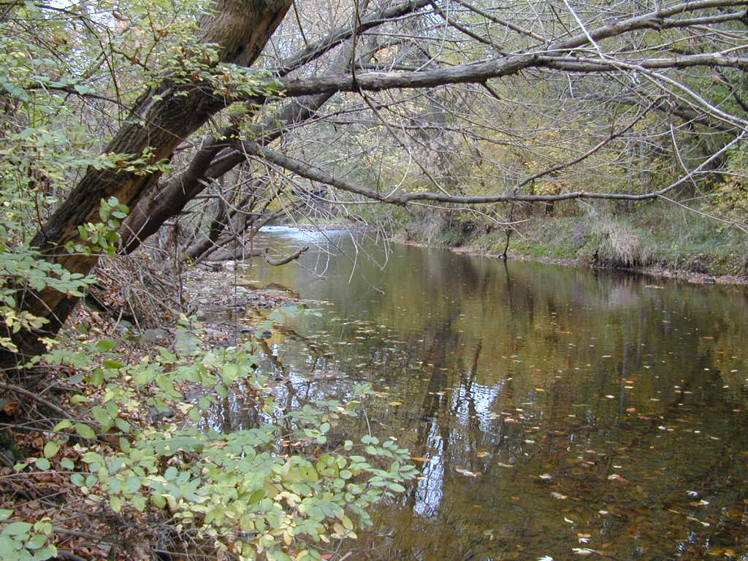  USGS | 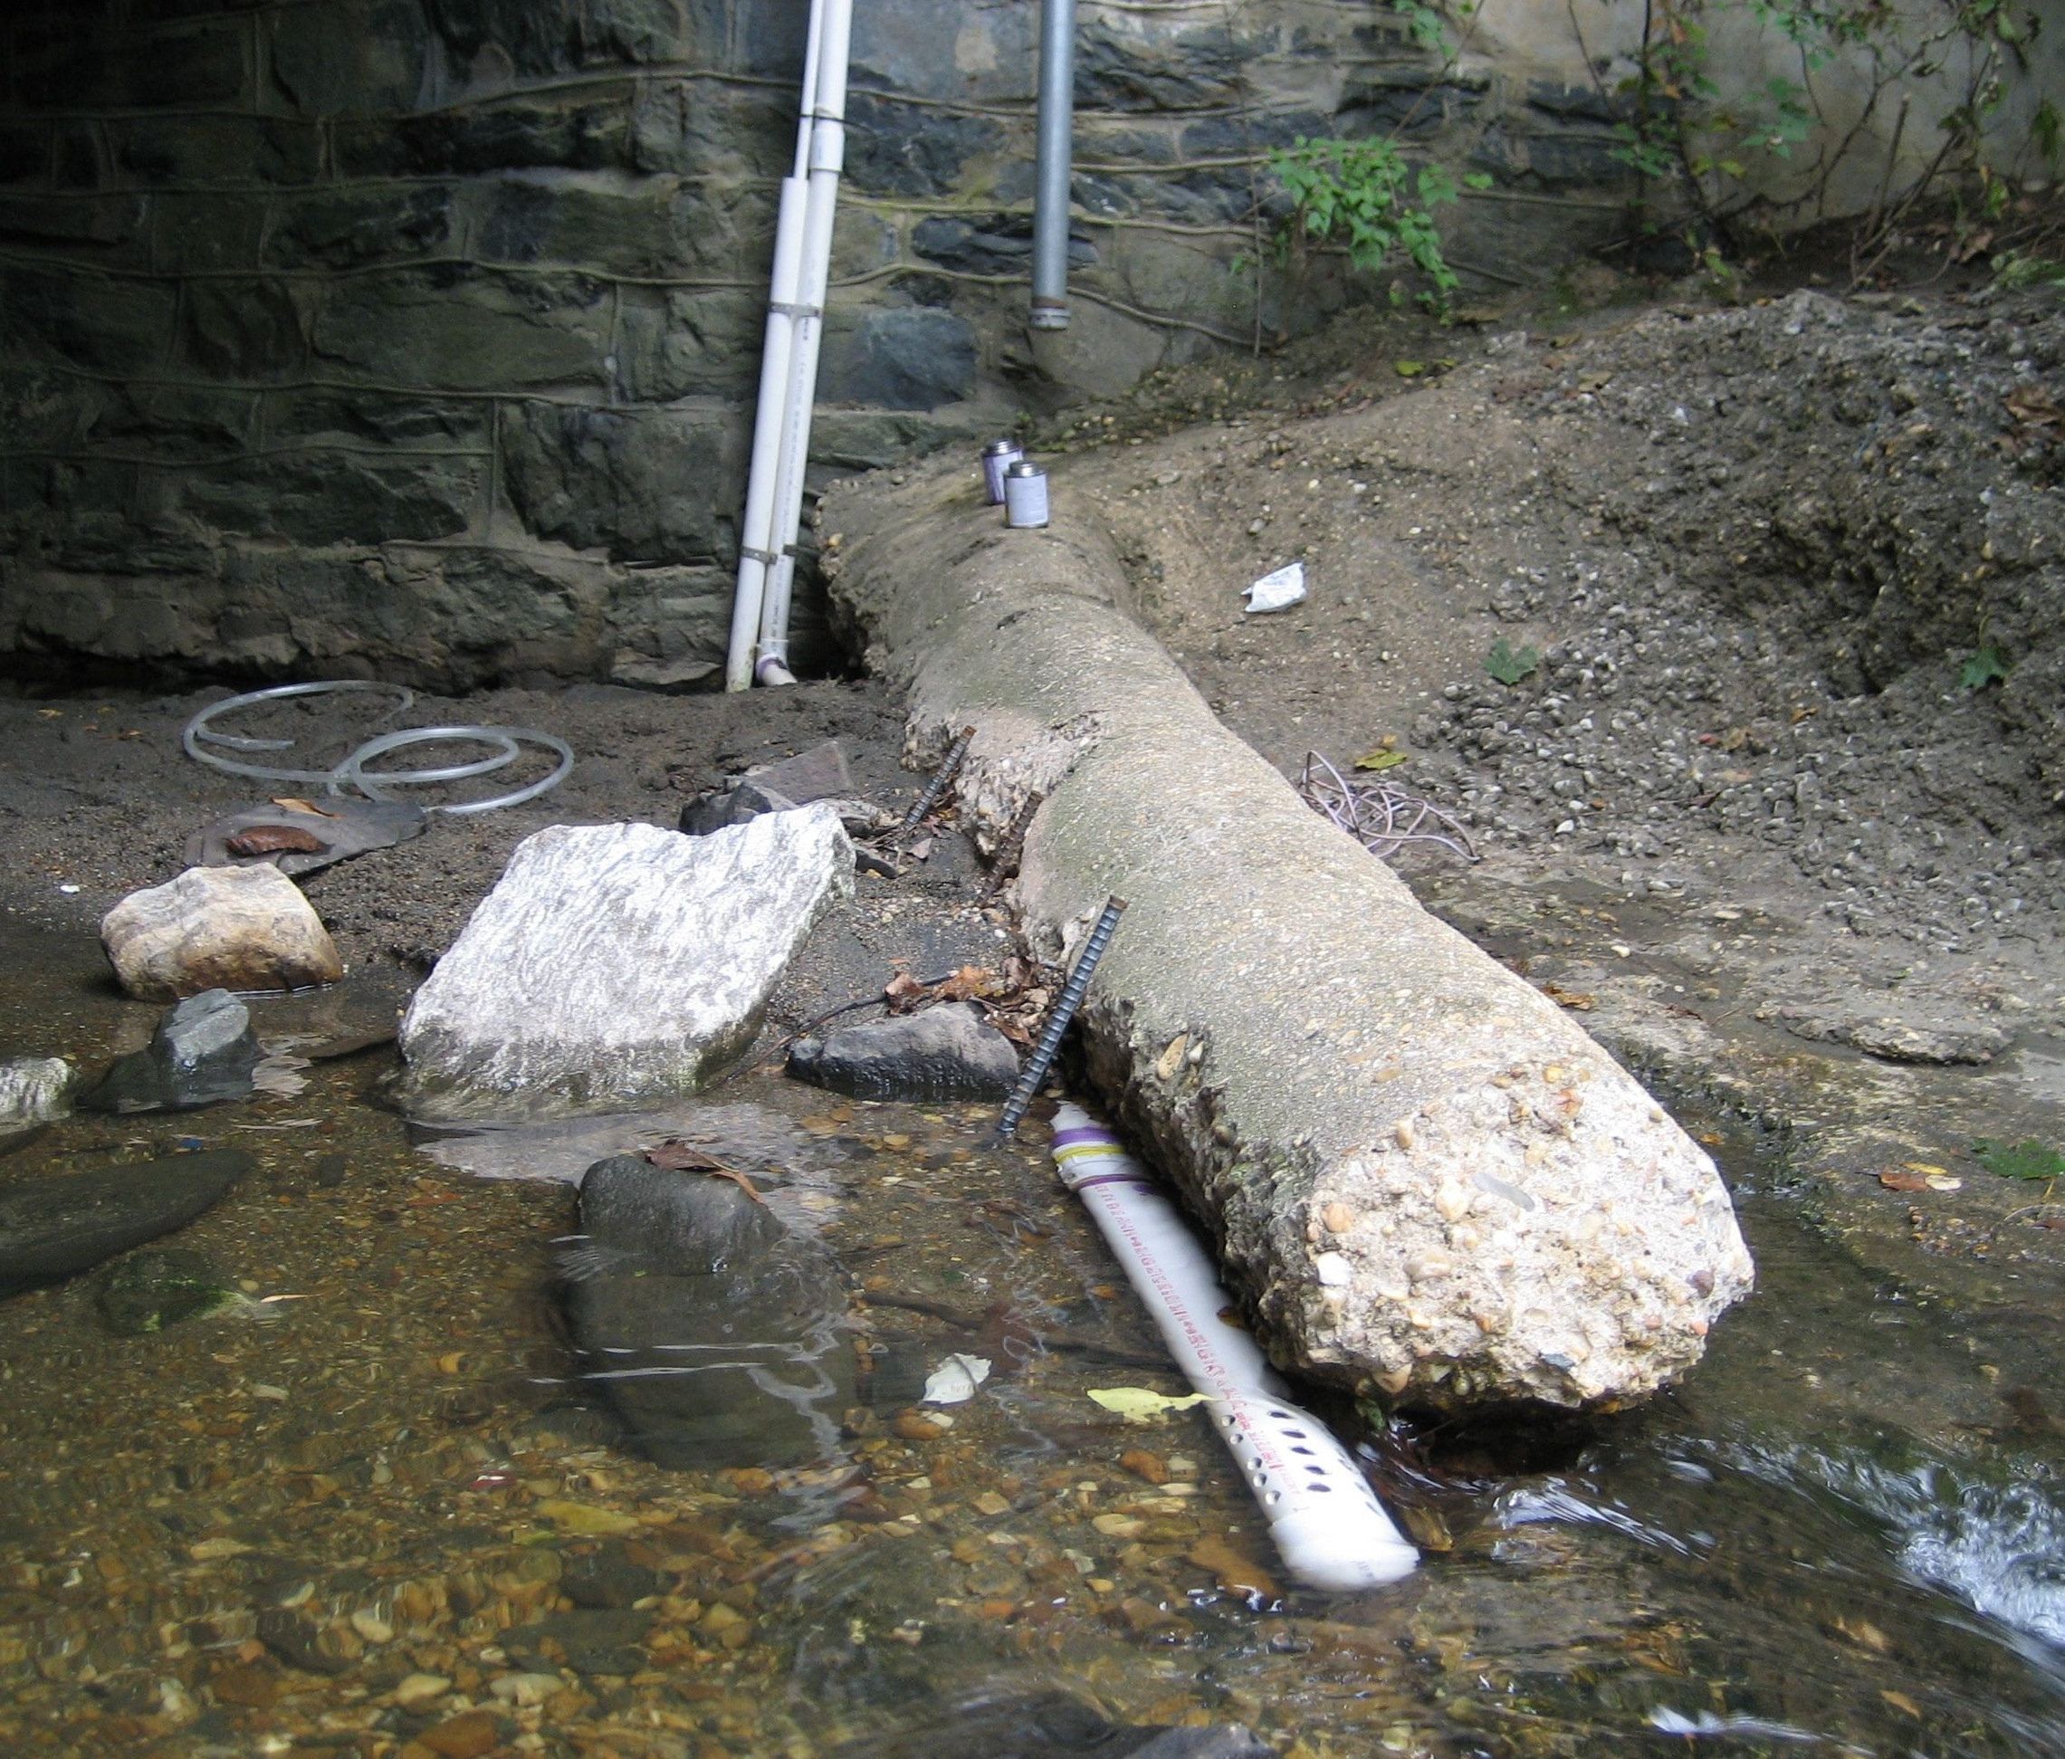  USGS
Year | Average Salt Content in mg/L
1999 | 2.60 | 243.79 | 332.22
2000 | 2.54 | 62.43 | 344.98
2001 | 2.66 | 68.81 | 235.47
2002 | 2.39 | 89.08 | 256.34
2003 | 2.69 | 96.74 | 358.47
2004 | 2.77 | 115.70 | 454.90
2005 | 2.66 | 181.23 | 777.73
2006 | 2.62 | 98.05 | 548.36
2007 | 2.88 | 141.39 | 427.17
2008 | 2.86 | 110.37 | 303.64
2009 | 3.03 | 211.17 | 716.44

Annual Average Salt Levels in Baltimore County

