Climate Change Affects Ecosystems
Impacts from the Intergovernmental Panel on Climate Change (IPCC) 2007 report.

Recall the Ecology Disrupted curriculum learning goals:
- Human daily life can disrupt ecological function leading to environmental issues.
- Scientists can collect data to investigate human impact local ecology.
Students watch additional Science Bulletins videos to learn about how human daily life can affect ecological function, and to pull out the ecological principles. An introduction to the video and background information are provided below.
While watching the Bulletins they will complete a graphic organizer with the following questions:
- What abiotic factor(s) have people changed and what is the impact on the biotic factors in the ecosystem?
- What is the evidence/data for your conclusion?
- How has daily life contributed to this change and how is it affected?
- What are possible solutions?

Introduction
"You may have heard the catchwords – “climate change”, “global warming”, and maybe even “carbon footprint.” Scientists have looked at past temperature and carbon dioxide levels and found a disturbing correlation. Since the beginning of the industrial revolution when people started burning great quantities of fossil fuels and carbon dioxide levels began to increase, temperatures have also been increasing. Carbon dioxide traps the sun’s heat on our planet – this is a good thing, because without it our planet would be very cold. Unfortunately, now excess carbon dioxide is trapping too much heat, rapidly warming our climate. This next Bulletin describes just a few ecosystem responses to a rapidly warming climate. Get ready to fill out your graphic organizers."

Why burn fossil fuels?
Burning fossil fuels has transformed daily human life. Instead of huddling freezing in our homes in winter, we have heating. Instead of trying to see at night with candlelight, we use electric lighting. Food is more diverse and easier to come by than in the past before refrigeration, tractors, fertilizers, and worldwide transportation networks. Travel to different parts of the globe or even to other areas of the State are all easy with the use of buses, trains, cars, and airplanes – all powered by fossil fuels. Finally, cell phones, television, computers, or any of the other products that you use in your daily life would not exist without the electricity to power them or the fossil fuel powered factories to manufacture them.

Burning fossil fuels disrupts the carbon cycle
Before industrial times, the carbon remains of ancient organisms lay mostly sequestered deep in the Earth, a dormant stockpile of stored carbon. These dead organisms had dropped out of the carbon cycle. However, today by burning the carbon remains of these fossilized organisms (fossil fuels), we are drastically changing the carbon cycle. We have suddenly injected into the carbon cycle what was for millions of years only a cycle spectator buried underground. This sudden great influx of stored carbon into the carbon cycle is contributing to our warming planet, just as an unexpected influx of water can start a flash flood and a great influx of nutrients can cause algal blooms.

Evidence
The evidence for climate change is overwhelming. Visit http://climate.nasa.gov/evidence/ for more information. Included is a graph of carbon dioxide levels from the NASA website.

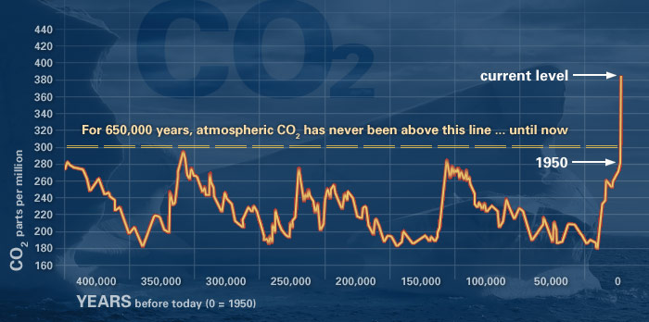

Solutions
Many steps can be taken to reduce our carbon footprint (the amount of carbon dioxide we emit). The government can set limits on global warming pollution levels, invest in green jobs and clean energy like wind and solar power. Also, we can create more energy efficient jobs, homes, and buildings, and invest in public transportation. (Note: New York City already models many of these items like an extensive public transportation network and high-density dwellings that conserve more energy than freestanding homes).

