Zebra Mussel Invasion: Day 1
by Victoria Ford and Garrett Adler

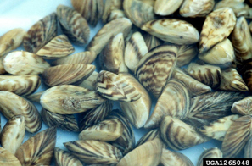
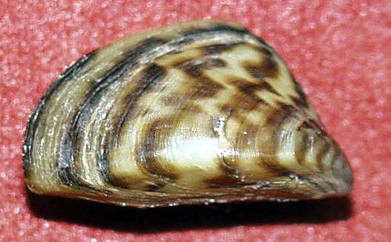

The zebra mussel, Dreissena polymorpha, is a small freshwater mussel. This species is originally from the lakes of southeast Russia. They are filter feeders, which means they eat tiny, mostly microscopic organisms floating around in the water including various kinds of zooplankton and phytoplankton.

Take a look at the maps below to see how the Zebra Mussel population has spread around the US over time.

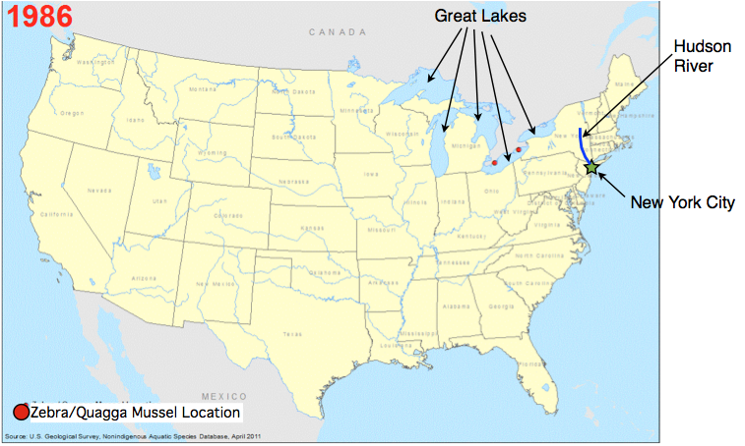

- Were there many zebra mussels living in the US back in 1986? __________

- What part of the country were they living in? _________________________

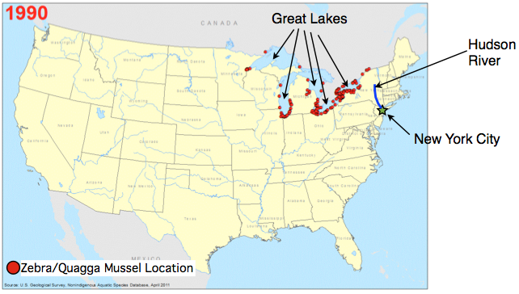

- How is the 1990 map different from the 1986 map? How had the situation changed?

______________________________________________________________________

______________________________________________________________________

- In 1990, were any zebra mussels living in the Hudson River, near New York City?
______________

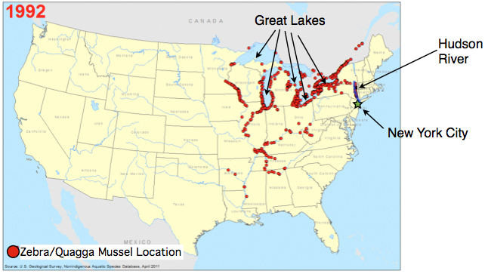

5. How is the 1992 map different from the 1990 map? How had the situation changed near New York City?

______________________________________________________________________

- In 1992 were any zebra mussels living in the Hudson River, near New York City?

______________________________________________________________________

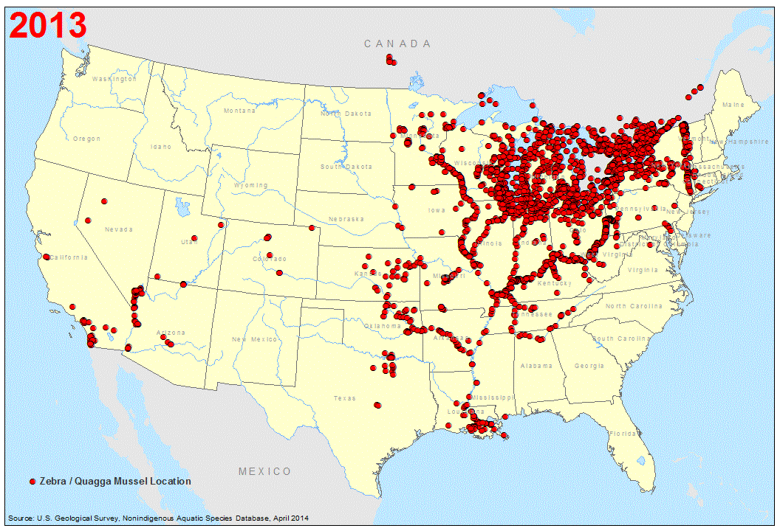

7. How is the 2013 map different from the 1992 map? How had the situation changed over the whole country?

______________________________________________________________________

______________________________________________________________________

- How do you predict it will change in the future? If you saw a map of the situation in 2020, how do you think it would be different? Why?

______________________________________________________________________

______________________________________________________________________

The Spread of Zebra Mussels

Zebra mussels were accidentally brought to North America in the ballast water of trans-oceanic cargo ships. On ships, ballast water is located at the bottom of a ship below the water level. It provides stability to ships by counteracting the effects of the weight above the water level. This water is usually taken from the ship’s origin point and travels with the ship to its destination. It is then dumped into the surrounding water so the ship can be cleaned or because the ship doesn’t need as much ballast to counterbalance the new weight on the ship.

Because zebra mussels are so small (they are usually the size of a fingernail), they are not easy to see. They can easily be transported in the ballast water from the ship’s origin point to its destination point and then dumped into the surrounding water.

Zebra mussels are also the only freshwater mussel that can attach to objects.

- Did the zebra mussels arrive in the US naturally or did they come because of human actions?

______________________________________________________________________

______________________________________________________________________

- Have the zebra mussels been spreading around the US on their own or have they had lots of help from humans?

______________________________________________________________________

______________________________________________________________________

- What do humans do that can lead to the spread of zebra mussels?

______________________________________________________________________

______________________________________________________________________

______________________________________________________________________

- What can humans do to help prevent the spread of zebra mussels?

______________________________________________________________________

______________________________________________________________________

______________________________________________________________________

Exit Slip:

What impact or changes do you think this invasion of zebra mussels will have on the native species living in the Hudson River ecosystem? (Hint: Think about what it means to be the only freshwater mussel species that can attach itself to objects.)

