Zebra Mussel Invasion: Day 1
by Victoria Ford and Garrett Adler

Take a look at the graphs. Each one shows how the zebra mussel population has changed over time and how the populations of other organisms in the Hudson River have changed over time. Answer the questions below each set of graphs:

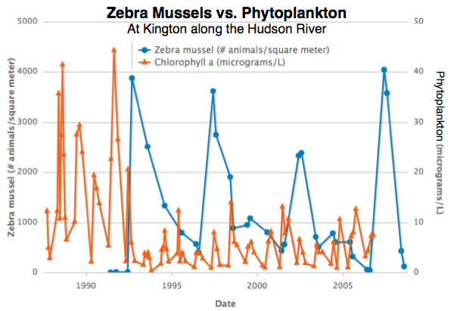
A) Which shape is on the line on the graph that shows the zebra mussel population? _________

B) Which shape represents the line that shows the phytoplankton (circle or triangle)? ________

- Were there any zebra mussels around before 1990? ________________________________

- Was the population of phytoplankton high or low before 1990? ________________________

- What happened to the population of zebra mussels after 1992? _______________________

- What happened to the population of phytoplankton after 1992? __________________________________________________________________________

- In general, how does the phytoplankton population change when the zebra mussel population changes?
____________________________________________________________________________

H) Why do you think this happens?
____________________________________________________________________________

____________________________________________________________________________

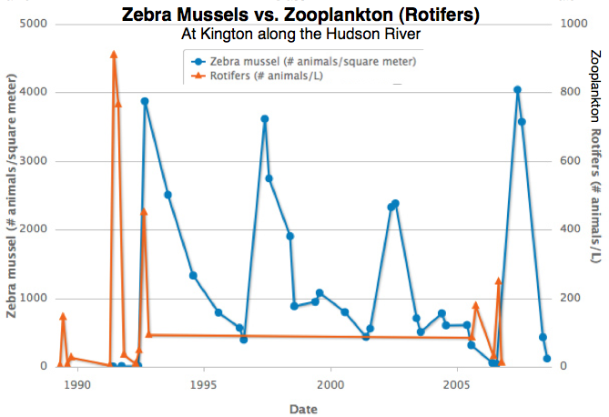

A) Which shape is on the line on the graph that shows the zebra mussel population (circle or triangle)? ____________________________________________________________________

B) Which shape represents the line that shows the zooplankton - rotifers (circle or triangle)? ____________________________________________________________________________

- Were there any zebra mussels around before 1990? ________________________________

D) Was the population of zooplankton high or low before 1992? _________________________

- What happened to the population of zebra mussels after 1992? _______________________

- What happened to the population of zooplankton after 1992? _________________________

- In general, how does the zooplankton population change when the zebra mussel population changes? _________________________________________________________________

__________________________________________________________________________

H) Why do you think this happens? ________________________________________________

____________________________________________________________________________

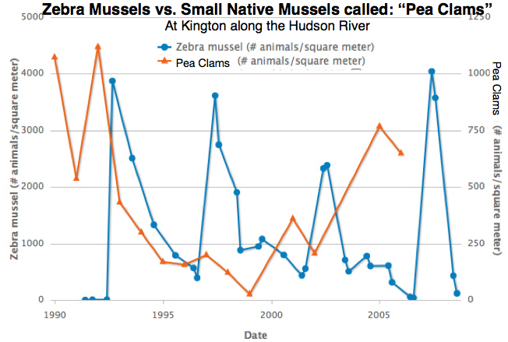
A) Which shape is on the line on the graph that shows the zebra mussel population (circle or triangle)? ____________________________________________________________________

B) Which shape represents the line that shows the pea clams (circle or triangle)? ___________

- Were there any zebra mussels around before 1990? ________________________________

D) Was the population of pea clams high or low before 1992, when the zebra mussels arrived? ____________________________________________________________________________

- What happened to the population of zebra mussels after 1992? _______________________

- What happened to the population of pea clams after 1992? __________________________

____________________________________________________________________________

G) In general, how does the pea clam population change when the zebra mussel population changes? ____________________________________________________________________

____________________________________________________________________________

- Unlike phytoplankton and zooplankton, zebra mussels do not feed on pea clams. Can you think of another reason why the graph for the pea clam population would be relatively similar to the previous phytoplankton and zooplankton graphs? _____________________________

____________________________________________________________________________

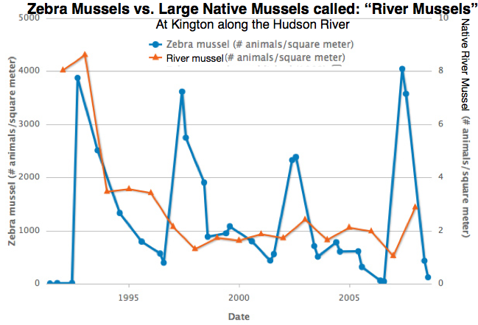

A) Which shape is on the line on the graph that shows the zebra mussel population (circle or triangle)? ____________________________________________________________________

B) Which shape represents the line that shows the native river mussel (circle or triangle)? ____________________________________________________________________________

C) What is similar between this graph and previous graph about pea clams? _______________

____________________________________________________________________________

D) What is different between this graph and the previous graph about pea clams? ___________

____________________________________________________________________________

E) Why do you think the river mussels responded differently than the pea clams? ___________

____________________________________________________________________________

____________________________________________________________________________

Hudson River Ecosystem Before the Zebra Mussels Arrived

When your teacher draws the food web on the board, draw it on your sheet.

On the picture above, draw how you think the ecosystem will change after the zebra mussels are introduced? If you think certain organisms will die, cross them out. If you think certain organisms will increase, circle them. Do you think new species will show up? Draw them.

Describe the kinds of changes you would expect to see below:

Hudson River Ecosystem After the Zebra Mussels Arrived

- Describe at least 3 differences you notice between this picture and the one from before the Zebra Mussel invasion:
____________________________________________________________________________

____________________________________________________________________________

____________________________________________________________________________

B) How does the data in the graphs support your claim that these changes happened? Use information you see in one or more graphs to prove how the populations in the river changed.

____________________________________________________________________________

____________________________________________________________________________

____________________________________________________________________________

C) How have the zebra mussels disrupted the Hudson River food web? How have they changed it? Why is this a problem?

____________________________________________________________________________

____________________________________________________________________________

____________________________________________________________________________

Final Discussion Questions:

1. If people keep doing what we have always done (filling up ships with ballast water and dumping it, carrying buckets and boats from one river or lake to another without cleaning them) where do you think we’ll find these mussels in the future?

____________________________________________________________________________

2. Why is this a problem?

____________________________________________________________________________

3. What can we do differently to prevent these changes?

____________________________________________________________________________

____________________________________________________________________________

4. Make a list of 3-5 guidelines you think people should keep in mind when they are interacting with the water of the Hudson River or other bodies of water where zebra mussels live. (Hint: use your “The Spread of the Zebra Mussel” sheet from yesterday to help!)

____________________________________________________________________________

____________________________________________________________________________

____________________________________________________________________________

____________________________________________________________________________

____________________________________________________________________________

5. Now that you have looked at this data, you, just like professional scientists, can work to help find solutions to the zebra mussel invasion. As a scientist, what other questions would you ask and what other data would you want to collect in order to help understand and solve this problem?

____________________________________________________________________________

____________________________________________________________________________

____________________________________________________________________________

____________________________________________________________________________

____________________________________________________________________________

____________________________________________________________________________

____________________________________________________________________________

