Zebra Mussel Invasion: Day 1
by Victoria Ford and Garrett Adler

Take a look at the graphs. Each one shows how the Zebra Mussel population has changed over time and how the populations of other organisms in the Hudson River have changed over time. Answer the questions below each set of graphs:

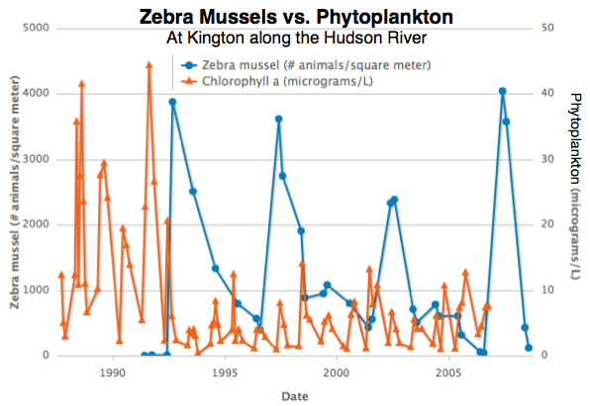
A) Which shape is on the line on the graph that shows the zebra mussel population? Circle.

B) Which shape represents the line that shows the phytoplankton (circle or triangle)? Triangle.

- Were there any zebra mussels around before 1990? No.

- Was the population of phytoplankton high or low before 1990? High.

- What happened to the population of zebra Mussels after 1992? It increased dramatically.

- What happened to the population of phytoplankton after 1992? It dropped dramatically and stayed low.

- In general, how does the phytoplankton population change when the zebra mussel population changes?
When the zebra mussel population increases, the phytoplankton population decreases.

H) Why do you think this happens?
Zebra mussels eat phytoplankton so if the zebra mussel population is large, they’re going to eat the phytoplankton and the population will decrease.

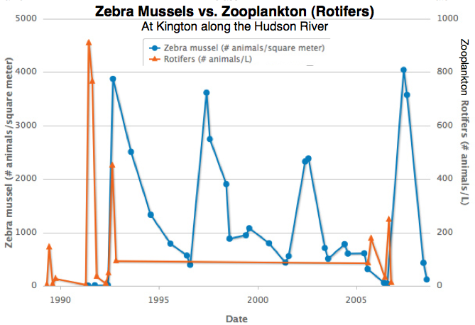

A) Which shape is on the line on the graph that shows the zebra mussel population (circle or triangle)? Circle.

B) Which shape represents the line that shows the zooplankton - rotifers (circle or triangle)? Triangle.

- Were there any zebra mussels around before 1990? No.

D) Was the population of zooplankton high or low before 1992? Relatively high.

- What happened to the population of zebra mussels after 1992? It increased dramatically.

- What happened to the population of zooplankton after 1992? It decreased dramatically and stayed that way.

- In general, how does the zooplankton population change when the zebra mussel population changes? When the zebra mussel population increases, the zooplankton population decreases.

H) Why do you think this happens? Zebra mussels eat zooplankton, so if the zebra mussel population is large, they’re going to eat the zooplankton and the population will decrease.

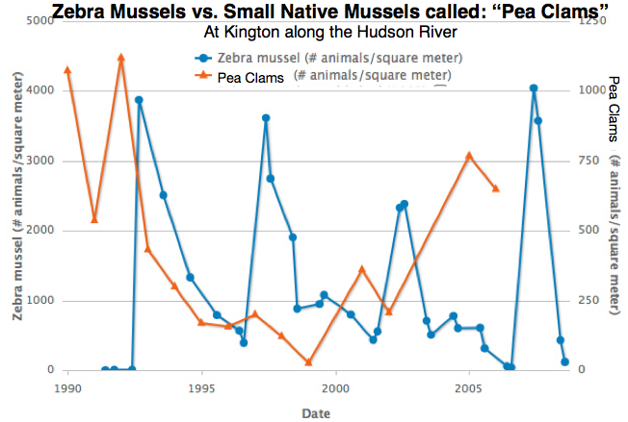
A) Which shape is on the line on the graph that shows the zebra mussel population (circle or triangle)? Circle.

B) Which shape represents the line that shows the pea clams (circle or triangle)? Triangle.

- Were there any zebra mussels around before 1990? No.

D) Was the population of pea clams high or low before 1992, when the zebra mussels arrived? High.

- What happened to the population of zebra mussels after 1992? It increased dramatically.

- What happened to the population of pea clams after 1992? It dropped quickly and stayed low until after 2000, when the zebra mussel population dropped.

G) In general, how does the pea clam population change when the zebra mussel population changes? When the zebra mussel population increases, the pea clam population decreases. When the zebra mussel population decreases the pea clam population increases.

- Unlike phytoplankton and zooplankton, zebra mussels do not feed on pea clams. Can you think of another reason why the graph for the pea clam population would be relatively similar to the previous phytoplankton and zooplankton graphs? The zebra mussels eat the same food as the pea clams so when the zebra mussel population is high, the pea clams don’t have enough to eat and their population shrinks.

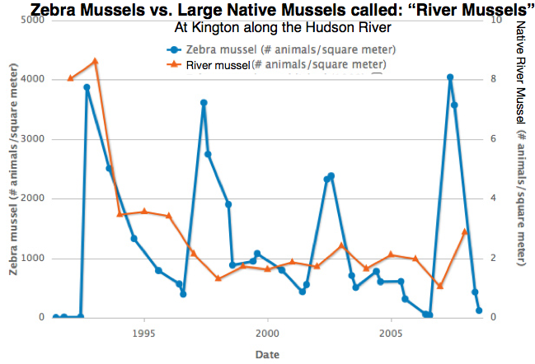

A) Which shape is on the line on the graph that shows the zebra mussel population (circle or triangle)? Circle.

B) Which shape represents the line that shows the native river mussel (circle or triangle)? Triangle.

C) What is similar between this graph and previous graph about pea clams? As soon as the zebra mussels were introduced, the population of river mussels decreased dramatically.

D) What is different between this graph and the previous graph about pea clams? The river mussel population did not bounce back in 2005 like the pea clams.

E) Why do you think the river mussels responded differently than the pea clams? Students’ answers can range, but should include a logical argument regarding different species have different reproduction rates or needing different resources from their environment.

Hudson River Ecosystem Before the Zebra Mussels Arrived

When your teacher draws the food web on the board, draw it on your sheet.

On the picture above, draw how you think the ecosystem will change after the zebra mussels are introduced? If you think certain organisms will die, cross them out. If you think certain organisms will increase, circle them. Do you think new species will show up? Draw them.

Describe the kinds of changes you would expect to see below:

Hudson River Ecosystem After the Zebra Mussels Arrived

- Describe at least 3 differences you notice between this picture and the one from before the Zebra Mussel invasion:

1.There are lots of zebra mussels, everywhere
2.There are far fewer phytoplankton and zooplankton
3.There are also fewer grey fish but more red fish

B) How does the data in the graphs support your claim that these changes happened? Use information you see in one or more graphs to prove how the populations in the river changed.

The graphs showed that the zebra mussel population would increase and we see that dramatic increase in the picture. The data also showed that the numbers of local mussels, phytoplankton and zooplankton would decrease after the arrival of the zebra mussels in 1992. This is what the picture shows as well.

C) How have the zebra mussels disrupted the Hudson River food web? How have they changed it? Why is this a problem?

The zebra mussels are eating the phytoplankton and zooplankton at too great a rate for the phytoplankton and zooplankton to be adequately replenished. These species are at the bottom of the food chain and are the main source of food for the native mussels. If the native mussels die out, those fish that eat the zebra mussels will overpopulate and those fish that don’t eat the zebra mussels will die out.

Final Discussion Questions:

1. If people keep doing what we have always done (filling up ships with ballast water and dumping it, carrying buckets and boats from one river or lake to another without cleaning them) where do you think we’ll find these mussels in the future?
In bodies of water all throughout the country.

2. Why is this a problem?
Because the zebra mussel will continue to damage ecosystems around the country.

3. What can we do differently to prevent these changes?
Make sure zebra mussels do not enter new ecosystems by restricting access to certain waterways or requiring boats to thoroughly clean their hulls.

4. Make a list of 3-5 guidelines you think people should keep in mind when they are interacting with the water of the Hudson River or other bodies of water where zebra mussels live. (Hint: use your “The Spread of the Zebra Mussel” sheet from yesterday to help!)

Wash any boats before they move from one body of water to another
Make sure to clear and wash out any buckets or other containers that have water from a place where there are zebra mussels
Don’t carry ballast water in ships or clean the ballast water before dumping it in a new environment

5. Now that you have looked at this data, you, just like professional scientists, can work to help find solutions to the zebra mussel invasion. As a scientist, what other questions would you ask and what other data would you want to collect in order to help understand and solve this problem?

